
Knowledge Organiser
Topic: Castles Subject: History
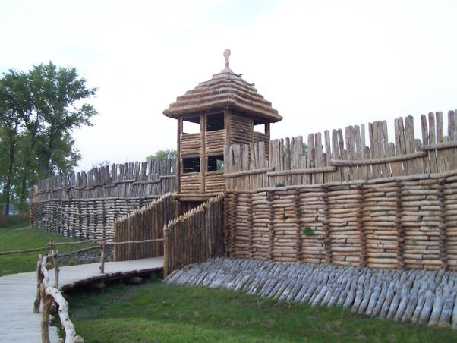
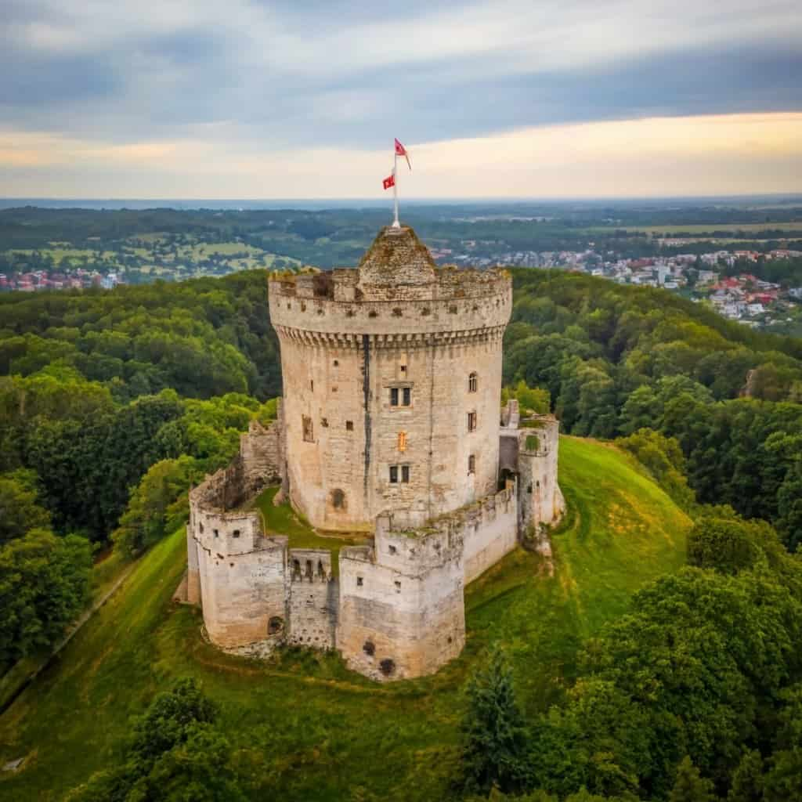
palisade – a strong fence made of many tall wooden posts.

keep – a big building inside the castle walls, usually a tower.

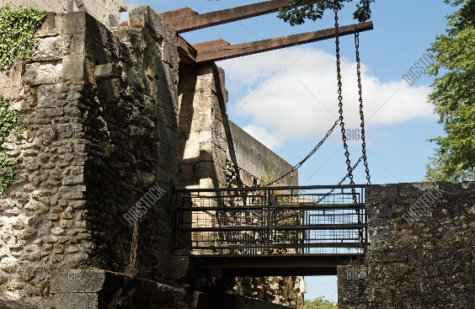
drawbridge – can be raised or lowered to let people cross over the moat.

moat – a deep trench or ditch that was dug all around the outside of the castle and then filled with water.

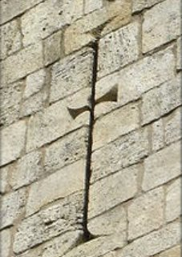
arrow loops/slits – used to defend the castle from attackers.
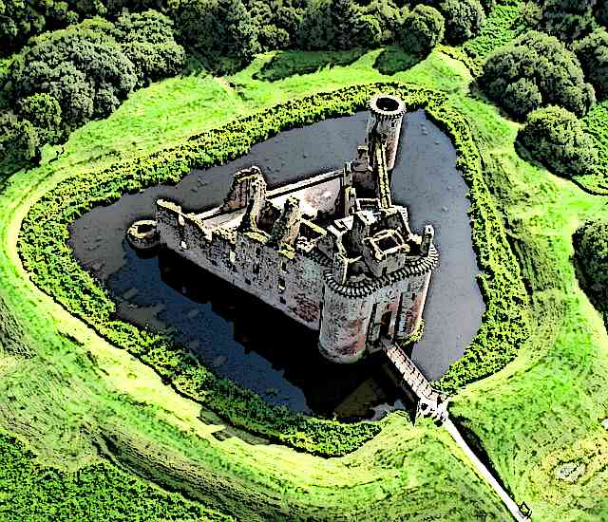

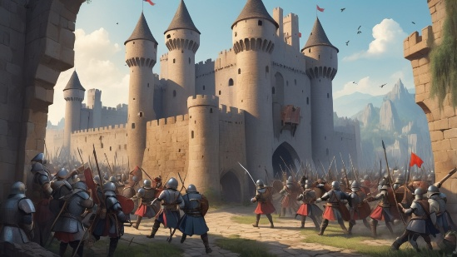
siege – a long, tough fight where one team was in a big, strong castle and the other team were outside trying to get in.

What key facts will we be learning?
- The different types of castles.
- How castles have changed over time and why.
- The different parts of a castle.
- Who lived in a castle and what jobs they did.
- What it looked like inside a medieval castle and how they are different from modern day castles.
- Why people attacked castles and what weapons they used.
- The role of a monarch and the chronological order of nine British monarchs.

