1. OBSERVATIONAL DRAWING  Find a tree in your garden or close by your house and make an observational drawing of it.  Look carefully at the tree before you start. Do you notice how it starts off wide and then gets narrower and so do all the branches?  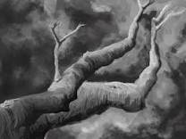 | 2. CARDBOARD FOOT  Use a scrap of cardboard e.g. from an old cereal box to draw around your foot. Ask an adult to help cut it out. Place it somewhere in your garden or when you are out for a walk – what can you ‘stomp’ on? Daisies? Mini-beasts? Stones? See what is in your footprint. Can you draw and label this?  CHALLENGE – Can you use this data to make a graph of what you have found?  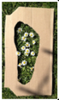 | 3. CREATE AN Obstacle Course  Using what you can find in your garden, design and create an obstacle course. You need to have up to 5 different obstacles. This might include dribbling a ball in and out of shoes or making a circle and doing 10 star jumps inside it. Try to be as creative as you can – you could even use some exercises that you have used from your very own Joe Wicks workout!  CHALLENGE: How could you make it harder? How could you make it easier?  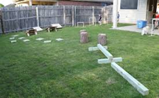 | 4. Ball run Challenge  Design and build a tennis ball run.  Use a range of small and large materials e.g. recycling, scrap construction, materials, natural items, and other bits ‘n’ bobs!  Fasten them together to move a tennis ball around your outdoor space.  Try to follow these instructions or just make your own  • The tennis ball run must be on at least two levels and at different heights.  • It must change direction.  • It must have a start and finish point.  • The tennis ball must be able to travel from beginning to end on its own.  The size of your ball run is up to you! | 5. Blindfold Safari  Collect different objects from your garden or on a walk, such as some bark, stones, leaves etc.  Put on a blindfold (if you don’t have a blindfold you could use a scarf) and have someone from your family hand you one of the outside objects.  Think of as many adjectives as you can to describe the object. Can you guess what the object is?
6. LOOK FOR SIGNS OF SUMMER  Make lists of the things that SUMMER is:  List 1: What things LOOK like summer?  List 2: What things SOUND like summer?  List 3: What SMELLS are summer?  List 4: How does summer FEEL?  List 5: What makes you FEEL summer?  List 6: What things TASTE of summer?  List 7: What EXPERIENCES or IDEAS seem to represent summer? | 7. A –Z ON YOUR DAILY WALK  Before you go out for your walk or into your garden write the alphabet down the side of a piece of paper.  As you walk look for different objects, plants or wildlife for each letter of the alphabet.  How many can you find? | 8. FIVE SENSES SCAVENGER HUNT  Look for different things for your five senses as you go for your daily exercise.  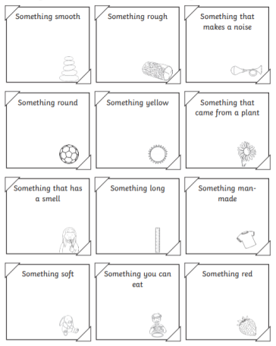 | 9. LEAF NECKLACE  While you are out collect as many leaves as you can find (hopefully off the ground not from the trees).  When you get home cut a length of string or wool and thread the leaves on to the  String or wool to make a beautiful necklace.  You could try to make a pattern with the leaves. Wear your necklace with pride.  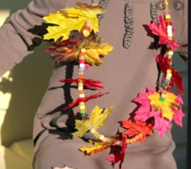 | 10. MAKE A WIND CHIME  Collect sticks of different lengths when you are out and about (or see what you can find in your garden).  Hang them from a larger stick using wool or string so that they will bang together in the breeze.  Hang the large stick up in your garden and listen to the sounds.  You could paint or decorate the sticks before hanging them up.  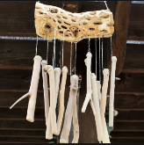

Outdoor Activity Learning Grid – Monday 18th to Friday 5th June
Please share your work on the blog and remember these activities are all optional. Don’t forget the week beginning the 25th May is half term so we will not be setting any work for this week.

