Monday 18th May - Friday 5th June - Indoor Home Learning Grid - YEAR 1 and 2
Please share your work on the blog and remember these activities are all optional.
Don’t forget the week beginning the 25th May is half term so we will not be setting any work for this week.
Activity 1 – WRITE A FACT SHEET ABOUT AN ANIMAL OF YOUR CHOICE  Can you write an information sheet about an animal of your choice? Try to include different headings to describe different things about your chosen animal. Try to include pictures to make your information sheet interesting.  CHALLENGE – Can you describe what your animal looks like using different adjectives?  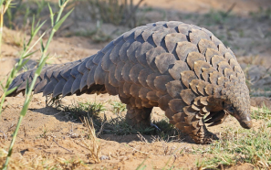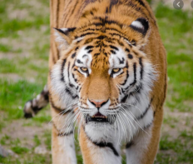 | Activity 2 – WRITE AN ACROSTIC POEM FOR THE WORD  S  E  A  S  I  D  E  Try to think about what you may have learnt about the seaside whilst being at home and see if you can include facts in your acrostic poem.  CHALLENGE – Can you write another acrostic poem with your own word? Can you try to include rhyme? | Activity 3 – DESIGN YOUR OWN JOE WICKS WORKOUT  Can you design your own Joe Wicks workout? Watch Joe Wicks live on YouTube to see the types of exercises he does. Think of up 10 exercises you and your adults could do at home. You will need to think about:  - How long each exercise will be  - How long your rest time will be  Draw and name each exercise and write a short sentence about how to do it.  CHALLENGE - Can you think of ways to make it harder for your adults at home? For example, if you put press ups down as one your exercises, make it harder for your adult by telling them they must touch each shoulder before they do the next press up. | Activity 4 – HOW MANY WAYS CAN YOU MAKE AND SHOW THE NUMBER 16?  Can you use addition, subtraction, multiplication and division? Can you draw it? Can you make it on a tens frame? Can you make it drawing dienes?  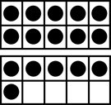  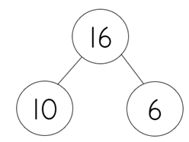
Activity 5 – WRITE 5 QUESTIONS  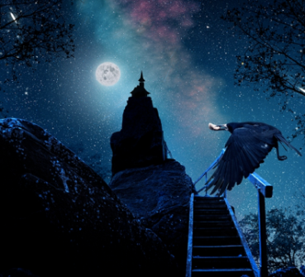  Look at the picture of the mysterious tower. Write 5 questions that you have about it. Think about who may be in the tower and why.  Remember to use different question words such as Who, what, why, where and how and to finish your question with a question mark. | Activity 6 – MAKE YOUR OWN CREEPY CRAWLIE!  Make your favourite creepy crawly out of any recycling you have in your house. You could use yoghurt pots, paper, cereal boxes - anything!  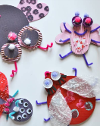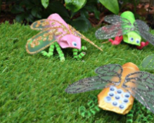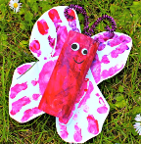 | Activity 7 - WRITE A NEWS REPORT  Think of something happy that has happened to you or that you have done during the past few weeks.  Now write your own newspaper article complete with a headline and pictures about what happened.  
Activity 8 – WRITE A NEW STORY  Read your favourite picture book.  Now try to rewrite it so that it is better, has different main characters, has a different ending, has a different baddie, alter whatever you like.  Whatever you do remember to use amazing adjectives and super descriptions. | Activity 9 – FAMILY TREE  Using photos, pictures or even your computer create your family tree.  You can add sentences about each person and share it with your family when you see each other next.  How far back can you go?  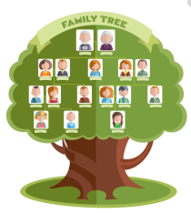 | Activity 10 – WHAT DOES IT MEAN?  Choose one of the following words that relate to our seaside topic...  PROMENADE, CHARABANC, BATHING MACHINE,  try to find out what it means.  Research in books or online.  Then present your work in an interesting way either in pictures, writing or my using WORD or PowerPoint.

