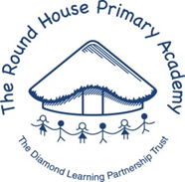

Year 5 Curriculum Newsletter

Autumn Term 2026

Dear Parents & Carers

Welcome back! We hope you had a wonderful time off during the holidays. Please find below a summary of the main learning areas during the next term and some general reminders.

Homework

- Reading- children are expected to read for 10 minutes, 5 times a week from their AR book in school. Reading for pleasure is encouraged at home.
- Spelling - children are expected to practice their spellings, which are posted on Dojo every Monday. Spellings are changed every week and are quizzed on Fridays.
- Maths.co.uk - children are expected to complete the test set on maths.co.uk each week. This will be set and checked on Mondays. Children who do not complete it will do so in their break or lunch times.

P.E.

P.E. will be on Fridays but we recommend keeping P.E. kit in school everyday.

Please ensure that your child has the appropriate clothing and footwear in school for these P.E. lessons – a white t-shirt, navy or black football-style shorts (not cycling shorts), pumps/trainers, a warm top, jogging trousers (not leggings). A change of shoes is particularly useful when the ground is wet or muddy. Children must have their P.E. kit in school all week otherwise they cannot participate. Please tie up long hair. Your child will be asked to remove their earrings on days that they have P.E. If your ears are newly pierced, you can use plastic spacer earrings for P.E. lessons. Any other jewellery should not be worn to school.

Thank you.
Mr Ward, Mrs Rush and Miss Day

Autumn Term 2026 - Curriculum Units for Year 5

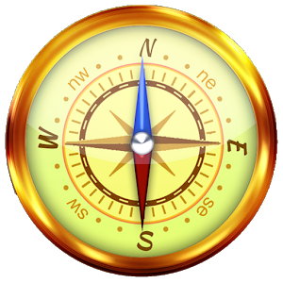

Geography

The children will be learning about the globalisation. We will be looking specifically at how communication, transport and food are connected across the world.
Computing
The children will be exploring e-safety and search engines and how best to find information on the internet. They will also consider whether information is reliable or not.

Science
During the Autumn term, Year 5 will be focusing on Chemistry and will be learning about mixtures and how to separate them. Then, they will move on to study the properties of different materials.

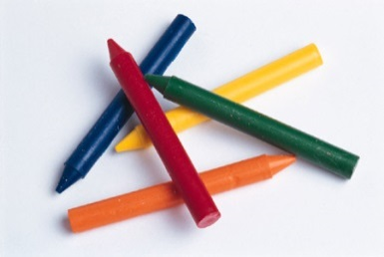



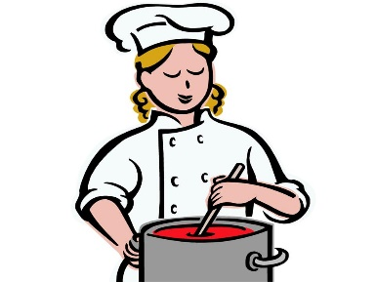
Music
In Music, Year 5 are creating chords and melodies inspired by nature.

History
After half term, the children are learning about the Ancient Mayans and how they lived.

Religion & Worldviews

The children in Year 5 will be learning about worldviews and why people stand up for what they believe in.

PSHE
In PSHE, the children will be learning about why community is important and how people are different and similar.

DT
In Design and Technology, later in the term, the children will be looking at where food comes from and cooking a spaghetti bolognese.
P.E.
This term, we will be focusing on tag rugby, fitness, gymnastics and netball.
Art
In Art, the children will be completing a topic called ‘Sculpture and 3D’, where they will learn about and create installation art.

