Tuesday 24th March 2020
Good Morning Year Three,
Today is National Chocolate Covered Raisins Day

Our Vocab Ninja Word of the Week is penultimate. Definition: last but one, second from last. 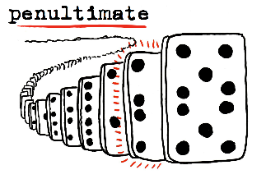
Answer to Monday’s Riddle: Which letter has the most water. (the letter c)
Tuesday’s Riddle: What is more useful when it’s broken?
Reading: | Maths: | Writing: | Handwriting: | Spellings / Key Words:
30 minutes of daily reading from an AR book or a book of your choice. | 30 minutes of TT Rock Star (Complete Garage Bands).  On Espresso: watch the video; adding 2 3-digit numbers.  https://central.espresso.co.uk/espresso/primary_uk/subject/module/video/item433008/grade2/module414571/index.html  Have a go at adding your own 2, and 3-digit numbers together.  Remember how to set them out as column addition:  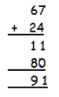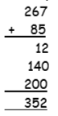 | Design an avatar for your blog. Write a description about yourself.  What are your likes and dislikes? What are your hobbies? | Complete first sheet from your handwriting booklet (Tongue Twisters 1) | Continue to practice reading and spelling your Key Stage Two Word Walls.  On Spelling shed, complete the daily 10 tasks.  Our spelling words this week are (These are the spellings for Miss Voce/Mr Thomas’s groups. You will be set spellings for your spelling groups every week):  - loudly, gladly, cheerful, handful, dutiful, restless, endless, tasteless, happiness, kindness

Wider Curriculum (Science and Ice Zone):
PE time – have you tried a work out with Joe Wicks ? PE with Joe on his YouTube channel It is live very day at 9am, but you can also find it saved on his channel to do at another time.
https://www.youtube.com/user/thebodycoach1
Remember to take learning breaks and to stay safe.
Best wishes,
Mrs Voce, Miss Knox, Mr Thomas.
Websites for learning:
https://play.ttrockstars.com/auth/school/student/14864
https://www.edshed.com/en-gb/login?return_url=https%3A%2F%2Fhub.edshed.com
https://www.discoveryeducation.co.uk/what-we-offer/discovery-education-espresso
https://ukhosted11.renlearn.co.uk/3406764/
http://primaryhomeworkhelp.co.uk/

