Monday 30th March 2020
Bore Da ‘Good Morning’ Year Three
Today is Doctor’s Day | Our Vocab Ninja Word of the Day is...
 | 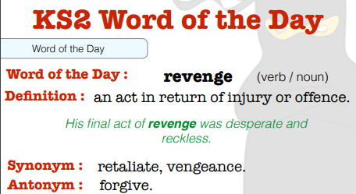
Answer to yesterday’s Riddle: Which month has 28 days? (All the months)
And ….Why can’t you trust Elsa and Olaf with a balloon? (Because she will let it go)
Today’s Riddle: What has 4 legs but cannot walk?
Reading: | 30 minutes of daily reading- an AR book / book of your choice.
Maths: | 30 minutes of TT Rock Star (Complete Garage Bands)  Look at the Interactive Fraction Wall: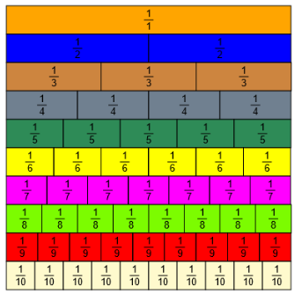 https://www.visnos.com/demos/fraction-wall  Compare the fractions. Explore which are more >, which are less < and which are equal =.  Which fractions can you use to equal a whole 1?  - Write your own sentences to compare them,  e.g. ½ = 2/4,  >, 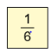<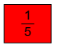  You can print off the fraction wall attached to help.
Writing: | Today we are looking at adverbials. Specifically, fronted adverbials.  Here is the link to the Adverbials Song:  https://www.youtube.com/watch?v=B3hR3BHpeho&t=2s  Here is a video to help you...  https://www.bbc.co.uk/bitesize/topics/zwwp8mn/articles/zp937p3  Can you write 8 sentences normally, then rearrange the sentence using the adverbial at the front, followed by a comma.  I walked to the shop slowly.  Slowly, I walked to the shop.  Earlier today, whilst eating my breakfast I hummed a cheerful song.
Handwriting: | Complete 4 lines of the Proverbs sheet from your handwriting booklet.
Spellings / Key Words: | Continue to practice reading and spelling on your Key Stage Two Word Walls.  On Spelling shed, complete the daily 10 tasks.  Mrs Voce and Mr Thomas’s Spelling Group words this week are:  famous, favourite, February, forward, forwards, fruit, grammar, group, guard, guide.  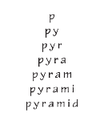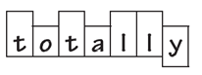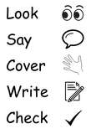  You can print off the Look, say, cover, write check sheet to help.
Wider Curriculum (Science and Ice Zone): | From Mrs Rodgers – Art:  Have a look at these pictures from the website link and you can do some arty activities related to these art works.  https://www.fitzmuseum.cam.ac.uk/lookthinkdo/about

Remember to take learning breaks and to stay safe.
Best wishes,
Mrs Voce, Miss Knox and Mr Thomas.
Websites for learning:
https://play.ttrockstars.com/auth/school/student/14864
https://www.edshed.com/en-gb/login?return_url=https%3A%2F%2Fhub.edshed.com
https://www.discoveryeducation.co.uk/what-we-offer/discovery-education-espresso
https://ukhosted11.renlearn.co.uk/3406764/
http://primaryhomeworkhelp.co.uk/

