Tuesday 31st March 2020
Maidin Mhaith, Good Morning Year Three,
Today is Crayola Crayon Day | Our Vocab Ninja Word of the Day is...
 | 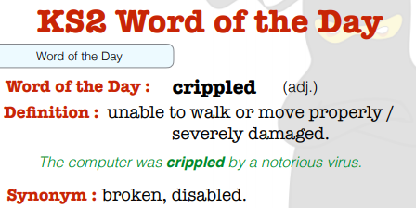
Answer to yesterday’s Riddle: What has 4 legs but cannot walk? (A Table)
Today’s Riddle: How do you make the number one disappear?
Reading: | 30 minutes of daily reading- an AR book / book of your choice.
Maths: | 30 minutes of TT Rock Star (Complete Garage Bands) Try to improve your Rock Speed by doing 10 Studio Games!  Look at the Interactive Fraction Wall again (or your printout):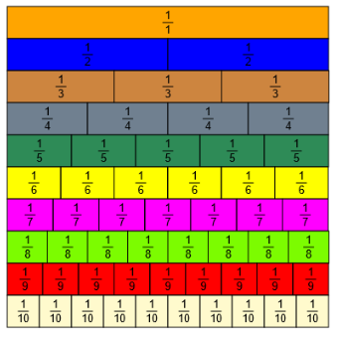  https://www.visnos.com/demos/fraction-wall  How many combinations of fractions can you make that are equal to (=) to 1?  e g.2/4 + ½ = 1  Add some of the fractions together and write their number sentences, e.g. 2/8+ 4/8 = 6/8, ¾ + ¼= 1,  Challenge: Fill in the missing numbers:    Write your own for your parents to complete.
Writing: | Watch the short video clip from the Literacy Shed: https://www.literacyshed.com/catchit.html  Freeze frame different parts of the movie or look at the photo attached and describe the action,  Remember to include prepositions and fronted adverbials to describe what happened to each of the characters, e.g.  Frantically, the curious, petrified meerkat leapt onto the repulsive, dreadful eagle hoping to get the exotic fruit.
Handwriting: | Complete 4 more lines of the Proverbs sheet from your handwriting booklet.
Spellings / Key Words: | Continue to practice reading and spelling on your Key Stage Two Word Walls.  On Spelling shed, complete the daily 10 tasks.  Mrs Voce and Mr Thomas’s Spelling Group words this week are:  famous, favourite, February, forward, forwards, fruit, grammar, group, guard, guide.  Can you write a sentence with one or more of these words?
Wider Curriculum (Science and Ice Zone): | PSHE: Well-Being -  Take part in the live 30min lesson:  https://www.bbc.co.uk/teach/growth-mindset-and-wellbeing-lesson/z4g4382
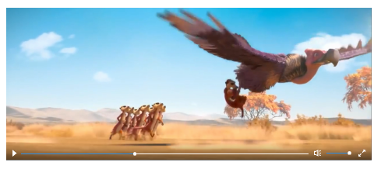
Remember to take learning breaks and to stay safe.
Best wishes,
Mrs Voce, Miss Knox, Mr Thomas.
Websites for learning:
https://play.ttrockstars.com/auth/school/student/14864
https://www.edshed.com/en-gb/login?return_url=https%3A%2F%2Fhub.edshed.com
https://www.discoveryeducation.co.uk/what-we-offer/discovery-education-espresso
https://ukhosted11.renlearn.co.uk/3406764/
http://primaryhomeworkhelp.co.uk/

