South America Topic
Our topic for the Summer is South America so if you want to look into anything about South America you may but here are some ideas:
- Learn the countries and capital cities of South America
https://www.youtube.com/watch?v=Nw1H8aIhKNk
- Choose a country and become an expert on the country.
- Research about the Amazon rainforest – create a fact file/PowerPoint
What animals live near the river? What countries does it go through? Where is the source of the river?
- Rainforests – What are the layers of the rainforest? What animals live there? Which layer do they live in?
- Can you create any of these animals in your own imaginative way?
- Create your own rainforest using your DT skills
- Cook some South American food

Make a natural bunny out of materials in the outdoors.
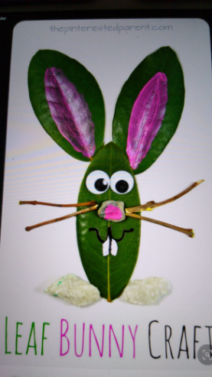
- Find out how Easter eggs are made:
https://learnenglishteens.britishcouncil.org/study-break/video-zone/how-are-easter-eggs-made
- Remind yourself of the Christian Easter story
- Decorate an egg like a Fabergé egg or create a Fabergé egg out of materials at home
- Easter egg mindfulness colouring

Other Activities
- Make your own instrument using recycling – think about how to change the pitch and volume.
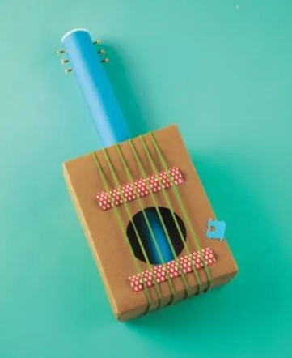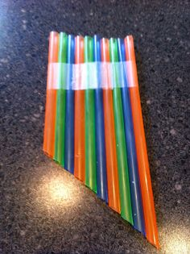

- Research and create a booklet or poster about plants (you can choose the specific title – How to care for plants; Parts of a plant; How plants grow; The life cycle of a plant; etc.)
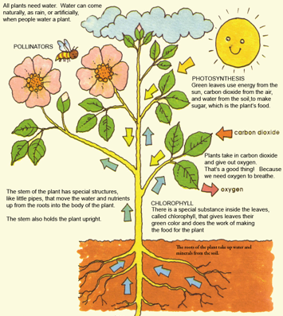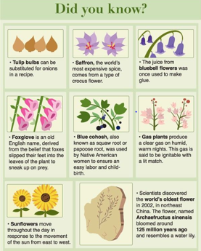
This website has some good information: https://www.bbc.co.uk/bitesize/topics/zy66fg8.
Feel free to also (or instead) work with real plants, caring for them and discussing what each part does and what the plant needs to grow.

- Send messages to each other using Fairy code, Morse code, telephony, semaphore or your own type of code. You could put messages on your windows for your friends to decode. Here are some examples:
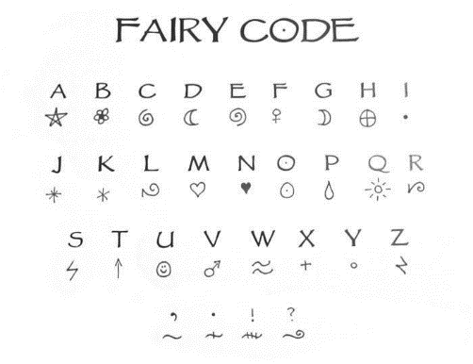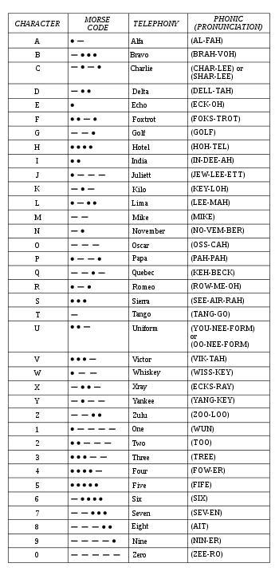
- Learn how to do a sudoku - http://www.kidsmathgamesonline.com/sudoku/printableworksheets.html

- Make your own new, magical world.
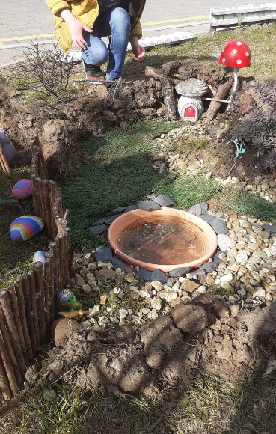
- Make your own plant pots from recycled tins.
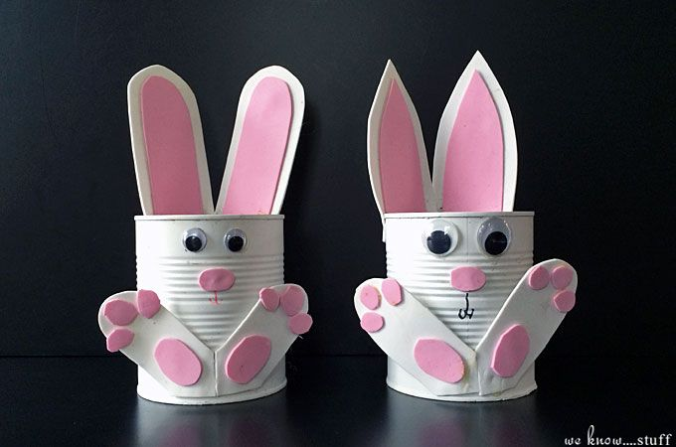
- Cooking – can you make a chocolate nest?
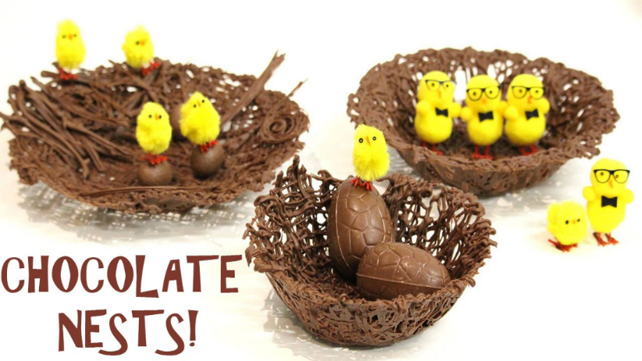


I’m sure that you have lots of wonderful ideas too so be creative and enjoy the rest of the Easter holidays!

Stay safe!
Mrs Voce, Miss Knox and Mr Thomas!

