Outdoor Home Learning Grid Year 3 and 4 Monday 20th April – Friday 1st May (May Day)
Activity 1: Capacity Challenge  Collect as many containers as you can (watering cans, plastic bottles, cups, pots, anything that can hold water!)  Before you add any water to the containers, line them up in order from the container you think will hold the least, to the container you think will hold the most. Then, fill them with water to see if you are right. Perhaps you can use a measuring jug to find out the exact amount each container holds.  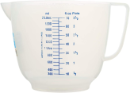  Challenge: How many millilitres can the smallest/largest container hold? Estimate and have a go. How many of one container would fill another? | Activity 2: FIT-Count!  FIT Count stands for ‘Flying Insect Timed Count’, and is a recognised UK survey. Why not join in! Sit and watch the flowers in your garden for exactly 10 minutes and record them on a tally chart. These could be any flowers in your garden – dandelions, daisies, clover, lavender etc.  What was the most common flying insect to visit your flowers? What does the information you have collected tell you? Did you see any other interesting insects?  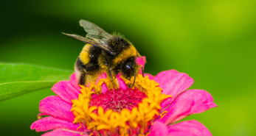  Challenge: What do you think attracts particular insects to your garden? | Activity 3: Potato Monsters  Did you know: You can create a monster from the potatoes! If you have any old potatoes lying in the cupboard, try and create a character by giving it eyes, a nose and a mouth with a marker pen. Put your potato character into a bag and hide it in a dark place for at least two weeks. Open the bag and see if your potato has turned into a monster! How has your potato changed? Why?  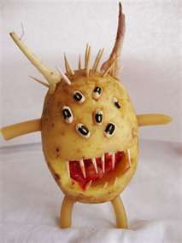  Challenge: Can you write a description or a story about your potato character? | Activity 4: Vocabulary Hunt  Search all around your garden, can you find something different that represents each of the words listed below?  habitat petal  seed  metal rock  never alive plastic wood  waterproof smooth  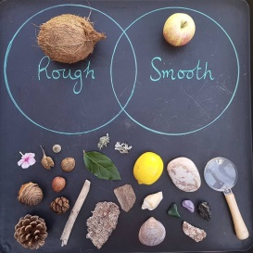  Challenge: Draw a Venn diagram to show 2 characteristics and their links.
Activity 5: Problem Solving  Collect items from your garden to solve this problem:  “I have some leaves. I have 1 more leaf than I do sticks. I have 6 fewer sticks than I do petals. I have 10 petals. How many leaves do I have?”  Can you create your own word problem using natural items? Post your word problems on the school blog for others to have a try at solving yours!  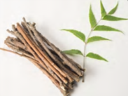  Challenge: Include multiplication/division (groups) or fractions to the problem. | Activity 6: Food Chain  Take a journey around your garden listing as many different plant or animal species as possible. Write them down onto post-it notes or just small slips of paper. Create food chains using the slips of paper you have collected.  For example: Box hedge – banded snail – blackbird.  You might have to add in some species you haven’t seen to complete the chain. What would happen if one of the species was taken away?  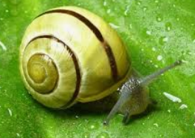  Challenge: Can you find out if they are herbivores, omnivores or carnivores. | Activity 7: Creating patterns  Head out into the garden and scavenge as many different natural items as you can find! These could be leaves, sticks, petals, weeds such as daisies & dandelions, bark chipping, pebbles, blades of grass - anything you have available! Create a repeating pattern using all the objects you have found.  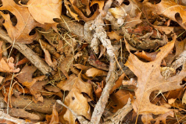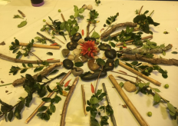  Challenge: Can you now arrange these objects into a Mandala? Each ring could have a more complex pattern! | Activity 8: Cloud Spotting  Lie on your grass and look up at the clouds. Can you see any shapes or figures in the clouds above? Perhaps you could take pictures on a camera. Or sketch the figures you see on a piece of paper. Can you spot a dragon breathing fire, a frog hopping across the sky or even a brave knight riding a horse! Let your imagination run wild...    Challenge: Clouds help meteorologists to predict the weather. Can you look up what type of cloud you can see and what this might mean about the weather?
Please share your work on the blog and remember these activities are all optional.

