Indoor Home Learning Grid Year 3 and 4 Monday 20th April – Friday 1st May (May Day)
Activity 1: Shape Hunt  Vigilantly, go on a shape hunt around the house. What can you find? Tell an adult their properties: number of corners (vertices), number of sides, types of angles (acute, right, obtuse), lines of symmetry..  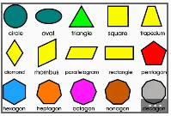  Challenge – Can you write some clues about some shapes for your family to guess? Eg. It has 4 vertices? | Activity 2: Postcard  Write a postcard to a friend. Cut out the card, draw a picture on the front and write a message on the back. Don’t forget a space for the stamp!  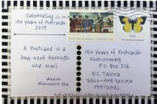  Challenge – Write a thank you letter to a key worker and display it in your front window. | Activity 3 – Mythical Creature  Invent a new mythical creature. You can draw it or make it. There are some good examples of different mythical creatures on this website:  http://kidsultimatezone.blogspot.com/2015/04/mythical-creatures.html  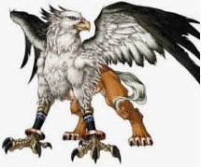  Challenge – Can you write a description/story of your creature – what does it look like? Eat? Do? How do they behave? What are their strengths and weaknesses?
Activity 4 – Senses Drawing  Draw/paint/colour a picture of what you can see from your window. Remember to look closely. What can you see that you’ve never noticed before?  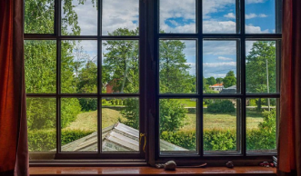  Challenge – write a setting description of what you can see. Can you describe what you can see, hear, smell? | Activity 5: Sounds of the Rainforest  Find out what a Rainforest is here -  https://www.youtube.com/watch?v=KMdD6TTDZ_g  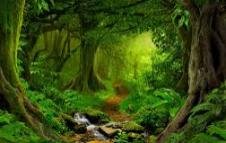  Challenge - Why are there 2 different types of rainforest? Record in any way you wish …. (draw, paint, poster, etc) | Activity 6 – Classical Music  Listen to a piece of classical music and draw a picture of what you think it is about or what it makes you think about.  https://www.classicfm.com/discover-music/best-classical-music-for-kids/  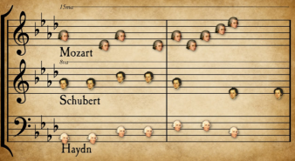  Challenge – Make lists of fabulous vocabulary to describe what you can hear / think of / feel. Imagine yourself on a journey and act out the story in your head.
Activity 7: Cooking  Plan and design a 3 course menu (starter, main course and pudding) for your family.  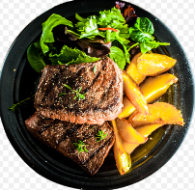  Challenge – Research different meals from around the world (including South America) and make a new meal of your choice. Look at the measurements carefully. | Activity 8: Poster  Create an information poster about a topic of your choice. (a sport, hobby, animal, country, science topic, Vikings ....) Share your enthusiasm about the topic!    Challenge – Can you write an information report/powerpoint about the topic you have chosen? | Activity 9: Doodle Arm  Carefully, draw around your hand and arm and fill it with doodles of your choice. When you fill your arms with doodles, you might consider the things you are currently missing - or the things you are currently appreciating whilst being at home with your family.  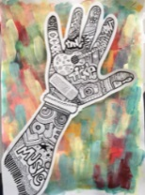  Challenge – use any different materials to collage, paint, colour, create a sculpture of your hand and arm or background like above. Be imaginative!
Activity 10 – Phone Number Maths
This is our school telephone number:
01480 479890
How many different two-digit numbers can you make using the numerals in the telephone number? Can you put them in order from smallest to largest? Can you get them all?
Challenge – Can you make it real! What can you buy for £48 or 48p? What is 48cm long/high? What does 48 blades of grass look like? How much is 48ml? Remember 10ml can be held by a dessert spoon.
Please share your work on the blog and remember these activities are all optional.

