Outdoor Home Learning Grid Year 3 and 4 Monday 4th May – Friday 15th May
Activity 1: Weight Challenge  Collect as many food packages as you can (flour, beans, soup, sugar, biscuits). Line them up in order from the heaviest package (the one with the most mass), to the lightest. Next, fill up different sized containers with rice, sand, pebbles and weigh them using weighing scales. Add them to your line up.    Challenge: Remember 1000 grams is equal to 1 kilogram. Can you convert the weight of grams into kilograms?  Can you work out how many of one item would you need to weigh as much as you? | Activity 2: Plant in a Jar 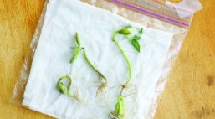Grow a plant and measure it every day (A runner bean seed on tissue in a plastic bag or jar will allow you to measure the roots growing too!). Can you plot a graph/ bar chart to show the plant growing? You could make a bean diary and draw the bean each day.  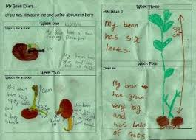  Use whatever seed you have.  Challenge: What do you think attracts particular insects to your garden? How can you attract insects? Create an explanation text to explain this. | Activity 3: Teddy Zipwire  Make a teddy zip wire to find the quickest way for teddies to descend from different heights:  https://www.science-sparks.com/teddy-zip-wire/  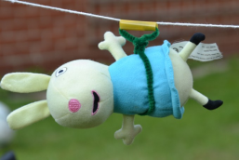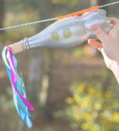  Challenge: Can you time the descent and find the fastest combination of zipline, harness and incline of the wire?  How can you make the teddy go quicker or slower? Think about materials and what creates more friction. | Activity 4: Wind Chime  Make a wind chime from different materials around your house/garden.  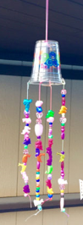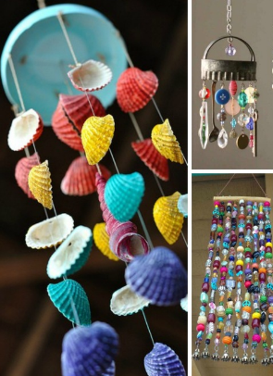  Challenge: Can you create different sounds from everyday objects and play a simple nursery rhyme, like ‘Three Blind Mice’. Make sure you get the correct notes. Think carefully about how you can make them different pitches – Remember long = low.
Activity 5: Plant Problem Solving  Throw a hoop on the grass and count the different plants in the hoop. How could you use this to help guess how many plants are in the whole garden?  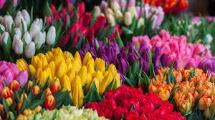  If it’s raining can you count the different flowers in this picture? Write a list of the number of plants that you found.  Challenge: Include addition/subtraction/ multiplication/division (groups) or fractions to the problem. | Activity 6: Make a Den  Making dens is a fantastic way to problem solve, thinking about angles, height, length and shapes. Can you make a den for a favourite toy instead? Measure the height, length and width of your den. How many people/toys can fit inside it? What South American animals could fit inside?  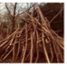  Challenge – If you made your den double/half the size how tall/wide would it be? Make three – one for each bear in Goldilocks and the 3 Bears. Think about the size of everything inside. | Activity 7: South American Flags  Research a flag of a South American country (Argentina, Brazil, Bolivia, Columbia, Ecuador, Guyana, Paraguay, Uruguay, Peru, Chile, Suriname, Venezuela)  Use outdoor, natural materials to replicate this flag?    Challenge: Describe your flag to a family member- can they guess what it is? Describe what it looks like. What colours, shapes and lines can you see? What is it made from? Why did you make it using these materials? Why are there symbols on a flag? | Activity 8: South American Animals  Research a South American animal (caiman, toucan, emerald tree boa, guanaco etc.) Using an outdoor space, pretend to be the animal. Act as the animal- what might you look like? What sounds will you make? How will you move? What will you do?  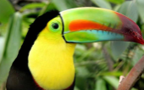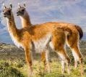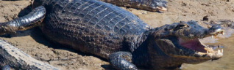  Challenge: Create a movement sequence, transforming from one animal to the next (caiman to a toucan to a guanaco). Think about your sounds, actions, body language. Create a jungle scene. Make a video of the scene outside.

Please blog to tell us about how you are getting on and feel free to post your work (not pictures of yourself). Remember these activities are all optional.
If it’s raining, lots of these activities can be done indoors.

Activity 9: Design your own mini garden for one of your teddies or your favourite book character.
What might they like in their garden?
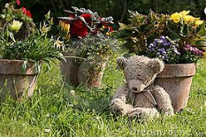

Challenge: How are you going to use the space? What plants might it like? For instance,
You can either create it in your garden, a shoe box, draw it on paper or use your imagination.

