Indoor Home Learning Grid Year 3 and 4 Monday 4th May – Friday 15th May
Activity 1: Fraction Basketball.  Scrunch up a piece of paper and see how many times you can throw it into a cup/bowl. Do this 20 times counting your score.  Keep a score board with tally marks for you and the other player. Let us know your scores on the Blogs!  Challenge –  Can you make this into a fraction on how many you scored? What fraction did you miss?  For Example: Mr Thomas Scored 15 out of 20 and missed 5  15 5  20 > 20  Can you simplify the fraction? | Activity 2: Discover A New Animal  Can you design a new animal? Look at the pictures below to remind yourself of just how different animals can be. Draw a picture of your new animal (if you have some play dough you could make a model). Think about how many legs and arms you want it to have. Do you want your animal to have fur or scales? What colour is the animal and why? remember it’s totally up to you; it can look very different to any animal that already exists!  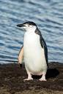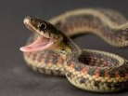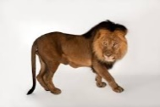  Challenge – What habitat does it live in? Why? What does it eat? Could your animal live in South America? Why and why not? | Activity 3 – Seed Dispersal  Seed dispersal is the way seeds get from the parent plant to a new place. "Dispersal" means to spread or scatter.  Make a poster, a PowerPoint or a fact file about the different way seeds can be dispersed.  Here is a video to remind you of the ways seeds gets dispersed … https://vimeo.com/218127343  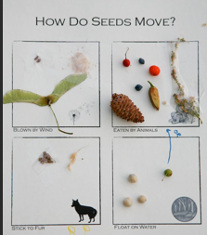  Challenge – Maybe you could act out these ways? Or find seeds to add to a poster.
Activity 4 – Tiny Treasure  Can you be a nature pirate? Find a little box and see how much tiny treasure you can put in it.  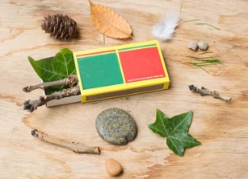  Challenge - Write a story about a tiny person/character who might live in this box. How would they use all the items? Do you know the book or movie, “The Borrowers”? Watch the film trailer below:  https://www.youtube.com/watch?v=lgZQ8gyUlwI | Activity 5: South American Animal Collage  Could you draw a South American animal (any animal) or plant and make it into a collage? You can use old magazines for the coloured paper.  Use these for ideas:  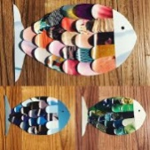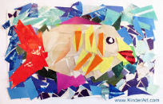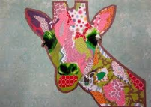  Challenge - Add a habitat for your animal. Describe the setting and how the animal has adapted to live there. Can you use mixed media (different materials) for the background? Eg. Paint, chalk, tissue paper. | Activity 6 – Calm Jar  Create a ‘calm jar’ to help you or your family members to settle emotions and make them feel relaxed again.  https://www.goodtoknow.co.uk/family/things-to-do/glitter-jars-how-to-calm-down-jar-105300  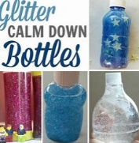  Challenge – Think of some words or phrases that you might use to make your friends/family feel calm. Ask your family what helps to keep them calm. (breathing exercises, listening to music, thinking about your favourite place, dancing.)
Activity 7: Measuring and maps  Using different items to measure can help with our estimating and counting skills. Can you estimate how long your street is? What unit of measure could you use? Can you estimate how long your living room is in metres?  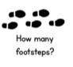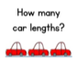  Challenge – draw your street and estimate the measurements of different buildings/gardens/sheds etc. | Activity 8: Computer drawings  Draw with Bob Biddulph.  http://www.robbiddulph.com/draw-with-rob  Use this website to draw an animal of your choice. This site is a lot of fun.  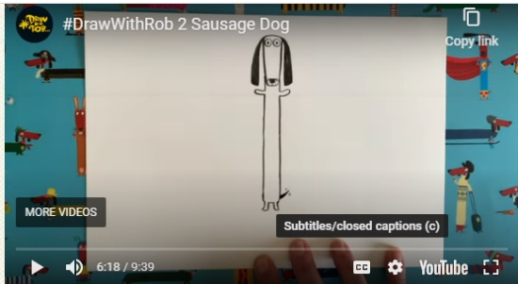  Challenge – re-draw your animal to make a secret card for your adults at home. Write a lovely message in it. Hide it somewhere they will find it. | Activity 9: Quiz  Create a small quiz on the blog for your class, adults or siblings in your home. This can be on any topic of your interest.  For Example,  Question 1:  How many players on a football pitch?  Make a blog of your best 5 questions – you can share the answers with us next week 😊  Challenge – Create a quiz for our next Ice Zone Topic about South America. Do your own research to make the questions.
Activity 10 : You have the day off today – it is a special May Day Bank Holiday this year (it is usually on the first Monday in May …)
Do you know why it was planned to be different this year?
https://www.twinkl.co.uk/resource/t-t-2548139-union-jack-template-display-bunting Maybe make some Red, White and Blue bunting for VE day. You can hang it over your house, or over the front door if you’re having a picnic outside. When you’re finished you can send it to Bletchley Park who are trying to get 1,945m of bunting to celebrate. (Why do you think they picked 1,945m?)
Please blog to tell us about how you are getting on and feel free to post your work.
Remember these activities are all optional.

