Dear Year 3 and 4 parents,
Welcome to the first Trust newsletter outlining the activities that we expect your child to complete from the week beginning 1st June. Eventually, all of this learning will be on our new online learning platform but whilst this is being set up, here are some independent activities for your child to complete.
These activities should provide up to 3 hours of work for your child every day. On top of this, they are encouraged to take part in the daily Joe Wicks workouts. These are found on his YouTube channel here: https://www.youtube.com/user/thebodycoach1
We also encourage your children to read for at least 15 minutes a day. Your child may have access to Accelerated Reader so we would encourage your child to quiz as much possible. Your child may also have access to Oxford Owl, where your child can read free books online.
We will also be setting spellings every week, please ensure that your child is practising these. Please see the attached sheet at the bottom of the page.
Monday 1/6/20
English  Your job today is to research the seasonal fruits of the UK.  Research as many fruits as you can and group them into which season they grow in.  Which fruit is your favourite? Have you got any interesting facts about these fruits? Could you make a Top Trumps game with fact cards?   | Maths  Today, you are going to do some estimating and measuring around the house!  You need to grab a ruler (if you do not have one, any item will do, for example a remote control).  - Choose 10 items from your house  - Estimate the length of these (35cm OR 2 and a half remote controls)  - Measure them!  - Record your findings.  Could you find the difference between your estimations and the real measurements? E.g. | Other  Be an internet legend and click on this link, play the games to play safe online.  https://beinternetlegends.withgoogle.com/en_uk/interland  
  object | estimate | measurement | difference
  My shoe | 15cms | 12cms | 3cms

Tuesday 2/6/20
English  You need to create your own mythical animal. It could be an animal adapted to the cold.  https://www.bbc.co.uk/teach/class-clips-video/animals-adapting-to-cold-climates-no-narration/z4j3kmn  It could be two animals merged together.  Your task is to create a drawing, label it and make notes in a mind map about:  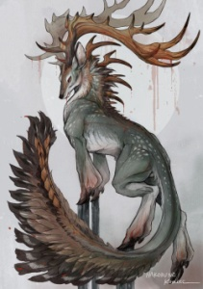  - Where it lives  -What it eats  - How it survives alone  - What it looks like  - How long it lives for | Maths  Log on to your online maths platform. This could be something like Maths Whizz or TT Rockstars.  Please complete 1 hour online. You could also log onto BBC Bitesize and complete an activity from there.  https://www.bbc.co.uk/bitesize/levels/zbr9wmn | Other  You are going to be researching the wonderful continent of South America. Your task today is to choose 1 of these countries and start your research. You could find out:  - Population  - Languages spoken  - Any significant landmarks found there  - Animals found in that country  - Other countries or bodies of water that it borders  - Any other amazing information.  Here are some example websites:  https://www.kids-world-travel-guide.com/south-america-facts.html  https://www.ducksters.com/geography/southamerica.php

Wednesday 3/6/20
English  Now you’ve created your new animal. We would like you to write a small description about it. Remember to include lots of description (expanded noun phrases, prepositional phrases) and remember the basic punctuation.  Here is a small example.  Here is the elusive, unique wolf deer. This amazing animal lives in solitary and is very rarely spotted in the wild. Almost unbelievably, the magnificent wolf deer can live up to 25 years in the Arctic forests. | Maths  Today, we want you to log on to this website:  https://youtu.be/vNgr9G3gZhg  You can also access this on:  http://www.iseemaths.com/lessons34/  Please complete the Broken Clock challenge! | Other  Now you’ve collected your research for your country. Can you create a really eye-catching poster/PowerPoint or fact file?  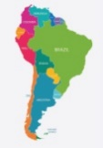  Include all of your amazing information.

Thursday 4/6/20
English  Instructions!  Imagine that an alien has landed in your kitchen. He sees you making a sandwich and wants to make one himself. You need to write down the exact instructions that he needs to follow. Make sure you use direct language.  Here’s a small example.  Firstly, and most importantly, you need to gather your ingredients and tools. You will need two pieces of bread, butter, a filling of your choice, a knife and a plate.  Once you’ve gathered these, place the two slices on bread on the plate. | Maths  Today, we are going to look at time differences in South America and the UK  Your task is to create a table and compare different South American countries to the UK. For example:  If it’s 09:00 in the UK, what time is it in Peru? 03:00 in Peru (- 6 hours)  You can use this website to help: https://www.timeanddate.com/worldclock/converter.html?iso=20200521T120000&p1=136&p2=tz_pet  Challenge – find/draw some clock faces and write down the 2 times. | Other  We are going to look at the art of Brazilian artist, Romero Britto.  Watch this clip and create some amazing art work!  https://www.youtube.com/watch?v=CxwJll1uI6I  

Friday 6/6/20
English  Now you’ve had some practise with writing instructions. You need to write down some instructions all about a typical school day (at school, not at home!).  The alien needs to know what to do first thing in the morning before school, how to get to school and what to do at school.  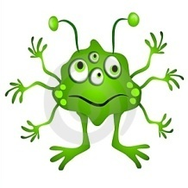 | Maths  Please have a go at this NRich maths activity: Dotty Six.  https://nrich.maths.org/7337  Can you play this game again with a different total in each box? Or you could change the shape of the grid (triangles rather than squares perhaps). | Other  Do something kind for someone (fill someone’s bucket!)  You could:  - Do some chores  - Draw a picture for someone  - Sing a song for someone  - Write a letter/record a video to your grandparents  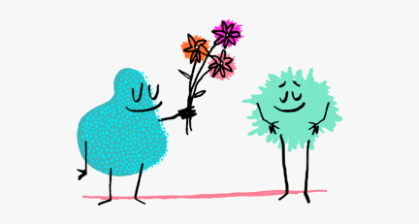
accident
actual
address
answer
appear
arrive
Spellings
Here are 6 spellings for you to practise.

Practise means you know the definitions and you can use them within a sentence.
Why not try: drawing round the letter, drawing an image around and in the word, words without vowels, pyramid words, look/say/cover/write/check:



