

Year 6 Curriculum Newsletter

Summer Term 2026

Dear Parents,

Welcome back! We hope you had a wonderful time off during the Easter holidays. Please find below a summary of the main learning areas during the next half term and some general reminders. This term is a very important one for Year 6, with end of primary school assessments and the transition to secondary school coming up. Please be aware that the SATs assessment week commences on Monday 11th May. The dates for class transition days to Longsands and Ernulf for the children are Monday 1st and Tuesday 2nd July, with other secondary schools confirming their dates separately.

Homework
Each Year 6 class will be handing out Maths and English homework (revision books) on a Friday, which will need to be returned by the following Friday. We expect the children to complete the given pages and ensure it is done with care and a high level of effort. Homework books must be handed in every week, and not at the end of each term.

After SATs, we will update the children and Class Dojo on how homework will be set.

P.E.
Year 6 will have P.E. sessions every Monday morning and Tuesday afternoon although children should have their kit with them each day as this is subject to change. Please ensure your child has their full P.E. kit in school at all times and are prepared for the changeable weather. Alongside this, swimming lessons will take place this term – a schedule for this has already been sent out and children should be aware of which group they are in.

There will be regular updates over the term on Class Dojo and on the school webpage, letting parents know about important updates and the learning that has been taking place.

Thank you in advance for your continued support.

Mr Clipsham and Miss Hicks.

Summer Term 2026 Curriculum Units for Year 6
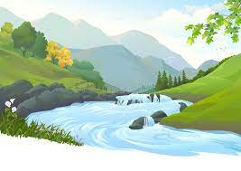
Science
Our unit for this term will be ‘Light and Reflection’, followed by a Science-based project.

Religion and Worldviews
Our unit question in R&W is ‘Why is there suffering?’, looking how different religions interpret negative issues in the world.

Geography
‘Rivers’ will be our geography unit this term, focussing on the different stages of a river and how they have shaped the land, towns and country we live in.

India


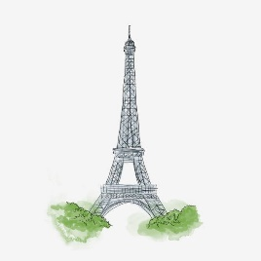
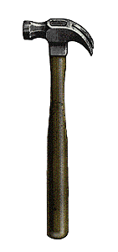
P.E.
The children will be swimming this term, looking at developing their ability in the water, depending on their current levels.

Music
We will be focussing on singing and performance within a school production, looking at how to project our voices, as well as composing a leavers’ song.

PSHE
This term we will be learning about relationships and the unit ‘Changing Me’.

DT
Our work this term will involve the construction of props and staging, looking at set design for our end-of-year production.

Spanish

The children will be introducing themselves to the basic elements of Spanish this term, including greetings and general conversation.
Art
Our artwork will involve Sculpture and 3D, in which the children will focus on creating expressive pieces of art to represent memories.

