Good morning Sparrows / Doves
Please see below for the work that we would like you to complete today.
If you experience any difficulties logging onto any of the online platforms/websites make sure you let us know on our class blog:
https://roundhouse.primarysite.blog/
Yesterday’s word – what did you find?
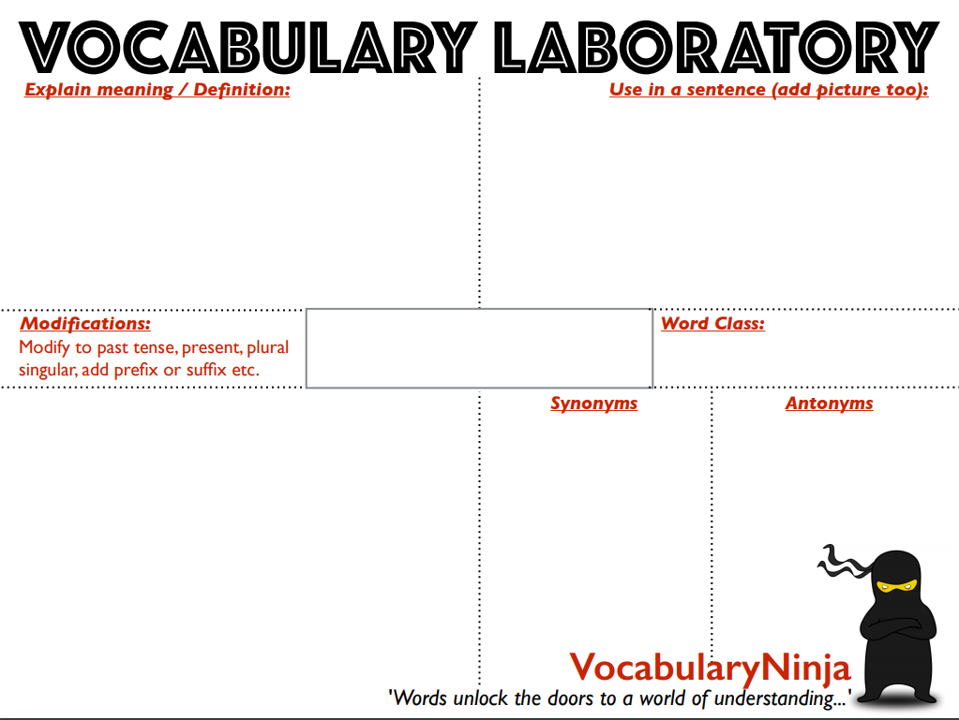Today’s activities:
adjacent
At 9am Joe Wicks will be running a “P.E. with Joe” workout on YouTube. Just search for Joe Wicks and today’s session should come up. Try this for 30 minutes or repeat yesterday’s!
Remember – don't be sat in front of the computer or be hunched over your work for too long. Every so often (30-45 minutes) get up stretch and move around.
If you are struggling to work from home because you don’t have a set place and aren’t used to it, try to complete short sharp sets of work and break up with a limited reward of time spent doing other things. See if you can slowly increase how long you work for and remember it is really important that you get through the different activities.
We recognise there are some issues with the number of people on Espresso. So, by all means complete these tasks in any order and if there any problems come back to them later.
 | Tuesday 24th March
Reading | 30 minutes of daily reading either of books sent home from school or books you have at home.  Make sure you are still quizzing on any book that you read at home. The AR website will be unrestricted so you can quiz from home.  AR website:  https://ukhosted45.renlearn.co.uk/3406764
Spellings  (Device required) | Complete 10 tasks on Spelling Shed which has been set by your spelling teacher.
Handwriting | Spend 15-20 minutes on the handwriting sheets.  For today please complete Alliteration sentences (page 2)
Key words | Get someone to test you on the 10 key words from the Word List that you practised yesterday. Any that you get wrong correct and practise again!  Today, practise the next 10 words:  different to fruit (KS2 Word List 1) or eighth to increase (KS2 Word List 2)  Try and practise in a different way to yesterday?  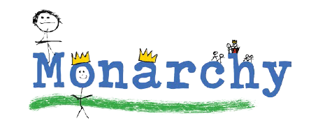  As well as the below try writing the same word as many times as you can in a minute, create a word search or try a spelling scribble.  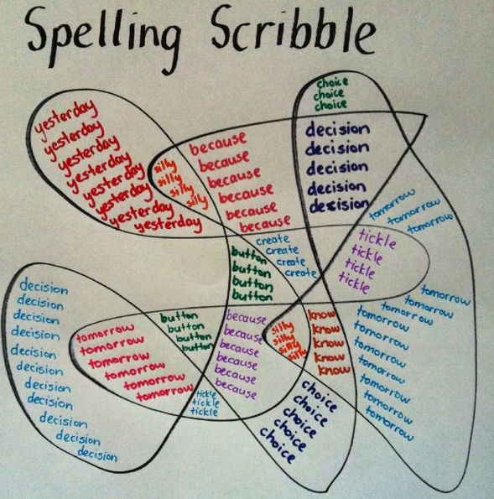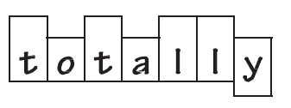  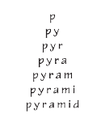
Maths | Maths Challenge – answers will be posted tomorrow:  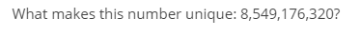  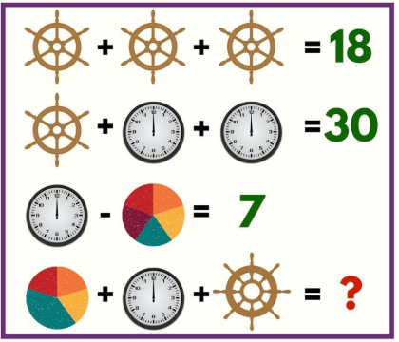  To log in to Espresso (www.discoveryeducation.co.uk ), these are our schools credentials:  Username: student43028  Password: school1  Today’s Maths:  Without your notes from yesterday, try this quiz on quadrilaterals:  https://central.espresso.co.uk/espresso/primary_uk/subject/module/activity/item534775/grade2/module326755/index.html  Was there anything missing from your work from yesterday? Add it to your fact files from yesterday. Then, watch the following video about triangles (if it doesn’t work use the dictionary instead).  https://central.espresso.co.uk/espresso/primary_uk/subject/module/video/item370426/grade2/module326755/index.html  Using this and the dictionary link below if needed, can you define the following types of triangle and draw an accurate and annotated example.  - isosceles  - scalene  - equilateral  - right-angle  By the end of today you will have built yourself a fantastic resource that will help with any shape work we do from now on!  e.g.  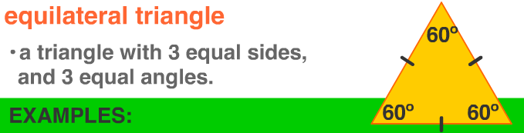  We will be quizzing you on this tomorrow!  Dictionary: http://www.amathsdictionaryforkids.com/dictionary.html  Fact file: https://central.espresso.co.uk/espresso/primary_uk/subject/module/factfile/item370742/grade2/module326755/index.html  Recap/revision:  You will need to know the following vocabulary, some of which we had as our spelling words for the last 2 weeks!  Polygon, perpendicular, parallel, horizontal, vertical, diagonal, vertex, regular, irregular, symmetrical.
Maths Fluency | Please spend a minimum of 30 minutes a day on one at least one of the Maths platforms:  TT Rock Stars or Maths Whizz  Sparrows you have been set a session on TT Rockstars so logon and have a go.  (Device required)
SPAG | Watch the following video about parenthesis:  https://central.espresso.co.uk/espresso/primary_uk/subject/module/video/item361722/grade2/module305326/collection361842/section361748/index.html  Then try the activity:  https://central.espresso.co.uk/espresso/primary_uk/subject/module/activity/item514844/grade2/module305326/collection361842/section362951/index.html
Writing | Based on: Letters from the Lighthouse  Watch this short video about Kindertransport.  https://central.espresso.co.uk/espresso/primary_uk/subject/module/video/item1119782/grade2/module1114234/index.html?source=search-all-all-all-all&source-keywords=kindertransport  Based on what you have watched, write a short paragraph explaining what Kindertransport was.  Once you have completed that can you then write a short explanation about Esther (a Kindertransport child) from our book and why she might have found moving to Budmouth Point so difficult?
Further Resources | The following websites are offering either free resources and/or free membership for the duration of any school closures so have a look:  https://www.twinkl.co.uk/search?term=school+closure (home learning packs)  www.whiterosemaths.com (free resources and video content)  Espresso (www.discoveryeducation.co.uk )- selection of learning resources and videos, including books with comprehension activities.

