Good morning Sparrows and Doves
Please look below for the work that we would like you to complete today.
Don’t forget to keep collecting recyclable materials for a DT activity next week. The more choice you have the more creative and amazing your finished model will be.
If you experience any difficulties logging onto any of the online platforms/websites make sure you let us know on our class blog:
https://roundhouse.primarysite.blog/
You can also blog any riddles, puzzles, news, observations, jokes and random facts! If you haven’t blogged yet, make today your first time! Let us know you are ok.
Today’s word of the day:
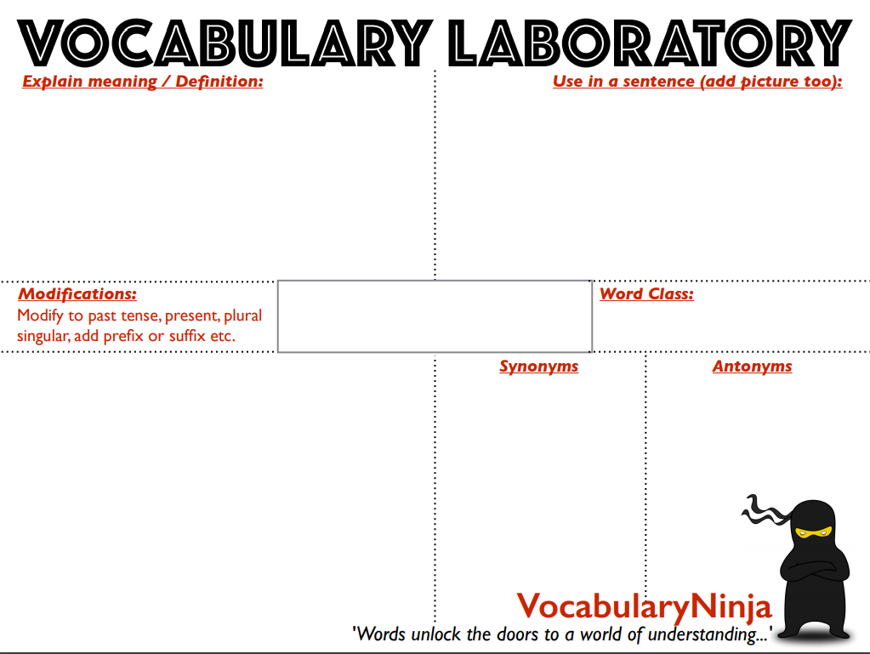
superfluous

Science
Last week was British Science Week which was based around the theme of “Our Diverse Planet”. Even though Science Week is over, you can still get involved in loads of great Science activities. Visit the Zooniverse website and become a Citizen Scientist where you can contribute to real-life Scientific research! Researchers at Liverpool John Moores University have provided a brand-new set of imagery taken by infrared cameras mounted on drones. These images need analysing and you can help. All instructions are available on the website so visit the following page and tag and classify as many images as possible of spider monkeys in their natural habitat in Central America.
https://www.zooniverse.org/projects/rossmcwhirter/spotting-spider-monkeys/classify

Today’s activities:
READ CAREFULLY AS SOME THINGS HAVE CHANGED
 | Thursday 26th March
Reading | Pick one of the electronic non-fiction books from the following website (WORLD e BOOKs) and read for 30 minutes.  https://worldbook.kitaboo.com/reader/worldbook/#!/bookshelf
Spellings  (Device required) | Complete 10 tasks on Spelling Shed which has been set by your spelling teacher.
Handwriting | Spend 15-20 minutes on the handwriting sheets.  For today please complete Idioms (page 4)
Key words | Get someone to test you on the 10 key words from the Word List that you practised yesterday. Any that you get wrong correct and practise again! Drop in some of the trickier words/words you got wrong from the days before!  Today, practise the next 10 words:  ordinary to special (KS2 Word List 1) or peculiar to suppose (KS2 Word List 2)  Try and practise in a different way to yesterday.
Maths | Maths Challenge – answers will be posted tomorrow:  Yesterday’s challenge answers:  1.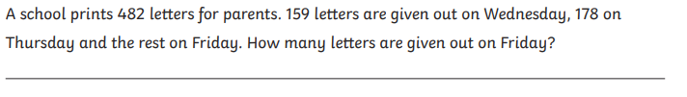  482 – 159 – 178 = 145  145 letters are handed out on Friday.  2.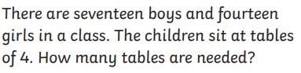  17+14 = 31  31÷4 = 7r3 = 7 tables plus 3 children left over  8 tables are needed for everyone to sit down  3.  6962 x 39 = 271,518  The total attendance will be approximately 271,518 as it is based on the average attendance of each match.  Today’s challenge:  1.  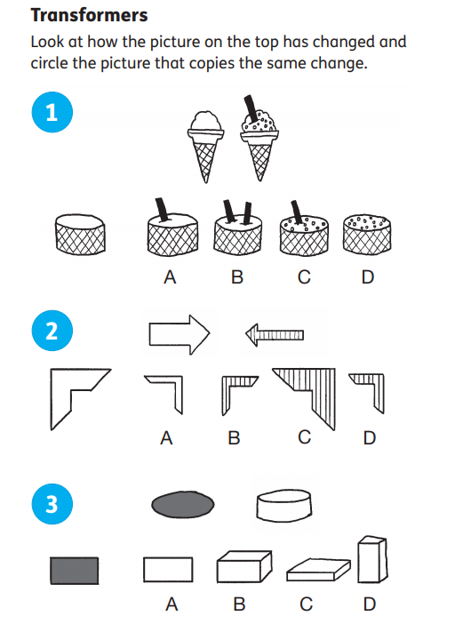  To log in to Espresso (www.discoveryeducation.co.uk ), these are our schools credentials:  Username: student43028  Password: school1  Today’s Maths:  2. Quick starter  Try this as a quick starter:  https://nrich.maths.org/5648  3. Main task - National flags:  During an Olympic Games many national flags are on display.  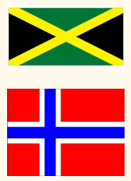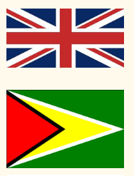  Here's a chance to investigate some of them. Pick a flag and investigate some of the following:  What shapes can you see in it? Can you describe them and their angles?  Can you draw them accurately? Do you know the countries they are for?  Does the flag have any lines of reflective symmetry and if so, how many lines?  Can you find any pairs of parallel lines? If so mark them on your flag.  Are there any lines perpendicular to one another?  Can you find a way to classify the shapes in your flag?  Now try with another flag.  4. Challenge:  Design your own flag for a new country using only quadrilaterals and triangles. Can you include each different type? Think how they might repeat and tessellate. Draw any flags you create in your orange book.  Help:  Dictionary: http://www.amathsdictionaryforkids.com/dictionary.html  Recap/revision:  You will need to know the following vocabulary, some of which we had as our spelling words for the last 2 weeks!  Polygon, perpendicular, parallel, horizontal, vertical, diagonal, vertex, regular, irregular, symmetrical, tessellate.
Maths Fluency | Please spend a minimum of 30 minutes a day on one at least one of the Maths platforms:  TT Rock Stars or Maths Whizz  (Device required)
Writing | Quick starter:  All the nouns in my work have been jumbled up! Can you swap the nouns round so that my writing makes sense?  Hives are famous for making bees. They live in honey and spend most of their pollen in the flowers flying round looking for summer that contain time.  Main task:  Based on the book that you read earlier from the WORLD e BOOK website, write a one paragraph summary of what you have read.  Challenge:  Can you create a short presentation (PowerPoint, poster, script, etc…) and present this to someone at home. It’d be great if you could share an image of your presentation with us on the blog.
Further Resources | The following websites are offering either free resources and/or free membership for the duration of any school closures so have a look:  https://www.twinkl.co.uk/search?term=school+closure (home learning packs)  www.whiterosemaths.com (free resources and video content)  Espresso (www.discoveryeducation.co.uk )- selection of learning resources and videos, including books with comprehension activities.

