Good morning Sparrows and Doves
Please look below for the work that we would like you to complete today.
Don’t forget to keep collecting recyclable materials for a DT activity next week. The more choice you have the more creative and amazing your finished model will be.
If you experience any difficulties logging onto any of the online platforms/websites make sure you let us know on our class blog:
https://roundhouse.primarysite.blog/
Today’s word of the day:
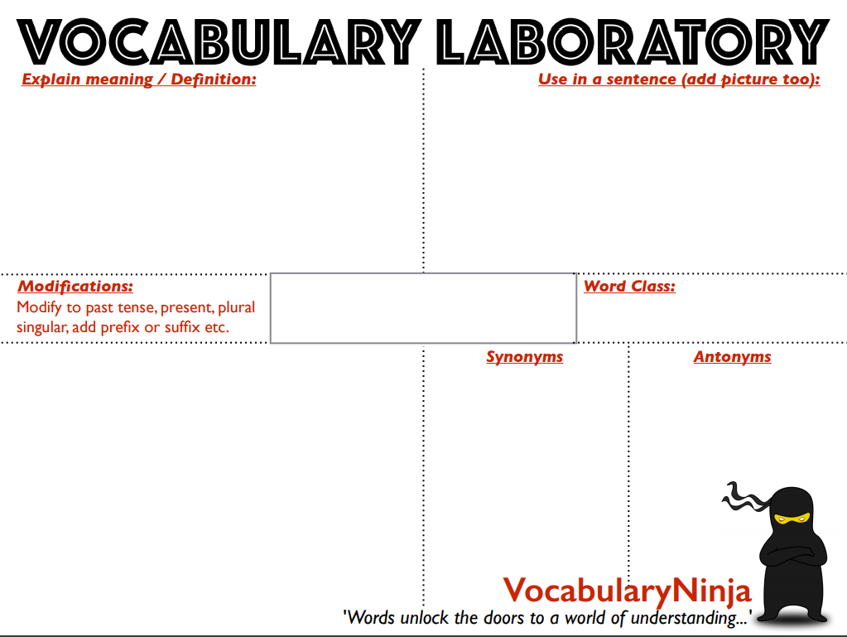
Comments on these letters would be superfluous, as they speak forcibly for themselves.
I will not be so superfluous as to exaggerate the difficulty.

superfluously, adverb
superfluousness, noun
unsuperfluous, adjective
unsuperfluously, adverb
pronounced [ soo-pur-floo-uhs ]
- being more than is sufficient or required; excessive.
- unnecessary or needless.
- Obsolete. possessing or spending more than enough or necessary; extravagant.

reasonable
useful
important
necessary
needed

superfluous
adjective
extra, redundant. excessive
expendable
gratuitous
redundant
unneeded
useless

Science
How many monkeys did you see?
https://www.zooniverse.org/projects/rossmcwhirter/spotting-spider-monkeys/classify
Or why not try one of the other incredible projects they have online:
Although don’t worry if you don’t get some of them, some of these are very complicated!
https://www.zooniverse.org/projects

Today’s activities:
 | Friday 27th March
Music | Watch Mylene’s Music Klass:  https://www.youtube.com/watch?v=8XXmBlTadys  Find out the difference between a quaver, a crotchet, a semi-quaver and a minim?  Can you clap your name? Play your name on an instrument? Draw your name in musical notes?
Reading | Why not try and read aloud for part of this time today.  30 minutes of daily reading either of books sent home from school or books you have at home.  Make sure you are still quizzing on any book that you read at home. The AR website will be unrestricted so you can quiz from home.  AR website:  https://ukhosted45.renlearn.co.uk/3406764
Spellings  (Device required) | Complete 10 tasks on Spelling Shed which has been set by your spelling teacher.
Handwriting | Spend 15-20 minutes on the handwriting sheets.  For today please complete Collective nouns for animal groups (page 5)
Key words | Get someone to test you on the 10 key words from the Word List that you practised yesterday. Any that you get wrong correct and practise again! Drop in some of the trickier words/words you got wrong from the days before!  Today, practise the last words on the Word wall and any you have been struggling with:  straight to woman (KS2 Word List 1) or surprise to certain (KS2 Word List 2)  Try and practise in a different way to yesterday.
Maths | Maths Challenge – answers will be posted tomorrow:  Yesterday’s challenge answers:  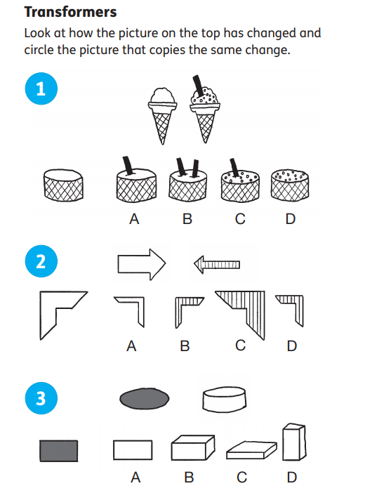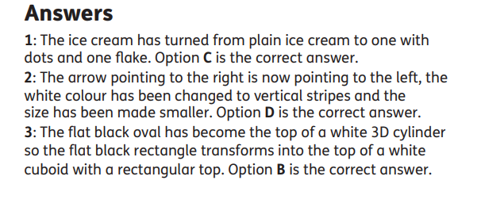  - Today’s challenge:  Fractional Triangles  Use the lines on this figure to show how the pattern of triangles can be used to divide the square into two halves, three thirds, six sixths and nine ninths.  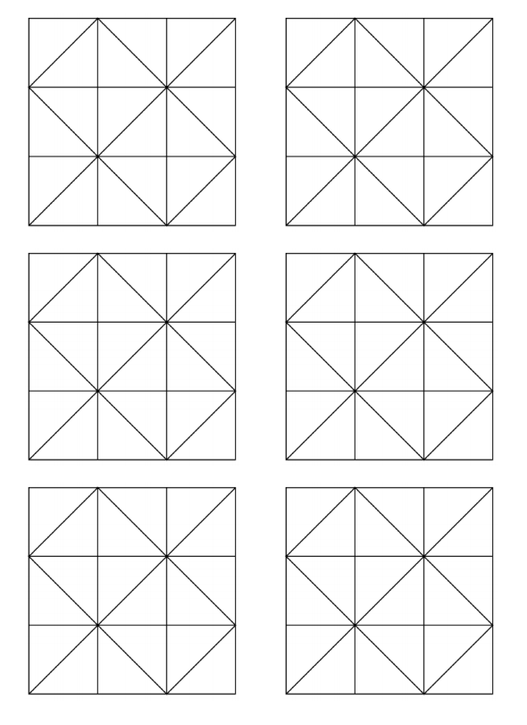Today’s Maths:  Try this as a quick starter:  https://nrich.maths.org/5648  - Main task:  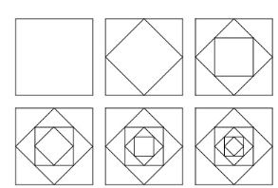  These pictures were made quite simply by starting with a square, finding the half-way point on each side and joining those points up. This creates a smaller shape (which also happens to be a square) inside the original. The half-way points of this new shape are then joined up to make a third shape. This way of making new shapes is continued until it gets too small to do properly.  You can, of course, start with any straight-lined shape even if it has different length sides.  Here's one where I've coloured each new halving line to help to see what has happened more clearly.  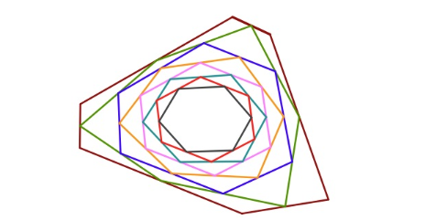  Have a go at creating your own. It's probably good to start with a large shape (and a regular square if you are uncertain) since it's going to get smaller and smaller each time. You could try drawing this in your orange book, or squared paper (if you have some – see link on website for square paper to print at home). Alternatively, use this website and practise using an online geoboard to create your diagram:  https://apps.mathlearningcenter.org/geoboard/  - Challenge:  Start with a regular shape that is not a square.  Start with an irregular shape with no lines of symmetry.  What do you notice happens as irregular shapes get smaller – does this always happen even with a shape with a different number of sides?  Recap/revision:  You will need to know the following vocabulary, some of which we had as our spelling words for the last 2 weeks!  Polygon, perpendicular, parallel, horizontal, vertical, diagonal, vertex, regular, irregular, symmetrical, tessellate.
Maths Fluency | Give yourself 15 minutes to complete the arithmetic quiz (pdf on class homepage).  Answers will be given Monday or you can check with a calculator.  Spend the remaining 15 minutes on either TT Rockstars or Maths Whizz.
Writing | Extended writing:  Write a newspaper report on a subject of your choice. You could link it to our book, something you read this week, you could over exaggerate something that happened at home (Mum spills beans everywhere‼!). Remember it has 4 main sections – Orientation, More detail, Quotes and Re-orientation.  Use the document below (that we spoke about in class) to plan what your article might include!  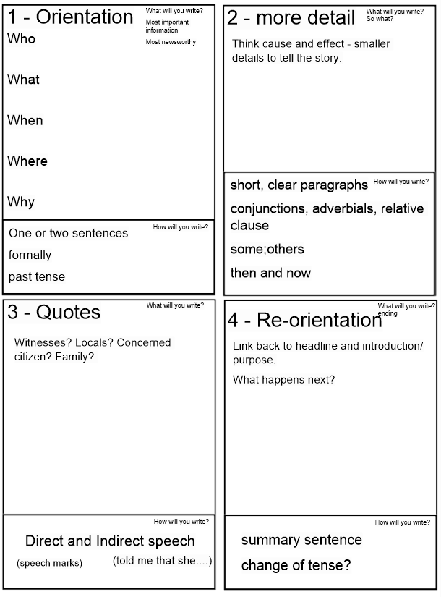
Further Resources | The following websites are offering either free resources and/or free membership for the duration of any school closures so have a look:  https://www.twinkl.co.uk/search?term=school+closure (home learning packs)  www.whiterosemaths.com (free resources and video content)  Espresso (www.discoveryeducation.co.uk )- selection of learning resources and videos, including books with comprehension activities.

