Good morning Sparrows and Doves
Please look below for the work that we would like you to complete today.
If you experience any difficulties logging onto any of the online platforms/websites make sure you let us know on our class blog:
https://roundhouse.primarysite.blog/
Today’s word:
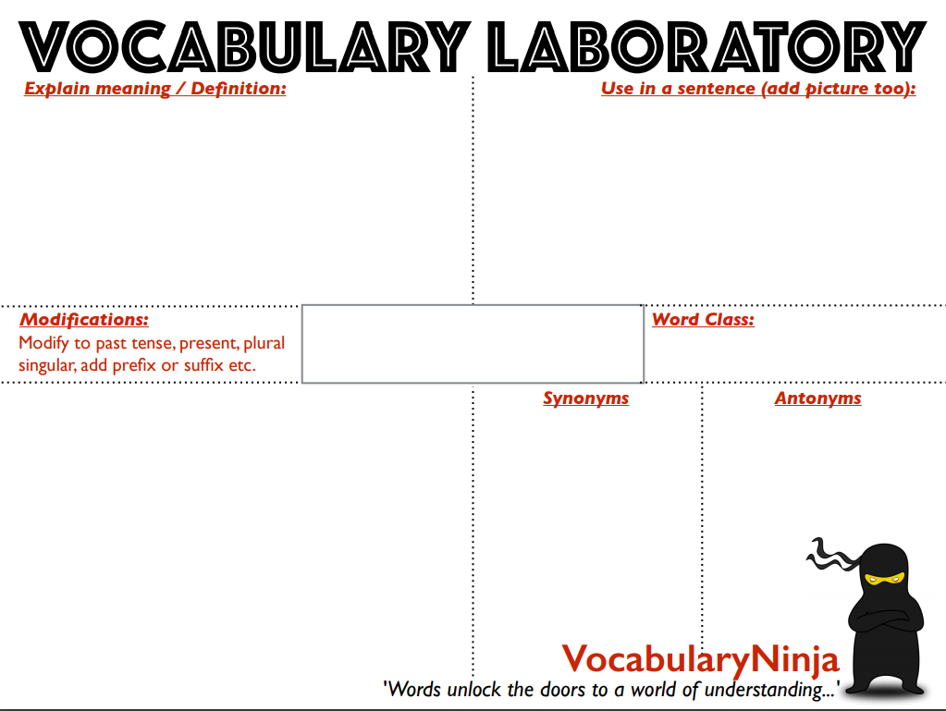Today’s activities:
synopsis
At 9am Joe Wicks will be running a P.E. with Joe workout on YouTube. Just search for Joe Wicks and today’s should come up. Try this for 30 minutes or repeat one from last week!
Can you draw (without taking you pencil off the paper) three things that you can see from your house that tell you Spring has arrived?
 | Monday 30th March
Reading | Have a go at Set A: Test 3 (from your handout packs) – 10 minute reading activity (there are 6 questions and a text you need to complete in 10 minutes.)  AND please make sure you do 30 minutes of daily reading either of books sent home from school or books you have at home.  Make sure you are still quizzing on any book that you read at home. The AR website will be unrestricted so you can quiz from home.  AR website:  https://ukhosted45.renlearn.co.uk/3406764
Spellings  (Device required) | Complete 10 tasks on Spelling Shed which has been set by your spelling teacher.
Handwriting | Spend 15-20 minutes on the handwriting sheets.  For today please complete Months of the Year (page 6)
Key words | Last week, you should have completed one of the word walls! Well done!  Time to move on to the next!  Today, practise the first 10 words:  accident to disappear (KS2 Word List 2) or according to competition (KS2 Word List 3)  Make sure you know what each word means‼!
Maths | Maths Challenge – answers will be posted tomorrow:  - What number is 100 more than 3683?  - How many less is 5693 than 5703?  - What number is 10 000 less than 1 234 508?  - If I add 100 to a number I get 3467. What number did I start with?  - 23 890 is how many more than 13 890?  Answers to Friday’s challenge:  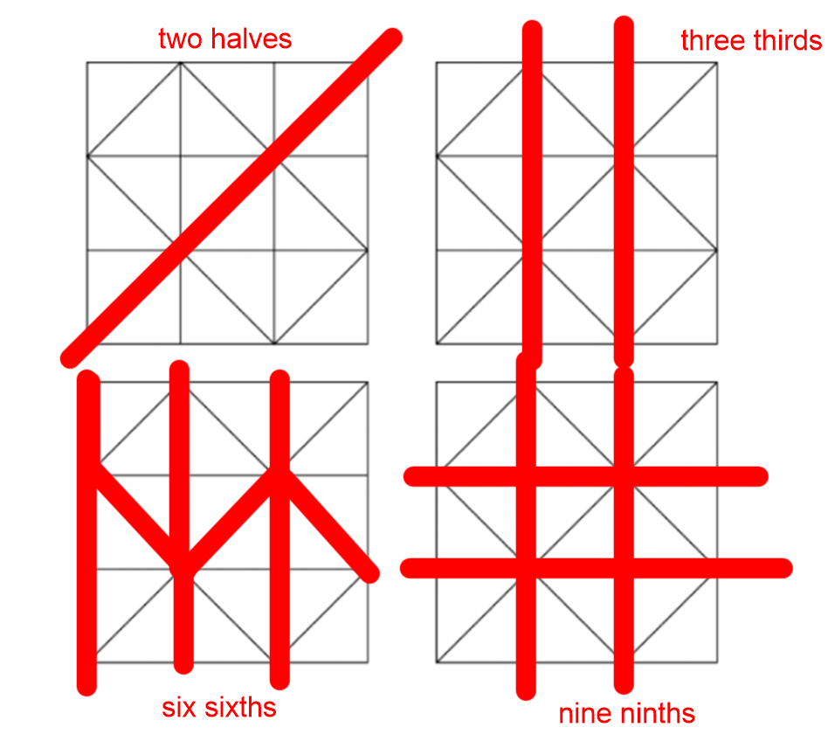  - Answers to the Arithmetic quiz can be found on the pdf on the class page.  - Today’s Maths:  Always, Sometimes or Never?  Are the following statements always true, sometimes true or never true?  Prove this by drawing shapes on an online geoboard to help prove whether they are true or not.  https://apps.mathlearningcenter.org/geoboard/  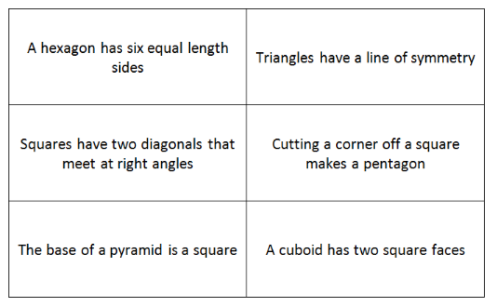  What about these more complex statements:  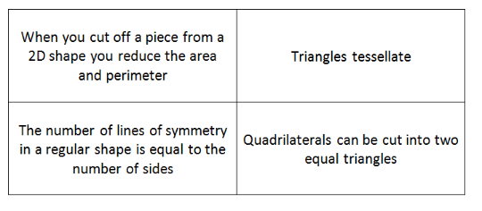  Arrange these statements on the table below:  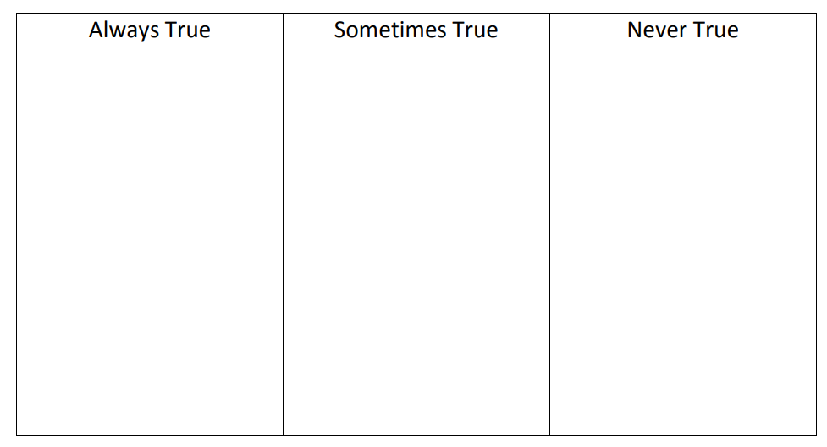  Dictionary: http://www.amathsdictionaryforkids.com/dictionary.html
Maths Fluency | Please spend a minimum of 30 minutes a day on one at least one of the Maths platforms:  TT Rock Stars or Maths Whizz  (Device required)
Writing | Over the next three days before the Easter break, we would like you create a film trailer for a book. This could be a book that we’ve studied/read in class (The Last Wild, Letters from the Lighthouse), your favourite book or even one you have recently finished at home. The purpose of the trailer is to get people to want to read the book!  To start with (to get your ideas going) you should complete a story board for this on the template below (or on a piece of paper/in your orange book - set out in the same way).  Remember, it is better to keep it short and try not to give away too much of the story! Just hint at the main story line. It is a difficult balance of mentioning the exciting bits of the book without giving everything away! For your plan/story board, you are essentially summarising each scene and using pictures to help.  Here is an excellent video example (of what a trailer could contain) made by a primary school for our most recent class book:  https://www.youtube.com/watch?v=RwnxJXk79N4  
Design and Technology | Build an Anderson Shelter:  See documents uploaded to class page.  We recognise this can be tricky to do at home (due to materials, space etc...) and may take longer than the next 3 days but give it your best and see how resourceful and resilient you can be! If you don’t finish before the Easter break, don’t panic – but we would love to see some photos of these at some point! If you want to delay the making of this until you have gathered the right materials – that is fine but make sure you have an accurate plan. In the meantime, could you design this beautifully with colour and annotations?  Overview:  Day 1 – Research what an Anderson Shelter is and plan your creation.  Day 2 – Build your Anderson shelter  Day 3 – Test your Anderson shelter  Note: This work can be done on plain paper or in orange books – whatever is easiest – but we would love to see documentation of this whole process so take photos!
Further Resources | The following websites are offering either free resources and/or free membership for the duration of any school closures so have a look:  https://www.twinkl.co.uk/search?term=school+closure (home learning packs)  www.whiterosemaths.com (free resources and video content)  Espresso (www.discoveryeducation.co.uk )- selection of learning resources and videos, including books with comprehension activities.

