Good morning Sparrows and Doves
Please look below for the work that we would like you to complete today.
If you experience any difficulties logging onto any of the online platforms/websites make sure you let us know on our class blog:
https://roundhouse.primarysite.blog/
Today’s word of the day is:

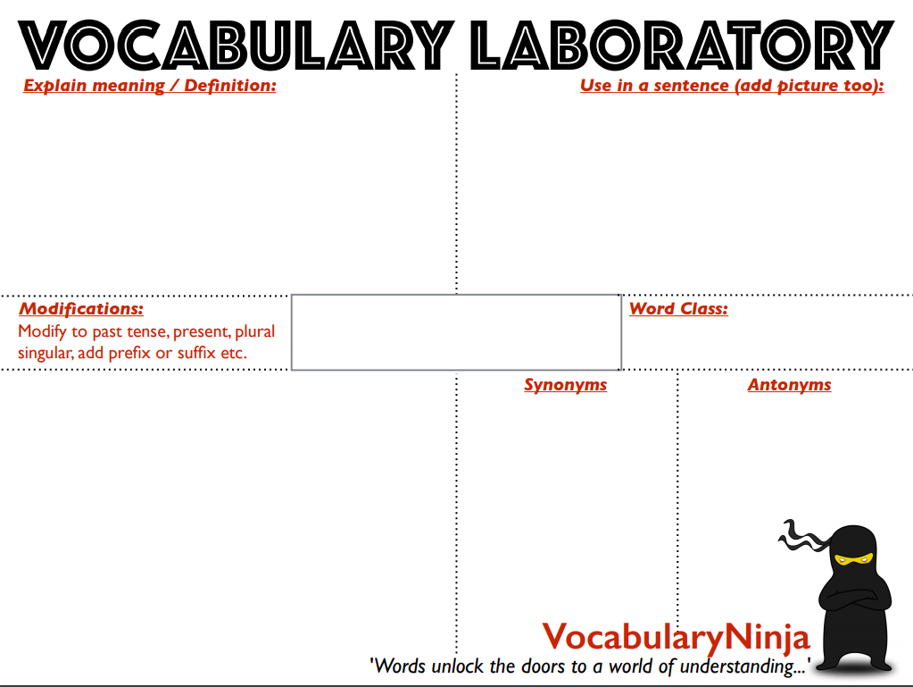
I will write a synopsis of the whole book at the end of the work.
This report has just been published, and the text below is a synopsis of the results.
expansion
“the whole thing”
recap
abstract
summary
outline
compendium
- a brief or condensed statement giving a general view of some subject.
- a brief summary of the plot of a novel, motion picture, play, etc.
(very formal)

plural - synopses
pronounced [si-nop-sis]
noun
synopsis
Today’s activities:
 | Tuesday 31st March
Reading | 30 minutes of daily reading either of books sent home from school or books you have at home.  Make sure you are still quizzing on any book that you read at home. The AR website will be unrestricted so you can quiz from home.  AR website:  https://ukhosted45.renlearn.co.uk/3406764
Spellings  (Device required) | Complete 10 tasks on Spelling Shed which has been set by your spelling teacher.
Handwriting | Spend 15-20 minutes on the handwriting sheets.  For today please complete Units of Measure (page 7)
Key words | Get someone to test you on the 10 key words from the Word List that you practised yesterday. Any that you get wrong, try again! Drop in some of the trickier words/ words you got wrong from the days before! Make a list of words you are finding difficult to remember.  Today, practise the next 10 words on the word wall you are working on  eighth to increase (Word List 2) desperate to foreign (Word List 3)  Remember, practise means you know the definitions and you can use them within a sentence. Why not try: drawing round the letter, drawing an image around and in the word, words without vowels, pyramid words, look/say/cover/write/check.
Maths | To log in to Espresso (www.discoveryeducation.co.uk ), these are our schools credentials:  Username: student43028  Password: school1  Today’s Maths:  Answers to Monday’s Challenge:  - What number is 100 more than 3683? 3783  - How many less is 5693 than 5703? 10  - What number is 10 000 less than 1 234 508? 1 224 508  - If I add 100 to a number, I get 3467. What number did I start with? 3367  - 23 890 is how many more than 13 890? 10 000  Today’s Maths:  Maths Challenge – answer will be posted tomorrow.  I need some ribbon to go round 5 rectangular cakes. Each cake is 28cm wide and 32cm long. How much ribbon will I need?  The ribbon costs 10p a metre. How much will it cost me?  Activity  Lines of symmetry – Find the lines of symmetry in the shapes on the Shapes for Symmetry sheet (on the Class Page). Answers tomorrow.  Tips: Use the answers to some of yesterday’s Always, Sometimes, Never questions to help.  Not all the shapes will have a line of symmetry. Can you find a rule to help you?  Extension  https://central.espresso.co.uk/espresso/primary_uk/subject/module/activity/item530926/grade2/module318136/index.html
Please spend a minimum of 30 minutes a day on one at least one of the Maths platforms:
TT Rock Stars or Maths Whizz
(Device required)
Writing | Yesterday, you should’ve completed a story board for a film trailer based on a book (you were asked to choose a book you know well, either a book we have read in school, your favourite book or even one you have finished at home).  Today we would like you to write the script for your trailer. Remember not to give too much away! Hint at the main storyline, in much the same way that a blurb does. Use your story board as a guide to what your voice over will say. Will you hear characters talking in your trailer? What will they be saying?  Here is the example you watched yesterday. Watch it again, thinking about the words you hear.  https://www.youtube.com/watch?v=RwnxJXk79N4  Below is an example of what your plan might look like  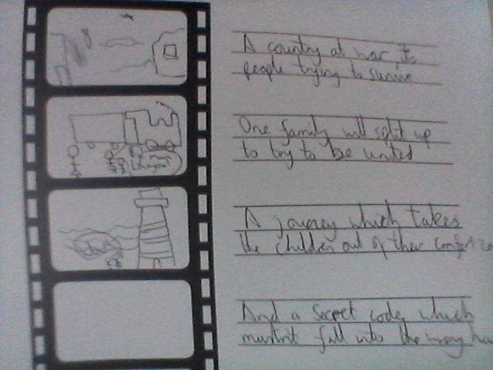  Here is the first part as a modelled script.  Narrator: (Talking over a picture from the Blitz, with damaged buildings, rubble everywhere etc) February 1941, London. A dangerous time. A country at war. The people of London, scared yet resilient, determined not to be defeated.  (scene changes to a family around a table – a mum and 2 siblings)  Narrator: But there comes a time when heads overrule hearts and safety becomes the priority over defiance.  Mum: I need to keep you safe.  Olive (guessing what is going on) You’re evacuating us, aren’t you? How could you?  (scene changes – a train station with lots of evacuees – mum and the children looking sad)  Narrator: Two children are about to begin an adventure that takes them beyond their comfort zone.  Cliff: (sobbing) I’ll miss you mum!  Mum: (to Olive) Look after you brother. You’ll both be fine.  Remember to use the margin of your orange book to write character names. Add stage directions to give “actors” ideas of how to speak or act.
Design Technology | Build an Anderson Shelter:  The instructions below are the same as yesterday. Carry on from where you got to. Ideally, you should be in a position to build your Anderson Shelter.  See documents uploaded to class page.  We recognise this can be tricky to do at home (due to materials, space etc...) and may take longer than 3 days but give it your best and see how resourceful and resilient you can be! If you don’t finish before Easter, don’t panic – but we would love to see some photos of these at some point! If you want to delay the making of this until you have gathered the right materials – that is fine but make sure you have an accurate plan. In the meantime, could you design this beautifully with colour and annotations?  Overview:  Day 1 – Research what an Anderson Shelter is and plan your creation.  Day 2 – Build your Anderson shelter  Day 3 – Test your Anderson shelter  Note: This work can be done on plain paper or in orange books – whatever is easiest – but we would love to see documentation of this whole process so take photos!
Further Resources | The following websites are offering either free resources and/or free membership for the duration of any school closures so have a look:  https://www.twinkl.co.uk/search?term=school+closure (home learning packs)  www.whiterosemaths.com (free resources and video content)  Espresso (www.discoveryeducation.co.uk )- selection of learning resources and videos, including books with comprehension activities.

