
Greek Gods and Goddesses
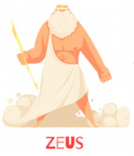  Ruler of the Gods | 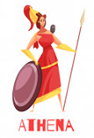  Goddess of Wisdom
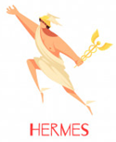  Messenger God | 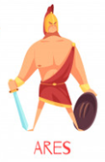  God of War
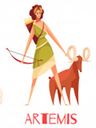  God of the Hunt | 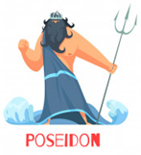  God of the Sea
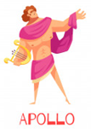  God of Light | 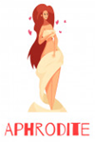  Goddess of Love

Key facts and dates
Cycladic civilization begins: 3200 BCE
Minoan civilization: 2700 BCE
The Trojan War: 1250 BCE
Archaic Period/Tyrants: 800-500 BCE
First Olympic games: 776 BCE
Coin currency introduced: 600 BCE
Age of Pericles: 445–429 BCE
Parthenon built: 432 BCE
Peloponnesian Wars: 431-404 BCE
Reign of Alexander the Great: 336-323BCE)
Defeat by Rome: 146 BCE
Knowledge Organiser
Topic: Ancient Greece Subject: History
Key words
Super special:
Hypotenuse
Hellenic
Oligarchy
Diarchy
tyrant
Diaspora
Peloponnesian
polis(city-state)
Good to know:
philosophy
architecture
peninsula
Parthenon
Persia
acropolis
assembly
Hellenic
Must know:
Sparta
Athens
democracy
government
Olympics
empire
sources
colony/colonise
Key people
King Agamemnon– Mycenaean king. Led in the Trojan War.
Homer – Famous writer who documented the Trojan War in his work ‘The Iliad’.
Draco – Wrote the ‘draconian’ tyrant constitution in Athens.
Euclid – ‘The Father of Geometry’. His work Elements is the second most printed book of all time after The Bible..
Pythagoras – Famous mathematician, known for his theorem for calculating values in a triangle.
Plato – Founded ‘The Academy’ in Athens, the first institution for higher education in the Western world.
Socrates – Influential figure in Philosophy and Ethics.
Pericles – Leader of Classical Athens and pivotal in the city’s dominance and growth.
Hippocrates – ‘The Father of Medicine,’ he helped to create medical standards used today.
Leonidas I – King of Sparta who fell at Thermopylae against Xerxes with his 300 men.
Xerxes – Powerful Persian king who occupied Greece before being defeated at the Battle of Salamis.
Aristotle – Leading Philosopher and Mathematician, who went on to tutor Alexander the Great.
Alexander the Great – Macedonian leader who built a Greek empire that stretched across Asia.
Archimedes – Physicist, famous for his ‘Eureka!’ moment.

