Good morning Sparrows and Doves
We hope you had a good Easter and managed to stay safe and stay active! Did you learn any new skills? If so, share with us on the blog – we will be sharing some of the things we have been doing as well…
https://roundhouse.primarysite.blog/
The separate grids detail all the work we would like you to try to complete over the next 2 weeks. You can do these as and when you are able but we will be giving some guidance on these on a Monday and Wednesday. There are also additional places you can go for interesting activities detailed on the curriculum pages on the website:
https://www.roundhouseprimary.co.uk/topic/curriculum
Today’s word:
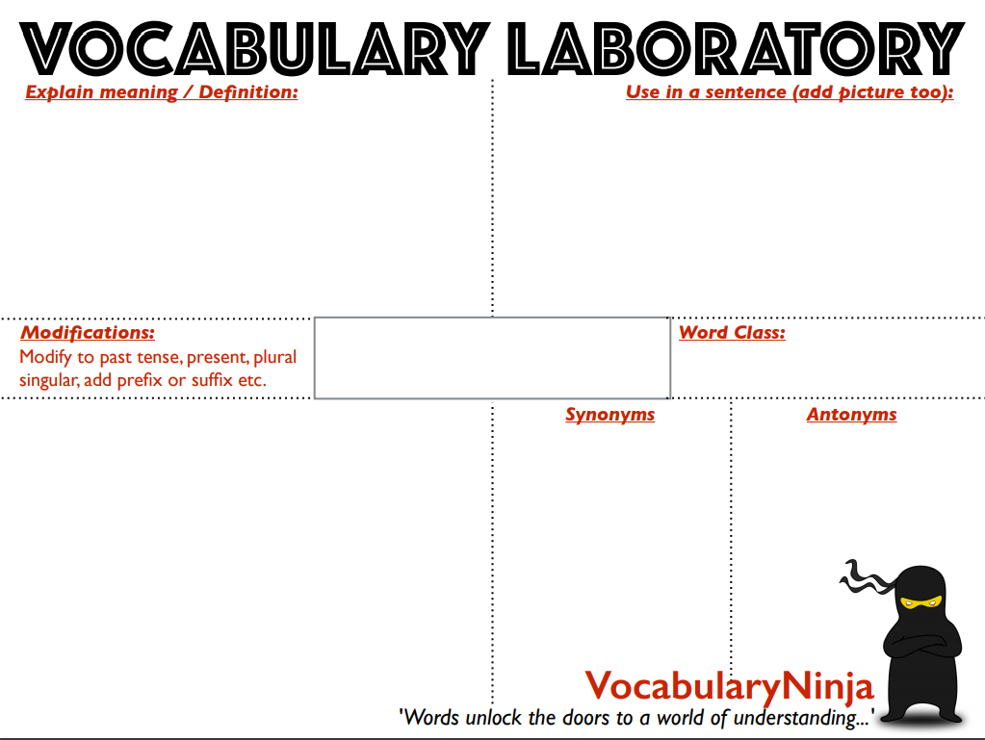
archaic

Activities:
Remember, at 9am Joe Wicks will be running a P.E. with Joe workout on YouTube so search for Joe Wicks and today’s should come up. Try this for 30 minutes or repeat one from last week!

Over the next fortnight (two weeks) we would like you to complete the following:
- 10 reads
- 10 Spelling shed tasks
- 10 sessions of Maths Whizz or TT Rockstars
- 10 online Maths learning sessions

You should also check the separate grids (uploaded to the class pages) for additional indoor and outdoor activities you should have a go at.

For this week’s online Maths lessons, we would like you to complete Week 1 from the following link:
https://whiterosemaths.com/homelearning/year-5/
The first lesson is called “Decimals up to 2DP.” You should aim to complete one lesson per day.

Why not use the below grid to keep track of what you have done:
 | 1 | 2 | 3 | 4 | 5 | 6 | 7 | 8 | 9 | 10
Reading
Spelling Shed
Maths Whizz or TT Rockstars
Online Maths lessons
Further Resources | Lots of websites are offering either free resources and/or free membership for the duration of any school closures so have a look on our school page for links to these:  https://www.roundhouseprimary.co.uk/topic/curriculum

