Snap  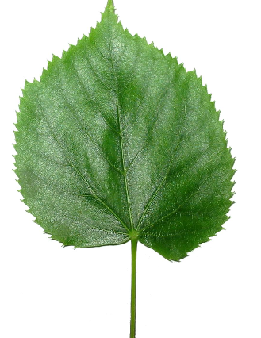Make your own nature snap cards. Collect two of as many different natural objects you can gather from your garden. You could add feathers, blades of grass, different plant leaves, daisies or petals.  To make extra cards you could draw some animals that you would find in your garden at this time of year. What about drawing some ladybirds, bees, caterpillars, spiders and even hedgehogs.  Once you have made all your cards (make sure there is two of each) challenge someone in your house to a game of garden snap! | Cloud Spotting    Lie on your grass and look up at the clouds. Can you see any shapes or figures in the clouds above?  Perhaps you could take pictures on a camera. Or sketch the figures you see on a piece of paper.  Can you spot a dragon breathing fire, a frog hopping across the sky or even a brave knight riding a horse!  Let your imagination run wild… | Capacity Challenge  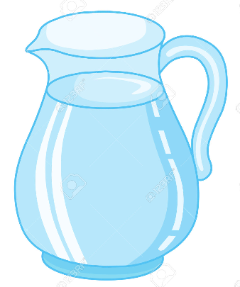Collect as many containers as you can (watering cans, plastic bottles, cups, pots, anything that can hold water!)  Before you add any water to the containers, line them up in order from the container you think will hold the least, to the container you think will hold the most.  Then, fill them with water to see if you are right. Perhaps you can use a measuring jug to find out the exact amount each container holds.  Were you correct?  Is the capacity of any of the containers equal?  How many millilitres can the smallest/largest container hold?
Carry out a FIT-Count!  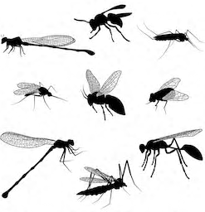  FIT Count stands for ‘Flying Insect Timed Count’, and is a recognised UK survey. Why not join in!  Sit and watch the flowers in your garden for exactly 10 minutes.  These could be any flowers in your garden – dandelions, daisies, clover, lavender etc.  Create a tally chart of all the flying insects you see visiting this patch of flowers.  What was the most common flying insect to visit your flowers? What does the information you have collected tell you? Did you see any other interesting insects? What do you think attracts them to your garden | Potato Monsters  Did you know you can create a monster from the potatoes you buy from the shop?  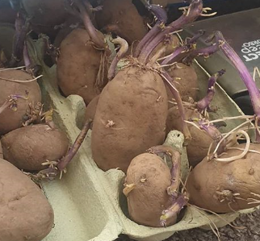If you have any old potatoes lying in the cupboard, try create a character by giving him eyes, nose and a mouth with a marker pen.  Put your potato character into a bag and hide dark place for at least two weeks.  Open the bag and see if your potato has turned into a monster!  How has your potato changed? Why?  Can you write a description on a story about your potato character? | Vocabulary Hunt    Search all around your garden, can you find something different that represents each of the words listed below?  - habitat  - petal  - seed  - rock  - plastic  - metal  - never alive  - wood  - waterproof  - smooth
Problem Solving  Collect items from your garden to solve this problem:  “I have some leaves. I have 1 more leaf than I do sticks. I  have 6 less sticks than I do petals. I have 10 petals. How  many leaves do I have?”  Can you create your own word problem using natural items?  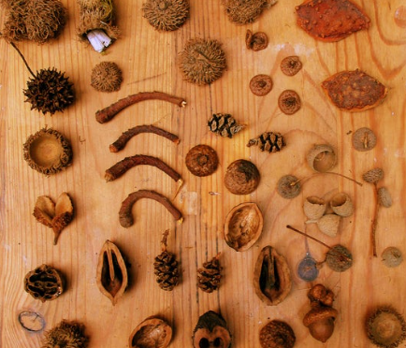Post your word problems on the school blog for others to have a try at solving yours! | Food Chain  Take a journey around your garden listing as many different species as possible. Write them down onto post-it notes or just small slips of paper.  Create food chains using the slips of paper you have collected.  For example:  Box hedge – banded snail – blackbird.  You might have to add in some species you haven’t seen to complete the chain.  What would happen if one of the species was taken away?  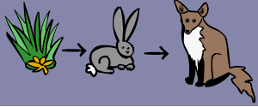How many different species does your garden alone support? | Creating patterns  Head out into the garden and scavenge as many different natural items as you can find! These could be leaves, sticks, petals, weeds such as daisies & dandelions, bark chipping, pebbles, blades of grass; anything you have available!  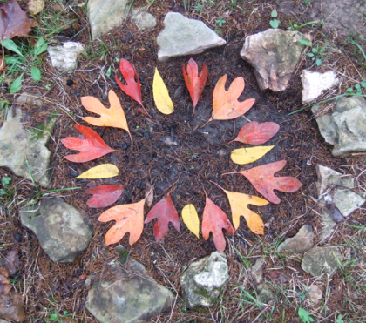Create a repeating pattern using all the objects you have found.  As an extra challenge, can you now arrange these objects into a Mandala? Each ring could have a more complex pattern!

