Monday 23rd March
23.03.20
Good morning Sparrows/ Doves
Please below for the work that we would like you to complete today.
If you experience any difficulties logging onto any of the online platforms/websites make sure you let us know on our class blog:
https://roundhouse.primarysite.blog/
Today’s word of the day is:
adjacent
Can you: define it? find a synonym? antonym? use it in a sentence? what word class?
Today’s activities:
 | Monday 23rd March
Reading | 30 minutes of daily reading either of books sent home from school or books you have at home.  Make sure you are still quizzing on any book that you read at home. The AR website will be unrestricted so you can quiz from home.  AR website:  https://ukhosted45.renlearn.co.uk/3406764
Spellings  (Device required) | Complete 10 tasks on Spelling Shed which has been set by your spelling teacher.
Handwriting | Spend 15-20 minutes on the handwriting sheets.  For today please complete Tongue Twisters: 1
Key words | Practise the first 10 key words from the Key Stage 2 Word List 1 (address to decide).  If you are very confident and can spell these words, then try the first 10 words from the Key Stage 2 Word List 2 (accident to disappear).  Practice means you know the definitions and you can use them within a sentence. Why not try: drawing round the letter, drawing an image around and in the word, words without vowels, pyramid words, look/say/cover/write/check.  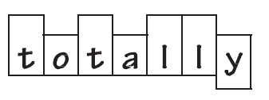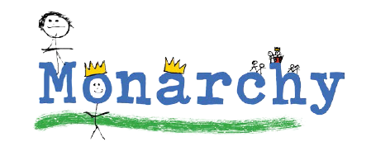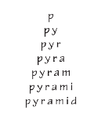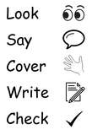
Maths | To log in to Espresso (www.discoveryeducation.co.uk ), these are our schools credentials:  Username: student43028  Password: school1  Today’s Maths:  Watch the following video about quadrilaterals.  https://central.espresso.co.uk/espresso/primary_uk/subject/module/video/item372357/grade2/module326755/index.html  Using this and the dictionary link below if needed, can you define each type of quadrilateral and draw an accurate and annotated example.  e.g.  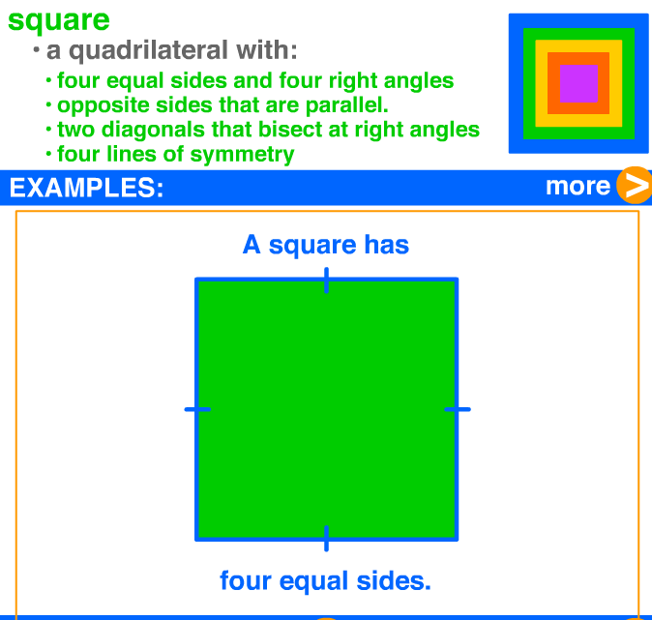  We will be quizzing you on this tomorrow!  Dictionary: http://www.amathsdictionaryforkids.com/dictionary.html  Fact file: https://central.espresso.co.uk/espresso/primary_uk/subject/module/factfile/item370742/grade2/module326755/index.html  Recap/revision:  You will need to know the following vocabulary, some of which we had as our spelling words for the last 2 weeks!  Polygon, perpendicular, parallel, horizontal, vertical, diagonal, vertex, regular, irregular, symmetrical.
Maths Fluency | Please spend a minimum of 30 minutes a day on one at least one of the Maths platforms:  TT Rock Stars or Maths Whizz  (Device required)
Writing | Based on: Letters from the Lighthouse  Write a paragraph explaining arguments for and against helping the injured Luftwaffe pilot who crashed at Budmouth Point. Can you then give me your opinion regarding what you think should be done.
Art | Rainbows for hope  Create a picture of a rainbow using whatever medium you want (paint, pencil, pens, collage, pastel etc.. - whatever you have at home).  For any Art completed over this period, please keep it together and bring it in to class to show me when you are back! In the meantime, why not put your artwork up in a window or on a wall (with parents' permission) and create a gallery of your work! You could even post pictures of it to the blog!
The following websites are offering either free resources and/or free membership for the duration of any school closures so have a look:
https://www.twinkl.co.uk/search?term=school+closure (home learning packs)
www.whiterosemaths.com (free resources and video content)
Espresso (www.discoveryeducation.co.uk )- selection of learning resources and videos, including books with comprehension activities.

