Good morning Sparrows / Doves
Please look below for the work that we would like you to complete today.
If you experience any difficulties logging onto any of the online platforms/websites make sure you let us know on our class blog:
https://roundhouse.primarysite.blog/
Yesterday’s word – what did you find?
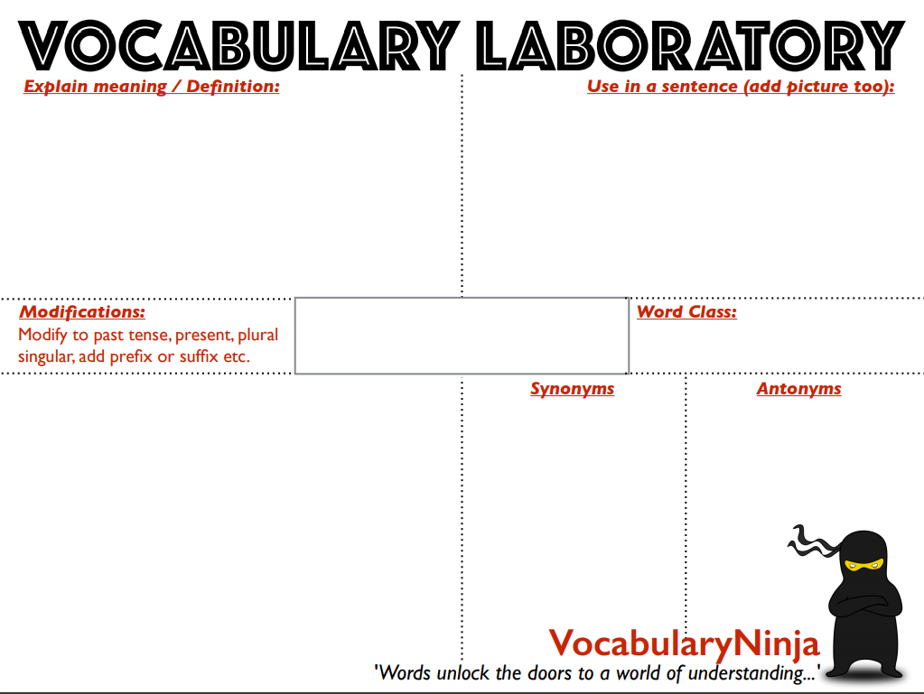Today’s activities:
She took a knife and fork from an adjacent table.
The bus station is adjacent to the railway station.
adjective
nonadjacent (adj.)
adjacently (adv.)
nonadjacently (adv.)
pronounced - [ uh-jey-suhnt ]

remote, separate, apart, detached, distant, divided, away, disconnected
adjoining, neighbouring, next door to, abutting, close to, near to, by the side of, beside, alongside, conjoining, bordering
- next to or adjoining something else.
- having a common endpoint or border
- adjacent angles: having the vertex and one side in common
adjacent
Please can you start to collect together any recycling that would be useful for making models. Early next week, we are going to look into setting some DT work but you will need to start collecting plastic containers, cardboard, paper etc... to help!
Remember to break up your work with short breaks.
Why not try sketching the view from your window or getting out in the garden and recording the changes that are happening as we enter Spring. Remember what Mrs Bryden said in assembly – what three things have you noticed today about the natural world around you?
For me it is – the buds on the trees at the bottom of my garden; the sight of a yellow butterfly fluttering around while we played cricket and the smell of fresh cut grass wafting round the neighbourhood.
Why not make a note of these things in your book and treat it like a journal. You could even use the diary section in your reading journal to make a note of what you see.
 | Wednesday 25th March
Reading | 30 minutes of daily reading either of books sent home from school or books you have at home.  Make sure you are still quizzing on any book that you read at home. The AR website will be unrestricted so you can quiz from home.  AR website:  https://ukhosted45.renlearn.co.uk/3406764
Spellings  (Device required) | Quick starter:  http://www.funenglishgames.com/grammargames/prefixsuffix.html  Complete 10 tasks on Spelling Shed which has been set by your spelling teacher.
Handwriting | Spend 15-20 minutes on the handwriting sheets.  For today please complete Proverbs (page 3)
Key words | Get someone to test you on the 10 key words from the Word List that you practised yesterday. Any that you get wrong correct and practise again! Drop in some of the trickier words/words you got wrong from the day before!  Today, practise the next 10 words:  group to often (KS2 Word List 1) or island to particular (KS2 Word List 2)  Try and practise in a different way to yesterday.  Why not write the words in a sentence? Can you come up with a crazy story including all the spelling words?  The group had heard the heart beating in their history lesson and…  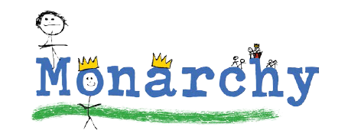  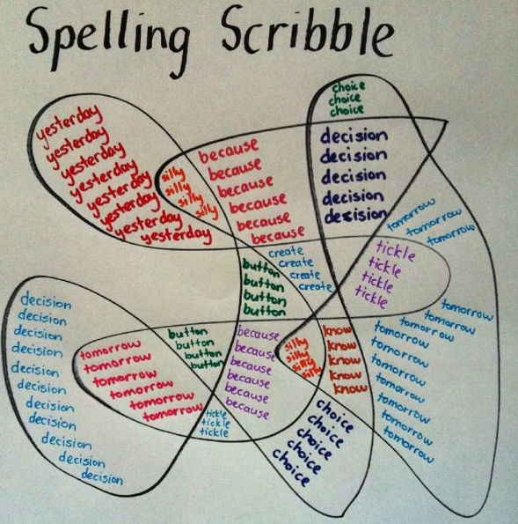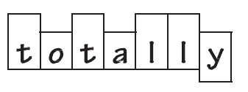  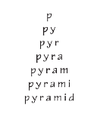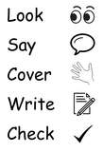
Maths | Maths Challenge – answers from yesterday and a new challenge:  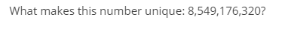  Answer: It has each digit, zero through nine, listed in alphabetical order.  eight, five, four, nine, one, seven, six, three, two, zero  What else did you think? Let me know on the blog.  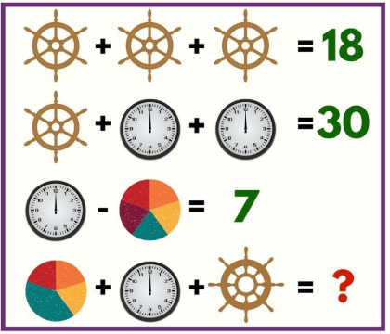  ? = 25 (If you have assumed the pie chart is still worth 5 as all section are worth 1)  If you may have a different answer, explain to me on the blog!  Today’s challenge:  1.  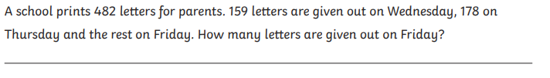  2.  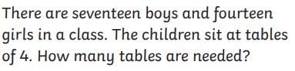  3.  To log in to Espresso (www.discoveryeducation.co.uk ), these are our schools credentials:  Username: student43028  Password: school1  Today’s Maths:  Without your notes from yesterday, try this quiz on triangles:  https://central.espresso.co.uk/espresso/primary_uk/subject/module/activity/item534672/grade2/module326755/index.html  Was there anything missing from your work from yesterday? Add it to your fact files that you created.  Now, have a go at creating your own Venn diagrams. Using the following link can you create 3 different diagrams that have shapes in each section? Can you place shapes outside of the entire thing? (If Espresso isn’t working, draw in your books).  https://central.espresso.co.uk/espresso/primary_uk/subject/module/activity/item556215/grade2/module326755/index.html  Use the words to ensure you label each section.  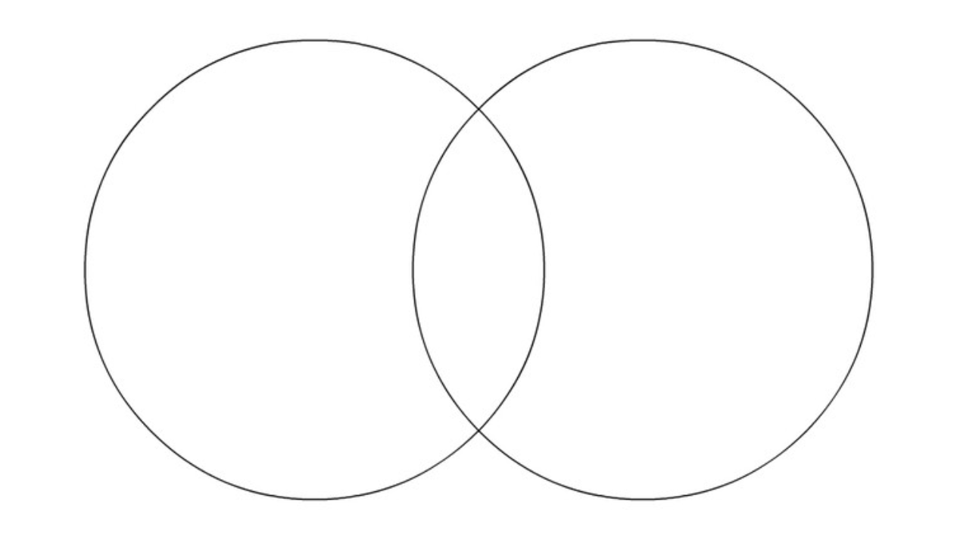  Dictionary: http://www.amathsdictionaryforkids.com/dictionary.html  Fact file: https://central.espresso.co.uk/espresso/primary_uk/subject/module/factfile/item370742/grade2/module326755/index.html  Recap/revision:  You will need to know the following vocabulary, some of which we had as our spelling words for the last 2 weeks!  Polygon, perpendicular, parallel, horizontal, vertical, diagonal, vertex, regular, irregular, symmetrical.
Maths Fluency | Please spend a minimum of 30 minutes a day on one at least one of the Maths platforms:  Why not challenge your teacher on TT Rockstars as we are currently winning!  TT Rock Stars or Maths Whizz  (Device required)
Writing | Try the Grammar: Word Types game at this link:  http://www.crickweb.co.uk/ks2literacy.html  Main task based on: Letters from the Lighthouse  If you were not at school and missed reading the ending of our book, then could you explain, in a short paragraph, what loose ends you think will be tied up in the last few chapters. Who will we see again? What will happen to the key characters? What would you like to happen? If there was another book where should that take us?  If you were present and read the end of the book, then using yesterday’s video link to help, write an emotive speech from Esther’s perspective (when she was standing on front of the class) about her experience of prejudice.
Further Resources | The following websites are offering either free resources and/or free membership for the duration of any school closures so have a look:  https://www.twinkl.co.uk/search?term=school+closure (home learning packs)  www.whiterosemaths.com (free resources and video content)  Espresso (www.discoveryeducation.co.uk )- selection of learning resources and videos, including books with comprehension activities.

