Good morning Sparrows and Doves
Over the Easter break (Thursday 2nd April – Sunday 19th April), we would like you to complete one hour of Maths Whizz and one hour of reading as well as completing a Spelling Shed session each week. We would also suggest that you try to keep a journal over the next few weeks as in the words of Emma Carroll (the author of our recent class book Letters from the Lighthouse), “Think of this as an experience that will make the history books in years to come. Keep a diary if you can, so you can tell people what it was like to live through these strange times. There's bound to be lots of funny, unusual, magical things that'll happen these coming weeks!”
Congratulations on your Spring Term full of learning, fabulous behaviour and hard work ... both at school and at home. We are incredibly proud of you and your families.
Mr Hills writes:
Over the Easter holidays and whilst you are learning from home, you have a fantastic opportunity to spend some time learning a new skill. This might be from a peer, a family member or even from YouTube. Over the past week or so, I have been teaching myself to draw cartoons using a simple formula I found on a Ted Talk on YouTube (the first ten minutes of this video https://www.youtube.com/watch?v=7TXEZ4tP06c&t=18s). I did share this with some Sparrows just before we left school.
Here is a time-lapse video documenting what I have learnt.
https://youtu.be/RIzh8_jEKFQ
Over the next few weeks, we will be trying to learn a new skill and will be posting our efforts online. Our challenge to you is to learn something new and show us evidence of this on the blog – it could be part of a new language, learning something on an instrument or a skill like juggling – it is up to you!
You could even start where I did and have a go at drawing your own cartoon! Just remember – Nose, then Eyes, then Mouth, then Ear, then Hair, then Neck. Keep the shapes simple and just change one thing at a time to create different characters!
Good luck!

For today’s activities:
 | Wednesday 1st April
Reading | 30 minutes of daily reading either of books sent home from school or books you have at home.  Make sure you are still quizzing on any book that you read at home. The AR website will be unrestricted so you can quiz from home.  AR website:  https://ukhosted45.renlearn.co.uk/3406764
Maths | Today’s Maths:  Answers to Tuesday’s Challenge:  I need some ribbon to go round 5 rectangular cakes. Each cake is 28cm wide and 32cm long. How much ribbon will I need? 28 + 32 = 60 x 2 = 120cm for one cake  Could also do 28 + 28 + 32 + 32 = 120cm for 1 cake  120 x 5 = 600 cm for 5 cakes  The ribbon costs 10p a metre. How much will it cost me?  600cm = 6m 6 x 10p = 60p  Today’s Maths:  Activity  Easter Egg Symmetry – as a little Easter treat for working so hard, we have a fun symmetry activity involving Easter eggs. Complete the Easter egg drawings symmetrically. You can find the sheets on the Doves/ Sparrows class pages near where you found this schedule.  If you have trouble printing them off, try drawing a symmetrical egg pattern of your own.
Maths fluency | Please spend a minimum of 30 minutes a day on one at least one of the Maths platforms:  TT Rock Stars or Maths Whizz  (Device required)
Writing | This week, you should’ve completed a story board for a film trailer based on a book (you were asked to choose a book you know well, either a book we have read in school, you favourite book or even one you have finished at home) and you should’ve written the script for your trailer, remembering not to give too much away!  Below is an example of what your plan might look like  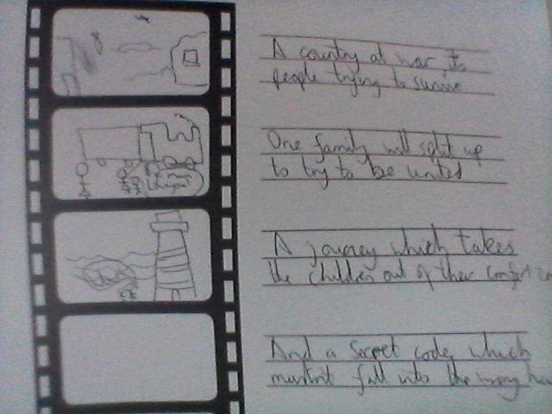  Here is the first part as a modelled script.  Narrator: (Talking over a picture from the Blitz, with damaged buildings, rubble everywhere etc) February 1941, London. A dangerous time. A country at war. The people of London, scared yet resilient, determined not to be defeated.  (scene changes to a family around a table – a mum and 2 siblings)  Narrator: But there comes a time when heads overrule hearts and safety becomes the priority over defiance.  Mum: I need to keep you safe.  Olive (guessing what is going on) You’re evacuating us, aren’t you? How could you?  (scene changes – a train station with lots of evacuees – mum and the children looking sad)  Narrator: Two children are about to begin an adventure that takes them beyond their comfort zone.  Cliff: (sobbing) I’ll miss you mum!  Mum: (to Olive) Look after you brother. You’ll both be fine.  Now, we would like you to rehearse and perform your trailer using your script and your ideas. If you can, why not film your trailer - you could even try and edit it if you are lucky enough to own an iPad! We understand that you will need to improvise (pretend!) things like trains and lighthouses but be imaginative and creative with props and backgrounds! Have fun with it though and maybe your family (or pets? or toys?) can get involved too!
Design Technology | Test your Anderson Shelter:  The instructions below are the same as yesterday. Carry on from where you got to. Ideally, you should be in a position to test your Anderson Shelter.  - If you were to make it again what would you change?  - Is there something that you think would work well for building the Anderson shelter – what is it and why?  - What was tricky about building this?  - If it worked/didn’t work, can you explain why?  See documents uploaded to class page.  We recognise this can be tricky to do at home (due to materials, space etc...) and may take longer than 3 days but give it your best and see how resourceful and resilient you can be! If you don’t finish before Easter, don’t panic – but we would love to see some photos of these at some point! If you want to delay the making of this until you have gathered the right materials – that is fine but make sure you have an accurate plan. In the meantime, could you design this beautifully with colour and annotations?  Overview:  Day 1 – Research what an Anderson Shelter is and plan your creation.  Day 2 – Build your Anderson shelter  Day 3 – Test your Anderson shelter  Note: This work can be done on plain paper or in orange books – whatever is easiest – but we would love to see documentation of this whole process so take photos!
Further Resources | The following websites are offering either free resources and/or free membership for the duration of any school closures so have a look:  https://www.twinkl.co.uk/search?term=school+closure (home learning packs)  www.whiterosemaths.com (free resources and video content)  Espresso (www.discoveryeducation.co.uk )- selection of learning resources and videos, including books with comprehension activities.

