Knowledge Organiser
Topic: Ancient Greece - Geography


Key diagrams:
Greece (Modern day):
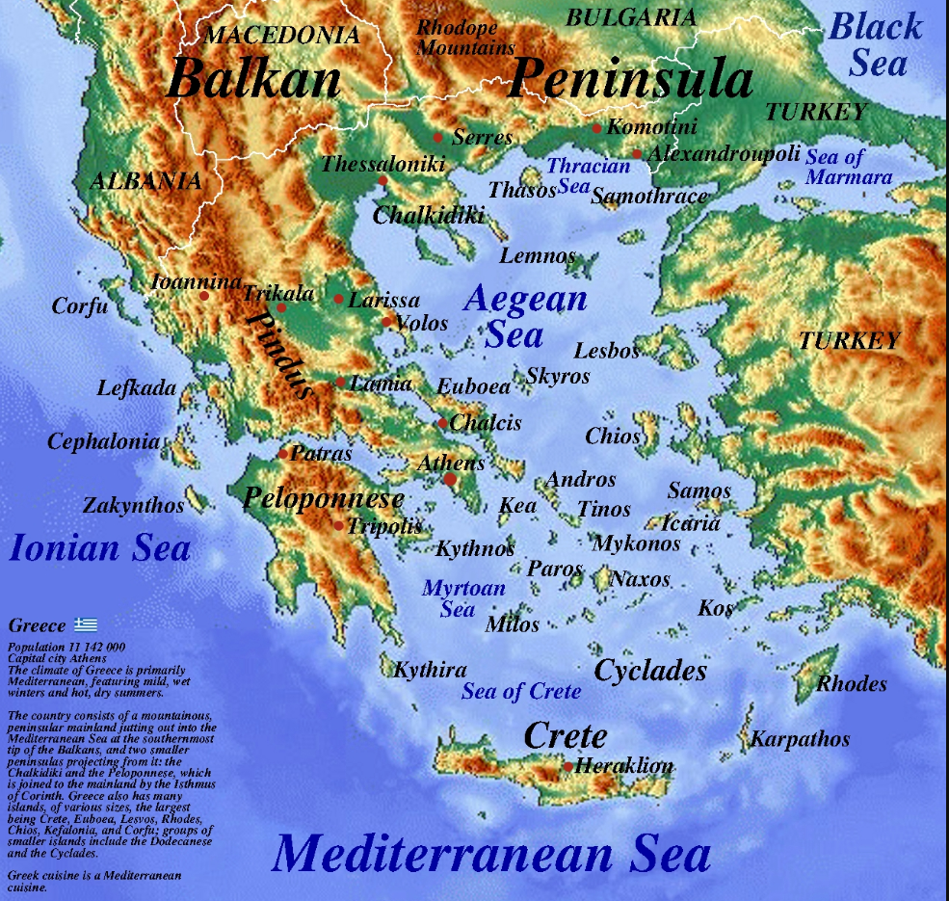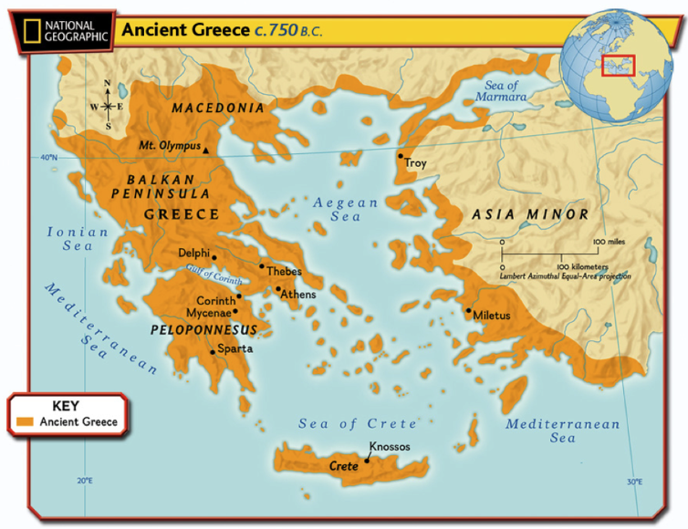
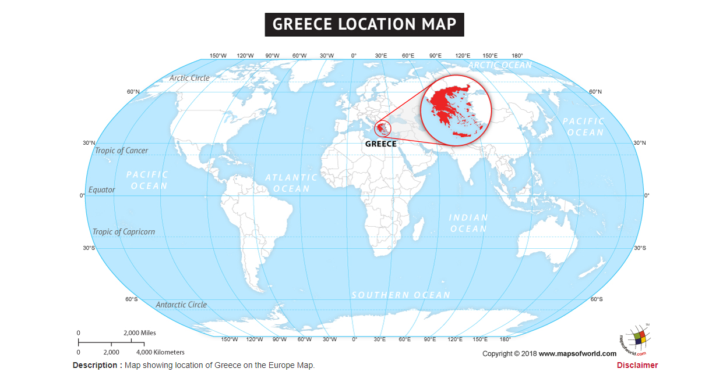
Key words
Peninsula - a landform surrounded by water on the majority of its border while being connected to a mainland from which it extends.
Crete - is the largest and most populous of the Greek islands, the 88th largest island in the world and the fifth largest island in the Mediterranean Sea
Athens - is the capital and largest city of Greece. Athens is one of the world's oldest cities.
Ionian - were one of the four major tribes that the Greeks considered themselves to be divided into during the ancient period. They are now a group of islands in Greece.
Aegean - is a part of/long bay in Mediterranean Sea located between the Greek and Anatolian peninsulas.
Mediterranean - is a sea connected to the Atlantic Ocean and is almost completely enclosed by land.
City state - is a sovereign microstate that usually consists of a single city and its dependent territories
City state with prefix -ian – means that you belong to that city e.g Mycenaean – lived in Mycenae, Athenian – lived in Athens
Key facts
Geography overview:
https://www.ducksters.com/history/ancient_greece/geography.php
Maps:
https://nsms6thgradesocialstudies.weebly.com/maps-of-ancient-greece.html
Time Zones:
https://www.bbc.co.uk/bitesize/topics/zvsfr82/articles/zjk46v4
Athens:
https://www.historyforkids.net/the-city-of-athens.html
Key features of Greece in ancient times
Formed of separate states – it was not one united country. There were fewer people and simpler ways of making money. Trade links between states was fragile and regularly ended in fighting with boat the main form of travel.

