Snail Race  Follow these steps to hold your own Sports Day – but for snails!  Find your snails  You can find snails hiding under leafy green plants or in trees. Snails like the cool and wet, so you won't often find them in the sunshine, so if you can remember that when you race them then they'll be happier.  Mark out the track  Snails move super slowly, so don't make your track too long or you'll have to watch for hours while they race.  If you're having trouble telling your racing snails apart then you could stick small stickers on their shells, but remember to take the stickers off after the race. A snail's shell is its home and helps protect it from harm.  Look after your snails  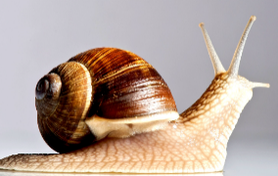  Just like top athletes have their favourite conditions for a race, snails do too! So, keep the track wet, don't leave the snails racing in full sun light. Once the race has been run/crawled then please pop your snail racers back where you found them so they can go home and tell their family how they've done. | Watch the Sunrise  There’s something magical about watching the beginning of a new day. Try getting up early with the birds to see the sun peek above the horizon and the skies fill with rich colours.  To see the sun rise you’ll need to wake up early in the morning. Check what time the sun is expected to rise where you live. Then set your alarm clock.  If you’d like to see a colourful sky, full of oranges, reds and pinks, you’ll need the right conditions. Check the weather forecast - you’re looking for a ridge of high pressure and light winds to keep pollution levels low.  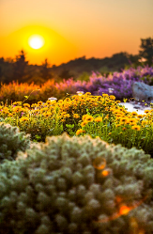  Lastly, try to find a clear view to watch the sunrise. You’ll want to be facing east, which is the direction that the sun rises. | Go Star gazing!  Grab your coats, head for a dark place and lie down in a cozy spot. The longer you look up, the more sparkly stars you’ll discover. As you gaze, take some time to enjoy the moment - how does it make you feel? What words can you use to describe your special view?  If you’ve got a star spotter guide with you, you could try to connect the dots of constellations like ‘Orion’ and ‘the bull’, but it can be just as much fun to find your own shapes. Try drawing them in your very own star diary. And if you’re lucky, you may even get to see a shooting star whizz across the sky... what will you wish for?  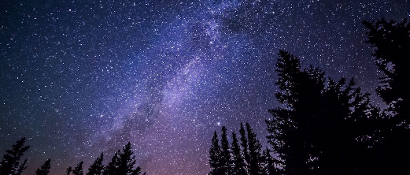

Year 5 and 6 Outdoor Activities – WB 20.04.20

Make friends with a Bug  You can find all sorts of creatures lurking in your garden, You'll need to be prepared though: looking for bugs is fun, but you might need to be fast, and some creatures like centipedes and millipedes move quickly (it must be all those feet!) so you'll need to keep your eyes peeled like a real nature detective if you want to see them.  Where to look?  Great spots for searching include under stones and wood, the branches, bark and leaves of trees and in long grass.  Be gentle  Once you've found your bugs, remember that you're a giant compared to them, so be gentle with any that you choose to pick up as they'll probably be scared of you. It's best if you choose something to hold that's relatively small and that's not going to sting or bite you - so no wasps, bees or snakes.  Let them go  All bugs appreciate being returned to their homes after you've looked at them - just like you'll want to go home at the end of your bug-friending adventure.  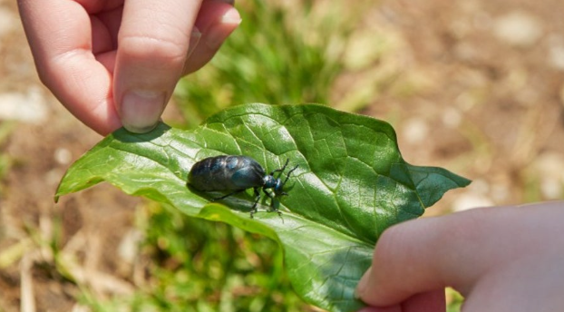 | Make a home for wildlife  What are you building a house for?  You can obviously build a home for any wildlife you think of, but it's probably best to go with smaller ones for this challenge.  Hedgehogs, for example, don't need a lot of space, but you could choose to build somewhere for even smaller things like woodlice, spiders or worms and you'd need even fewer materials and less garden space.  How will the animals use the home you've built?  Do you think that they will want to live in the home you make? Or maybe just visit it and explore? Or could they use it for hibernating? Ladybirds hibernate, so they might make a good guest for your wildlife hotel.  What else do you need to think about?  - Does the home need to be dry or wet?  - What sort of home does the animal currently live in?  - Can you learn anything from that about what it likes and dislikes?  - Where are you going to build it - can it be on the ground, underneath it, or in the trees?  - 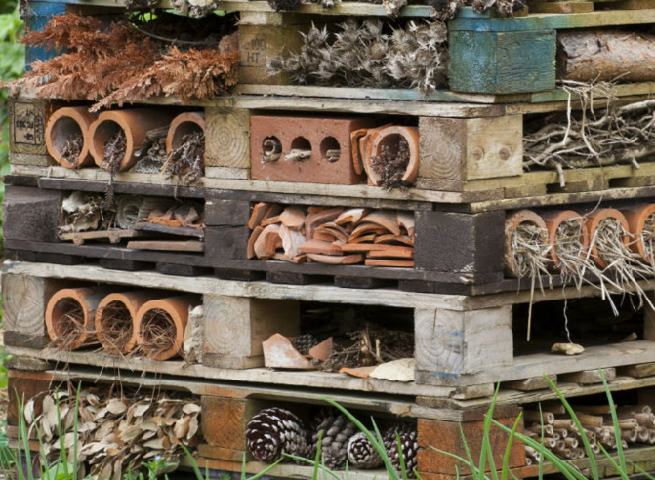What will you make it from? | Keep a nature diary  Decide how you’ll record your experiences of nature: will you use words, pictures, sounds or a mixture of everything? You could even write a poem or a story about your adventures.  Find yourself a diary, a scrapbook, or a sound recorder – and get started. Make a note of all the things you’ve seen and done in nature, whether it’s a picnic in the wild, rolling down a huge hill or getting to know a wild animal. Which activity did you enjoy the most?  Start to observe the nature in your garden. Every time you spot a new species record it in your nature diary!  You could even set yourself a target for the number of new animals you’d like to see this year. Count them up at the end of the year – how did you do?  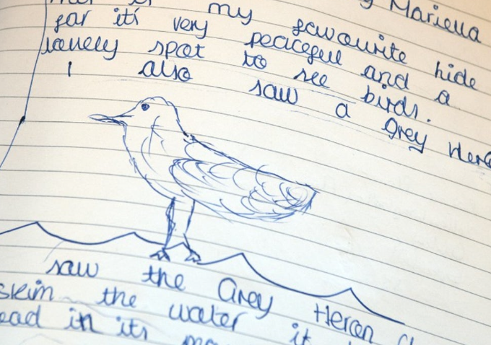

Garden Olympics  Seeing as the Summer 2020 Olympics has been postponed until next year, why not hold your own garden Olympics with your family?  Create 4 or 5 events that could take place in your garden and compete against your family to win a gold medal… or seeing as it’s the garden Olympics maybe a golden potato?  Use your imagination to think of some garden-related events – what about the 5m plant pot hurdle? Or synchronized weeding? A garden hose skipping relay? Or rhythmic gymnastics except your ribbon is a daisy chain? The possibilities are endless! Have fun creating some ‘at-home’ events and we would love to see pictures on your school blog.  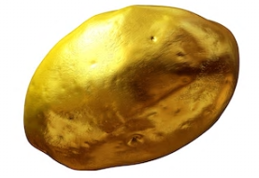 | Symmetry Hunt  Place a stick on the ground.  Find natural objects to make a symmetrical pattern. Make sure you place your objects on either side of the stick to keep your pattern symmetrical.  Can you use the following in your design:  2 petals  4 green leaves  6 blades of grass  4 stones  Extra Challenge:  Can you create a picture that has two lines of symmetry? This time you will need two sticks on the floor placed in a cross.  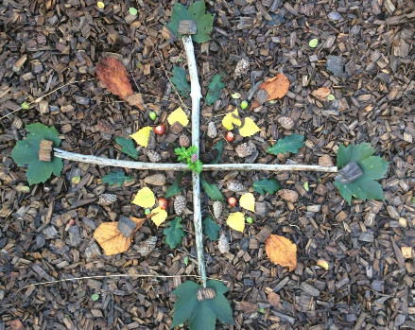 | Shadow Puppets and Monsters  Can you make animals and characters using just your hands?  On a sunny day go outside and see what shapes you are able to make using just your hands. Can you make a bird, or a horse or even a dragon?  How else can you make shadows in your garden?  Search you garden for anything that might make a crazy-looking shadow. Get creative and stack the objects to make your own shadow monsters!  

