Indoor Home learning Grid – Year 5 and 6
- Have a look at the Greek alphabet:  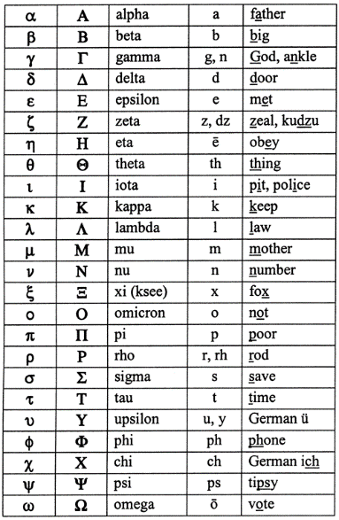  Can you write a message using the above? | - Write a diary of your time in isolation.  Try to include details about what you do, how you feel etc. Write entries for a number of days.  Remember, diaries are written using informal language and first person.   | - Have a look at the following videos all about Greek Gods and Goddesses.  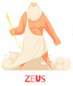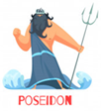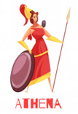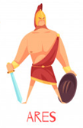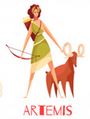  https://central.espresso.co.uk/espresso/modules/t2_greeks/life/video_worship.html?source=search-all-all-all-all&source-keywords=greek%20gods  https://www.youtube.com/watch?v=eJCm8W5RZes  Have a go at creating your own Greek God or Goddess.  What is it the God/Goddess of?  What special powers does it have?  Can you draw/describe them?
- Where is Greece?  Find it on a map either online or in an atlas if you have one. What do you notice about the land that makes up Greece?  https://nsms6thgradesocialstudies.weebly.com/maps-of-ancient-greece.html  Find 5 of the main cities and 5 of the main islands. What is the capital city of Greece?  What is the largest island?  Select 1 island you have discovered.  Find out 5 facts about it.  What are its main selling points?  Does it have a significance in Ancient Greek history?  Are any myths based there? | - Listen to a piece of classical music and draw a picture of what you think it is about or what it makes you think about.  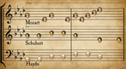  https://www.classicfm.com/discover-music/best-classical-music-for-kids/ | - Create a picture of the Parthenon in Athens.  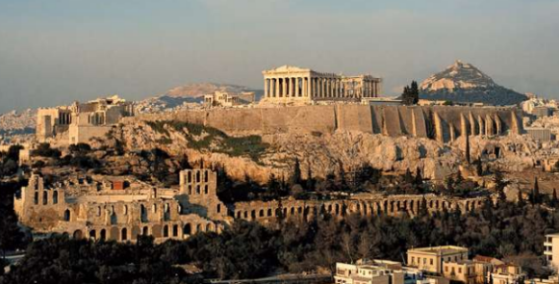  You could use any medium you would like, such as pencil, paint or collage, for example.  Think about the techniques you have used in school but be creative: how you  complete this task is up to you!  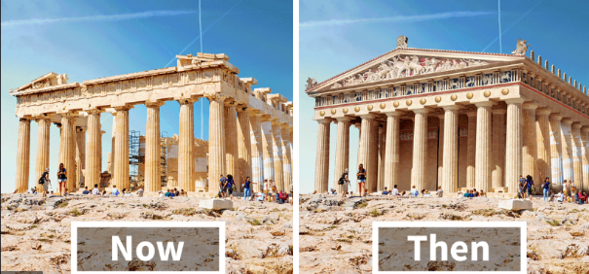  Challenge: Can you construct a model of the Parthenon using resources available to you? Think about how you would design and then construct in DT lessons.
- Explore the following page that summarises how the Ancient Olympic began.  Which sports were included in these ancient games? What events do athletes compete in the modern Olympic games?  Are there any sports that were included in both?  Task: Show in a Venn diagram.  https://www.bbc.co.uk/bitesize/topics/z87tn39/articles/z36j7ty  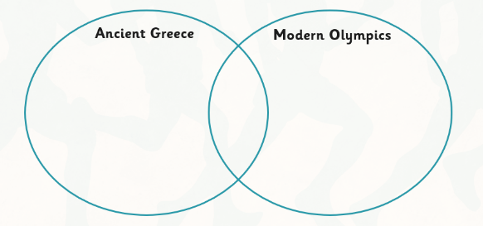 | - Create an information poster about a topic of your choice.  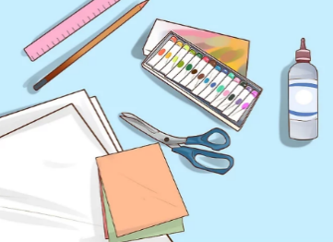  Challenge – can you write an information report about the topic you have chosen? | - Create your own mythological creature for Hercules to face.  Create a poster detailing what your creature can do, how it moves and how it behaves alongside a labelled picture.  Does it have many heads like Scylla?  Does it have the features of two animals, such as the Minotaur? (a man and a bull).  Does it turn any person to stone when you look in their eyes such as Medusa?  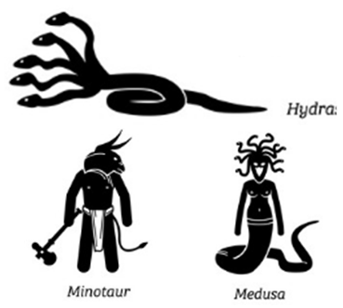
- Write a short descriptive narrative of Hercules fighting the Nemean Lion.

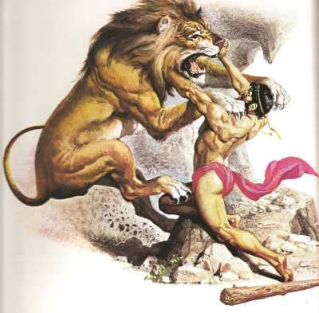

You could write a description of them both facing each other or create a short story of what may have happened.
Think about the emotions that the hero, Hercules, would have felt as he came face-to-face with the animal (FANTASTICs!).

