Indoor Home learning Grid – Year 5 and 6
Activity 1 – Try and bake something.  Ask an adult for help.  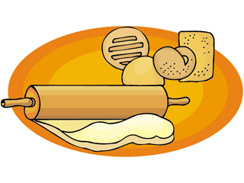Challenge: Can you write this out as a recipe that someone else could follow? | Activity 2 – write a 26-word story where each subsequent word is the next letter in the alphabet.  e.g.  A big cake, decorated elegantly, fell....  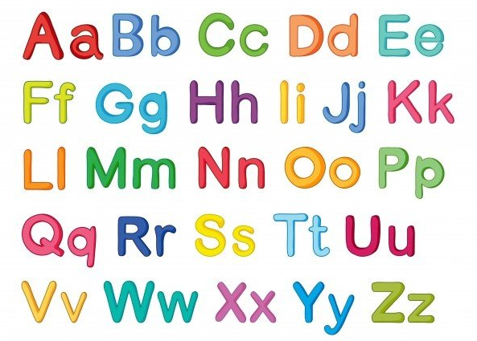 | Activity 3 –  Design a Greek style building and label the 3D shapes and materials you have used.  Can you add columns?  What is your building used for?  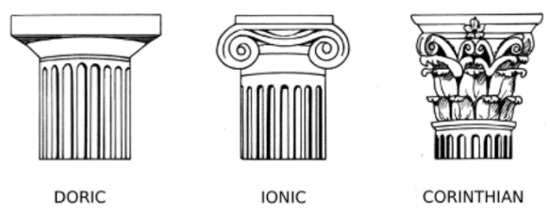  Challenge: Have a go at building your structure.
Activity 4 -  Write a postcard to a friend or relative in self isolation.  Draw a picture on the front and write a message on the back.  Remember to leave a space for a stamp.  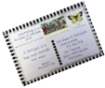 | Activity 5 –  Create a life cycle of your favourite animal (dog? dolphin? T-Rex? you could even create your own!).  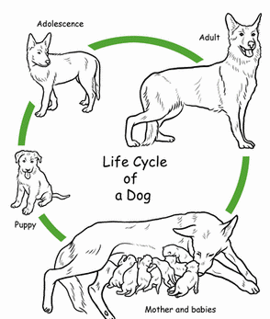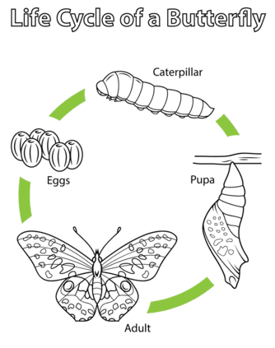  Make sure you annotate your work!  Challenge: What are the differences/similarities between the life cycle of a mammal and an insect? | Activity 6-  Design a healthy 3 course meal. What would you have for starter, main and dessert?    Extension: Can you research Greek food and include some traditional Greek dishes in your menu?
Activity 7 -  Read the story of Medusa (included in the Home Learning packs or use the link on the class page).  Write a 3-sentence summary of the story, making sure to include as many key facts and details as possible.  Challenge: Create a character description of what Medusa would look like. Think about the key features described in the story, as well as using her surroundings to create a negative atmosphere. Remember your FANTASTICs!  Extension: Find out what happens in another famous myth including Medusa and the hero, Perseus. | Activity 8 -  Using the myth of Medusa the Gorgon, create a piece of artwork of her. You could use any media you like, such as pencil, chalk or paint (if available).  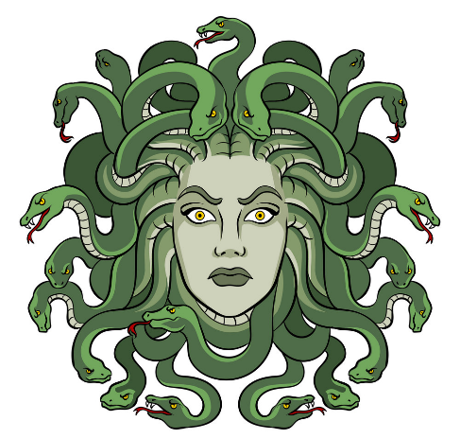  If you have online access, you could use this instructional video to help you:  https://www.youtube.com/watch?v=FmJZWVFYQZg | Activity 9 - Doodle Arm  Carefully, draw around your hand and arm and fill it with doodles of your choice. When you fill your arms with doodles, you might consider the things you are currently missing - or the things you are currently appreciating whilst being at home with your family.  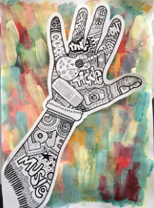  Challenge: use any different materials to collage, paint, colour, create a sculpture of your hand and arm or background like above. Be imaginative!
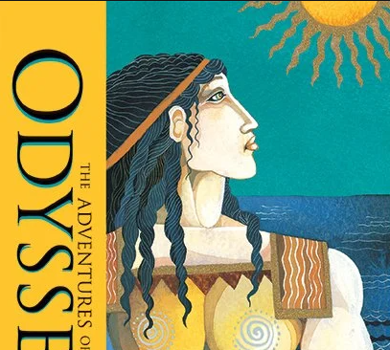
Activity 10 - Internet access option:
Watch Mr Smith read the opening chapter of The Adventures of Odysseus. Follow this link.
https://youtu.be/2t55sBToRRc
Would you make the same choice as Paris? Justify your opinion. Write a short paragraph.

Extension:
This story led to the Trojan War. Can you find out more about this? It is documented in a book called The Iliad.

The next chapter of the Adventures of Odysseus book is also available here:
https://youtu.be/GWjB1jKiC5U

Activity 4 - No internet access option:
Zeus asked Paris of Troy to give a golden apple to the most beautiful god. Three goddesses claimed the apple: Hera, Athena, and Aphrodite. Each of the goddesses also offered Paris a gift as a bribe in return for the apple; Hera offered to make him the king of Europe and Asia Minor, Athena offered him wisdom and skill in battle, and Aphrodite offered to give to him the love of the world's most beautiful woman, Helen of Sparta, who was already married to King Menelaus of Sparta. Paris chose Aphrodite, a decision that had fatal consequences.
Would you make the same choice as Paris? Justify your opinion. Write a short paragraph.

Extension:
This story led to the Trojan War. Can you find out more about this? It is documented in a book called The Iliad.

