Measurement Scavenger Hunt  Search your garden for the following objects. You will need a ruler.  A leaf that is 5cm long  - A stick that is 13cm long  - Two different things that are exactly the same height  - A line of pebbles that is around 20cm in length  - Something longer than your hand span  - Estimate how many steps it will take you to travel between two different points in your garden. Test it out – were you correct?  - Estimate the width or height of some of the objects in your garden. Then measure them to see how close your estimation was. (bricks, patio slabs, fences, plant pots) | 20 Something Challenge  Search your garden for exactly 20 different objects.  Can you divide your objects into two even groups? What about four even groups?  How else can you sort your objects just by looking at them? Decide on your own groups. You could sort them by colour or size, or perhaps by what they are made from.   | Paper Aeroplanes  Can you find out the best design for a paper aeroplane? There are so many different ways to fold your paper to create a paper aeroplane, but which method is best?  Try out different ways of making a paper aeroplane and then test them in the garden. You could even have a family competition! There’s no Olympics this year, so why not make your own championship…  Things to think about:  - How are you going to make it a fair test?  - How could you measure how far they have travelled?  - How will you decide which way to throw your paper aeroplane?
Make a Magic Potion  Use the nature objects you can find in your garden to create a potion!  First, you will need to decide who your potion is going to be for. Will it be for fairies to make them fly? Or may a protection potion? Or a lucky potion?  Now search your garden for as many ingredients as possible. You could add them to a pot to actually make your potion, or just write your recipe down!  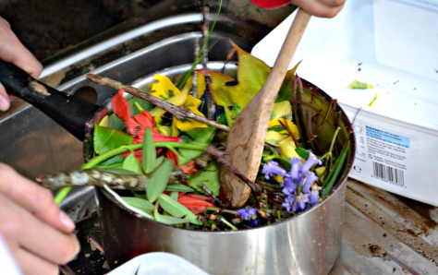Don’t forget to use your imagination! You could even rename the objects you find in your garden. For example, feathers are no longer feathers, they are fallen fairy wings. Leaves could now be fairy umbrellas and stones could be goblin teeth! | Memory Game  Hunt around your garden for at least 15 different objects and place them under a blanket. Try and find as many different natural items as you can, and identify them as you go!  Have a good look at all the objects before they are covered up. Ask someone at home to remove one of the objects and see if you can remember what has been taken. Once you get a little quicker, maybe two objects can be removed or even three!  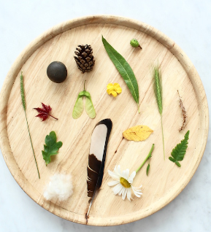 | Garden Bioblitz  What better time to get to know all the species in your garden? It’s time for a garden Bioblitz.  A BioBlitz is an event that focuses on finding and identifying as many species as possible in a specific area over a short period of time. At a BioBlitz, scientists, families, students, teachers, and other community members work together to get a snapshot of an area’s biodiversity.  So get to know all the species for flora and fauna in your garden. How many different plants can you list? What about animal species? You may need to conduct some research to identify some of the plants you are unsure of.  Every garden will be a habitat for some plants or animals.  How many does your garden have in total?
Build a Maze  Can you build a maze using natural materials you find in your garden? Make sure you include and entrance and an exit, but don’t forget to add in a few wrong turns to make it tricky to solve!  You could ask someone else in your house to see if they could find a route through your maze. Maybe they could use chalk to draw a line to show the path they took through the maze.  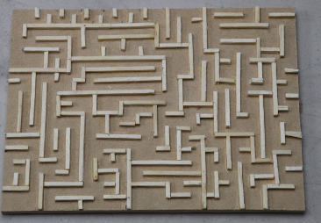There is a theory that suggests woodlice will always go left, then right, then left, the right etc. if forced to make a choice of turns. If you can find one, why not carefully place a woodlouse in your maze to test the theory? Do they always choose to go left then right alternatively? Don’t forget to put your woodlouse back where you found it when you are finished | Nature’s colour palette  Using close observation you will be able to find a surprising amount of colour in your garden - even in unpromising locations or at duller times of the year. Look at the edges of things, under things and round the back.  See how many colours you can spot in your garden looking at only natural objects. Can you find an object for every colour of the rainbow? Is there any colour you can’t find? Is there a particular colour you can find lots of?  Why not try and create new names for the colours you find For example, grass and leaves might both be green, but they will be completely different shades. Get creative and give it your very own description. What about ‘cat’s eye emerald’ for green, or ‘wild cat black’.  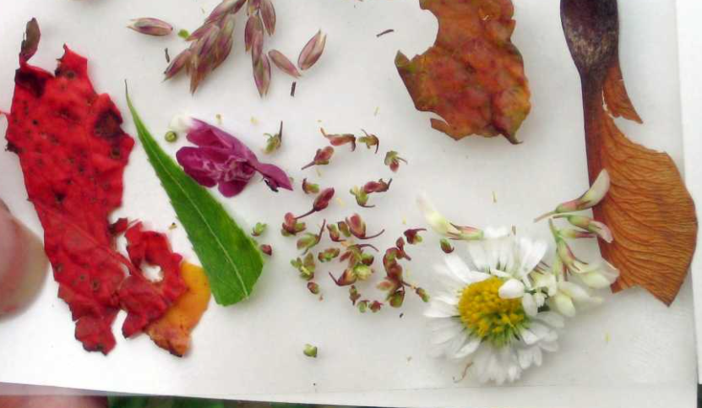 | Outdoor Magic Number Square  Draw a 3x3 grid with chalk or create one out of sticks.  Your challenge is to create a magic number square in which each row, column and diagonal of the grid will add up to 15.  Therefore you will need to collect 45 individual loose tokens (that is the total of 3 columns each adding up to 15.) These could be leaves, sticks, stones, petals etc)  With trial and error the tokens must  be arranged so that the numbers 1-9  each only appear once in the grid. But, remember that each row, column and diagonal must add up to 15!  

