Indoor Home learning Grid – Year 5 and 6
Activity 1 – Floorplan  Can you measure the perimeter of your home without going outside? What will you use to measure? Metres? Footsteps?  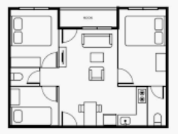  Challenge: Can you draw a floorplan of your home? Now, go outside and see if you get the same measurements. | Activity 2 – Music poster  Listen to a piece of music of your choice. Create a poster to show what you can hear. Draw whatever comes to mind!    Think about:  What instruments can you hear?  What does the music remind you of?  Does it paint a picture in your mind?  Draw a picture to show this. | Activity 3 - WHAT IS THE QUESTION?  Think of 3 questions as possible for each of these answers. Try to make them as unusual as possible:  My answer is blue – what is my question?  My answer is 7 – what is my question? My answer is round – what is my question?  My answer is potatoes – what is my question?  My answer is England – what is my question?
Activity 4 – Quiz  Create a small quiz on the blog for your class, adults or siblings in your home. This can be on any topic of your interest.  For Example,  Question 1:  How many players on a football pitch?  Make a blog of your best 5 questions – you can share the answers with us next week  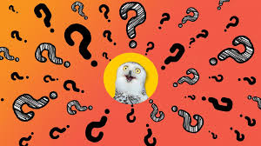  Challenge – Create a quiz for our topic of Ancient Greece.  Do your own research to make the questions. | Activity 5 - Sudoku  Complete this sudoku challenge, following the instructions below.  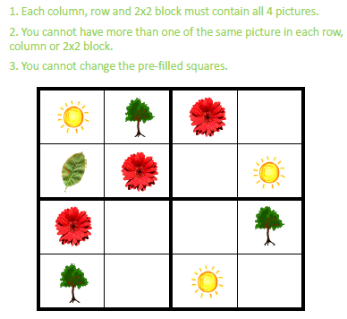  Extension: Can you design your own Sudoku?  It could be number or picture based!  Challenge: What about a 3x3 grid! | Activity 6  Theseus and the Minotaur  The myth of Theseus and the Minotaur is a famous tale of bravery and resourcefulness. The image of the half-man, half-bull Minotaur can be seen painted on a range of Ancient Greek artefacts from Crete and across Greece. Read the story and summarise what happens in three bullet points.  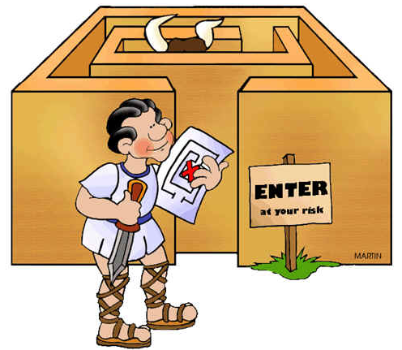  Challenge: Can you create a cartoon strip of the story to summarise they key points? Think about how speech and speech bubbles could be used to progress the story.
Activity 7  Theseus and the Minotaur  Create a piece of artwork in any media you wish (pen, pencil, paint etc.) to depict a scene from the myth.  You could focus on the ferocious Minotaur lurking in the labyrinth, Theseus finding his way out using the thread or even the battle between the two.  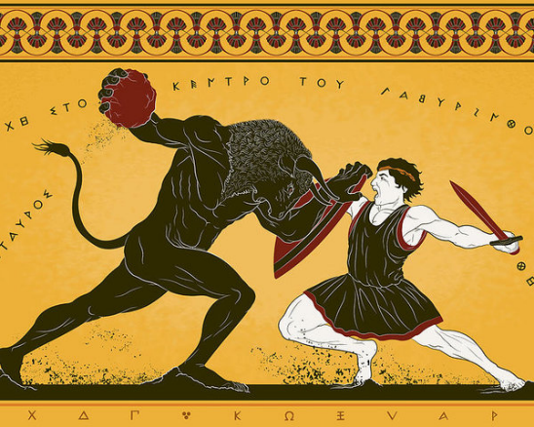 | Activity 8  Theseus and the Minotaur  Using the reading text and your artwork as inspiration, write a short descriptive narrative of Theseus making his way through the winding maze in order to defeat the Minotaur. Think about the tension and fear that Theseus would have felt, venturing through the silent darkness, knowing that the monster could be lurking around any corner. Make sure to interact with your senses, using the FANTASTICs to help!  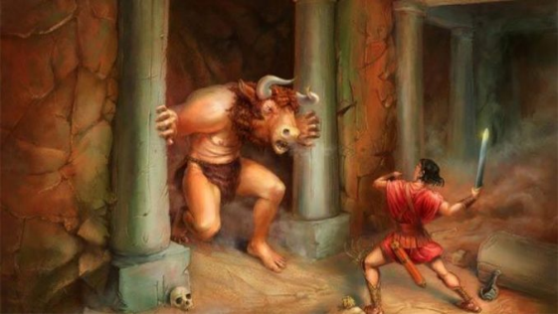 | Activity 9  Theseus and the Minotaur  DT – Create your own 3D maze, using whatever materials are available – Lego, building blocks, papier-mache, cardboard clothes … be creative!  Make sure there is a clear pathway from one corner to the opposite!  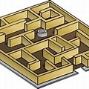
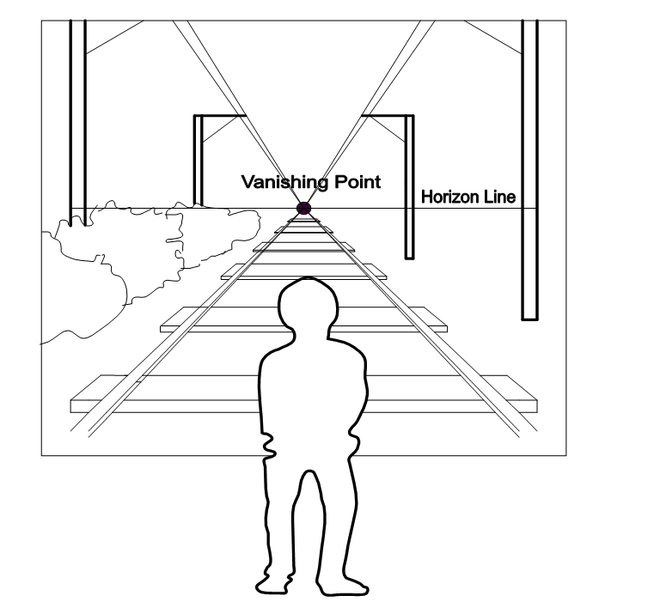
Activity 10 – Create your own one-point perspective picture
Have you ever noticed that the further away something is from us, the smaller it appears to be? Create your own one-point perspective picture. This could be an imaginary scene, your garden, the road outside your house.

A perspective drawing recreates the illusion of objects getting smaller and parallel lines converging (getting closer together) as they get further away from us. You may also have noticed how parallel railway lines appear to meet in the distance.

Tip: Draw the horizon line, vanishing point and any guidelines (which meet at the vanishing point) lightly in pencil (so you can rub out after) and remember that most objects that are tall will cross from below the horizon line to above it!

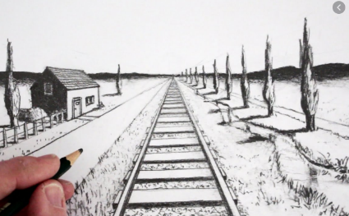
See this video for any help: https://www.youtube.com/watch?v=sZD8BjTK8dE
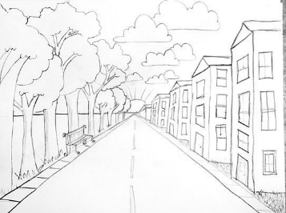
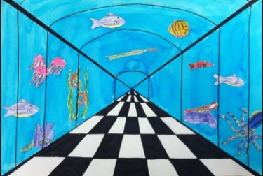
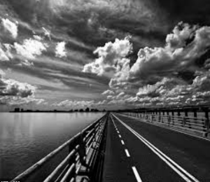
e.g.

