Go on a wintry walk  Just because it’s cold outside it does not mean you can’t get out and have wintery adventures! In fact, lots of things look different and even more incredible during the winter months so it’s a great time to explore.  For example, you could:  - look for wild animal clues e.g. habitats, footprints  - make some wild art e.g. sketch some leaves, make a nature collage  - take a small bottle of food colouring along and make frozen ice paint to add colour  - 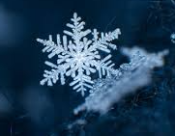make a home for a wild animal – they need a safe, cosy and warm spot in winter more than ever.  Identifying Winter Trees  Trees in Winter are much trickier to identify because most trees have lost all their leaves. It means that in order to identify which tree we are looking at we have to look very closely at their bark and branches and see if there is anything else growing on them that can help us.  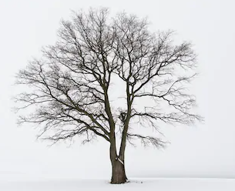Take a walk around your garden or your local area and look very closely at the trees you spot. Are you able to name any of the trees you find? You could take some bark rubbings or sketch the things you see and then come home and see if you can discover the trees you have found. | 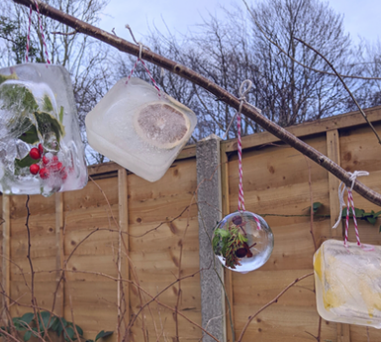Ice Sculptures  Check the weather forecast and choose the coldest night of the week in order to make an overnight ice sculpture.  Find a container and fill it with leaves, sticks, berries and other things you can find outside. You could also add some string into the water so that you can hang it from a tree once it has frozen. Then fill it with water and decide where you think the best place to leave it outside overnight will be if you want to make sure it freezes.  Perhaps you could fill up a few containers and see where in your garden works best!  In the morning, check all your containers to see if any have frozen. You could then find the best place in your garden to melt them the fastest.  Frosty spellings  Are there any words you need to practise and are finding a little tricky to remember? Writing things in lots of different ways helps us to remember.  Wrap up warm, take yourself outside on a frosty morning and write those tricky words in the frost! Maybe you could practice word walls or your 100 words, or even any words related to any of your home learning.  Where is the best place to write them? Do you have a shed that you can write them on using your finger? Or maybe you could write giant words on grass using your feet!  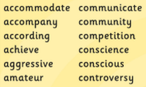 | Winter Season Spotter  Go on a Winter walk – how many of these things can you find?  - Ice  - Icy Spider Web  - Rough Bark  - Evergreen Tree  - Berries  - A stick longer than your arm  - Catkin  - Birds Nest  - Moss  - Lichen covered twig  - Your breath  - A smooth pebble  - A leaf bigger than your hand  Can you see any signs of Spring on your walk? Look for buds on trees, or flowers emerging from the ground.  Perhaps you can create your own winter scavenger hunt list complete with pictures to take with you on your journey; then you can tick your findings along the way!  “I wonder…”  Choose 3 ‘I wonder…’ challenges to complete.    I wonder… how many colours of the rainbow I can find in nature.  I wonder… what I can create using 15 sticks I have collected.  I wonder… how many rocks I can stack before they fall over.  I wonder… what pictures I can see in the clouds today.  I wonder… what is under that log.  I wonder… which way the wind is blowing today. How could I find out?  Which was your favourite challenge? | Mindfulness Minutes – Make a sound map  The idea of this activity is to sit somewhere and be absolutely still and silent, noticing the sounds around you and where the sound is coming from.  Get a piece of paper and make an X in the centre. The X is you! Anytime you hear a sound, make a symbol on the paper in the place you hear it, to represent the sound.  Make sure you wrap up warm before you go outside, and if it is too cold to sit still and listen trying walking softly around as you create your map.  Hunt the Alphabet  Take a walk in your garden or local area.  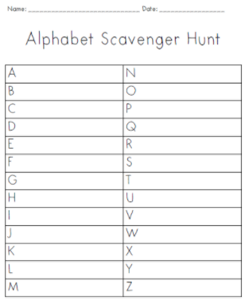  Are you able to find something that starts with every letter of the alphabet?  You could set yourself a challenge by only writing down things that are natural and not man-made. Or perhaps only writing down species of trees or animal. | Make a Bird Feeder  To encourage more birds to visit your garden (perhaps in preparation for your big garden birdwatch) you could make them their very own cake!  Ideal ingredients: sunflower hearts, peanut pieces and other bird seed mixes, dried fruits softened with water, crumbled or grated cheese, cooked rice and other leftovers or breadcrumbs.  Method  - Combine your ingredients in a bowl and add softened lard  - Mix together into a firm paste. For best results you’ll need to get your hands in there!  - Pierce the bottom of a clean yoghurt pot and poke a length of string through  - Knot securely on the inside of the pot so that it hangs upside down like a bell  - Fill with the fat mixture and hang outside  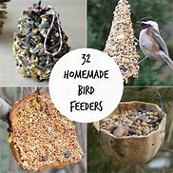  Nature Art  Go outside and collect a variety of natural objects.  Make them into shapes and patterns, thinking about their colour, size and shape.  Can you make these shapes?  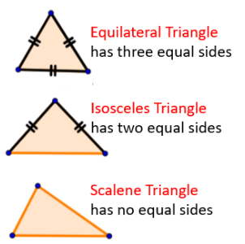  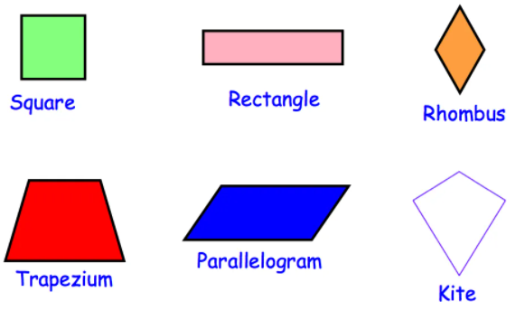  Can you make your pattern symmetrical?

