Year 4 Easter Activities
Over Easter, we are not going to be setting work. However, if you did fancy doing something, we have put together some ideas.
South America
Our topic for the summer is South America so if you want to look into anything about South America you may but here are some ideas:
- Learn the countries and capital cities of South America
https://www.youtube.com/watch?v=Nw1H8aIhKNk
- Choose a country and become an expert on the country.
- Research about the Amazon rainforest – create a factfile/powerpoint
What animals live near the river? What countries does it go through? Where is the source of the river?
- Rainforests – What are the layers of the rainforest? What animals live there? Which layer do they live in?
- Can you create any of these animals in your own imaginative way?
- Create your own rainforest using your DT skills
- Cook some South American food

Other Activities
- Make your own instrument using recycling – remember about how to change the pitch and volume, which we learnt in Science.
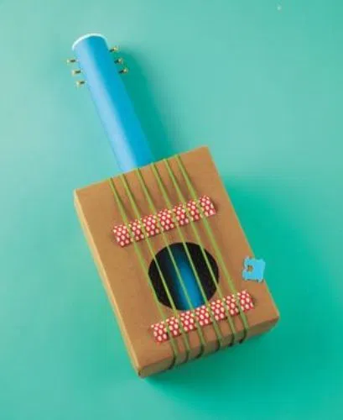
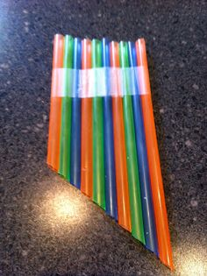

- Make a natural bunny out of materials in the outdoors.
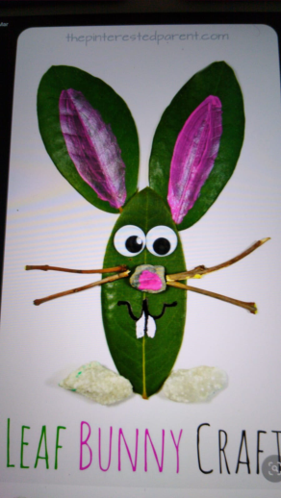
- Find out how Easter eggs are made:
https://learnenglishteens.britishcouncil.org/study-break/video-zone/how-are-easter-eggs-made
- Remind yourself of the Christian Easter story
- Decorate an egg like a Fabergé egg or create a Fabergé egg out of materials at home
- Easter egg mindfulness colouring
- Create an Easter card for a family member- be as creative as you can! 
- Send messages to each other using Fairy code, morse code, telephony, semaphore or your own type of code. You could put messages on your windows for your friends to decode. Here are some examples:
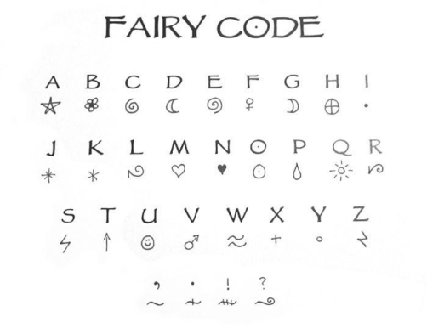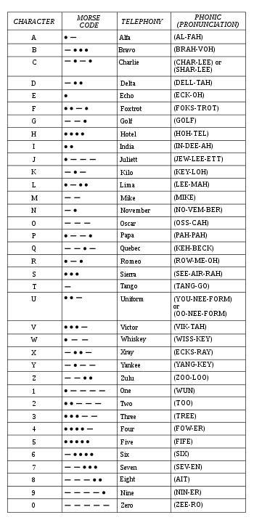
- Learn how to do a sudoku - http://www.kidsmathgamesonline.com/sudoku/printableworksheets.html

- Make your own new, magical world.
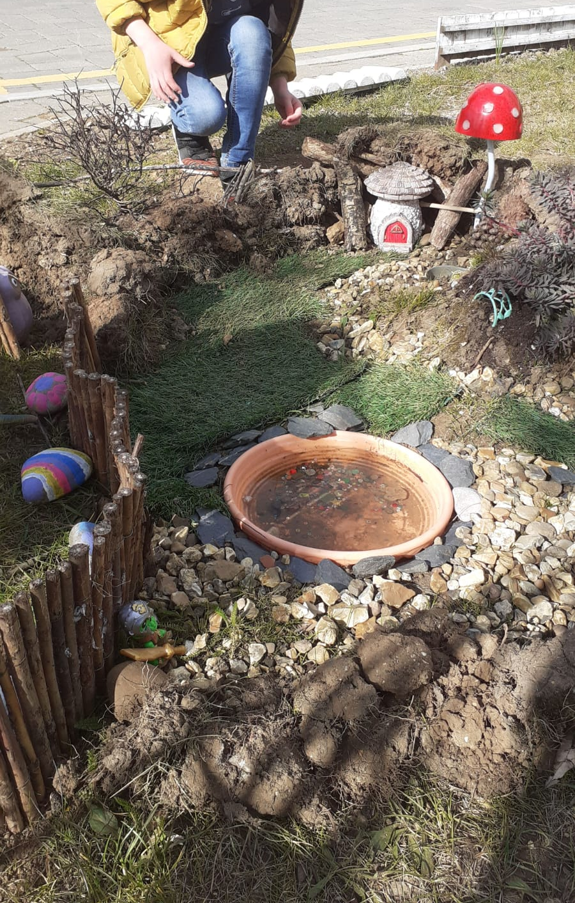
- Make your own plant pots from recycled tins.
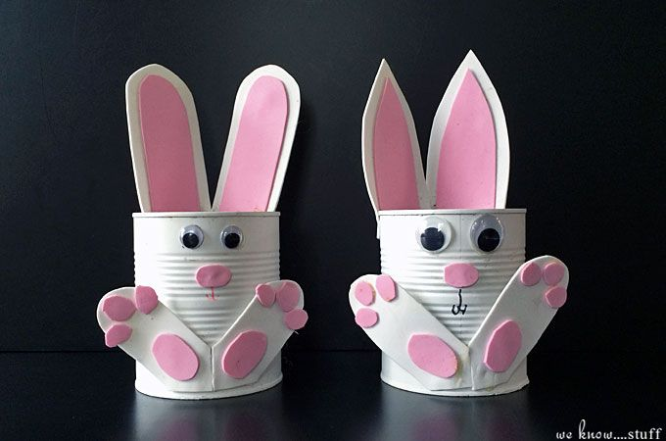
- Cooking – can you make a chocolate nest?
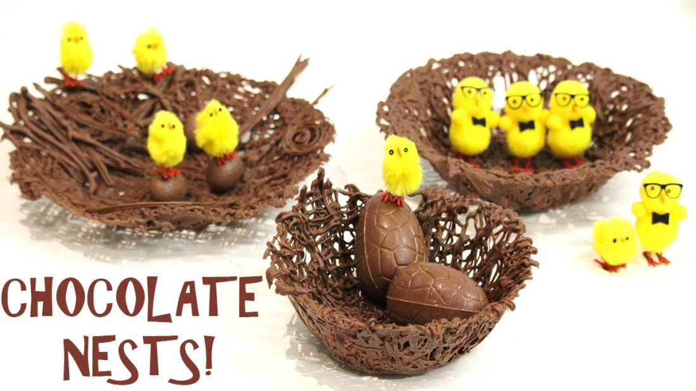
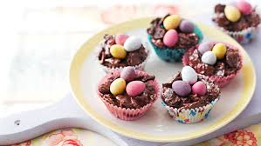

I’m sure that you have lots of wonderful ideas too so be creative, have a rest and enjoy Easter!

Stay safe!
Best wishes,
Mr Hall, Miss Parker, Ms Cullen & Mrs Howard

