Indoor Home Learning Grid Year 3 and 4 Monday 4th May – Friday 15th May
Activity 1: Fraction Basketball.  FRACTION BASKETBALL  Scrunch up a piece of paper and see how many times you can throw it into a cup/bowl. Do this 20 times counting your score. Keep a score board with tally marks for you and the other player. Let us know your scores on the Blogs!  Challenge – Can you make this into a fraction on how many you scored? What fraction did you miss? For Example: Mr Thomas Scored 15 out of 20 and missed 5  15 5  20 > 20  Can you simplify the fraction? | Activity 2: Discover A New Animal  Can you design a new animal? Look at the pictures below to remind yourself of just how different animals can be. Draw a picture of your new animal (if you have some play dough you could make a model). Think about how many legs and arms you want it to have. Do you want your animal to have fur or scales? What colour is the animal and why? remember it’s totally up to you; it can look very different to any animal that already exists!  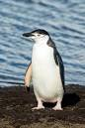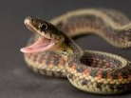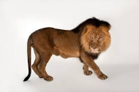  Challenge – What habitat does it live in? Why? What does it eat? Could your animal live in South America? Why and why not? | Activity 3 – Seed Dispersal  Seed dispersal is the way seeds get from the parent plant to a new place. "Dispersal" means to spread or scatter.  Make a poster, a PowerPoint or a fact file about the different way seeds can be dispersed.  Here is a video to remind you of the ways seeds gets dispersed … https://vimeo.com/218127343  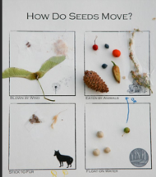  Challenge – Maybe you could act out these ways? Or find seeds to add to a poster.
Activity 4 – Tiny Treasure  Can you be a nature pirate? Find a little box and see how much tiny treasure you can put in it.  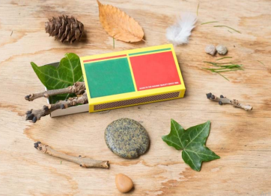  Challenge - Write a story about a tiny person/character who might live in this box. How would they use all the items?  Do you know the book or movie “The Borrowers” ? Watch the film trailer beloe:  https://www.youtube.com/watch?v=lgZQ8gyUlwI | Activity 5: South American Animal Collage  Could you draw a South American animal (any animal) or plant and make it into a collage? You can use old magazines for the coloured paper.  Use these for ideas:  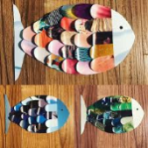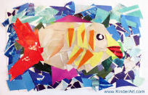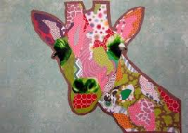  Challenge - Add a habitat for your animal. Describe the setting and how the animal has adapted to live there. Can you use mixed media (different materials) for the background. Eg. Paint, chalk, tissue paper. | Activity 6 – Calm Jar  Create a ‘calm jar’ to help you or your family members to settle strong emotions and make them feel relaxed again.  https://www.goodtoknow.co.uk/family/things-to-do/glitter-jars-how-to-calm-down-jar-105300  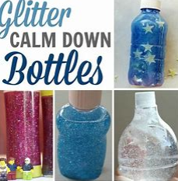  Challenge – Think of some words or phrases that you might use to make your friends/family feel calm. Ask your family what helps to keep them calm. (breathing exercises, listening to music, thinking about your favourite place, dancing.)
Activity 7: Measuring and maps  Using different items to measure can help with our estimating and counting skills. Can you estimate how long your street is? What unit of measure could you use? Can you estimate how long your living room is in metres?  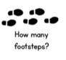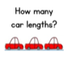  Challenge – If you could change one room in your house use the dimensions that you have worked out to think about what you could put in it. They must fit in. Eg. You can’t have an indoor swimming pool in your bedroom. | Activity 8: Computer drawings  Draw with Bob Biddulph.  http://www.robbiddulph.com/draw-with-rob  Use this website to draw an animal of your choice. This site is a lot of fun.  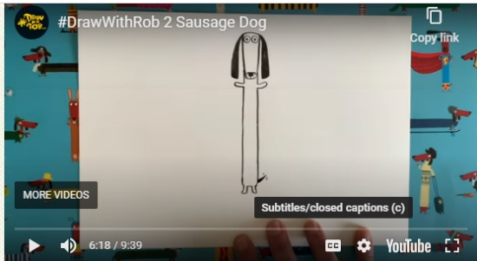  Challenge – re-draw your animal to make a secret card for your adults at home. Write a lovely message in it. Hide it somewhere they will find it. | Activity 9: Quiz  Create a small quiz on the blog for your class, adults or siblings in your home. This can be on any topic of your interest.  For Example,  Question 1:  How many players on a football pitch?  Make a blog of your best 5 questions – you can share the answers with us next week 😊  Challenge – Create a quiz for our next Ice Zone Topic about South America. Do your own research to make the questions.
Activity 10 : You have the day off today – it is a special May Day Bank Holiday this year (it is usually on the first Monday in May …) Do you know why it was planned to be different this year? https://www.twinkl.co.uk/resource/t-t-2548139-union-jack-template-display-bunting Make some bunting maybe ….
Please blog to tell us about how you are getting on and feel free to post your work. Remember these activities are all optional!
Outdoor Home Learning Grid Year 3 and 4 Monday 4th May – Friday 15th May
Activity 1: Weight Challenge  Collect as many food packages as you can (flour, beans, soup, sugar, biscuits,  Before you add any water to the containers, line them up in order from the heaviest package (the one with the most mass), to the lightest. Next, fill up different sized bowls with rice, sand, pebbles and weigh them using weighing scales. Add them to your line up.    Challenge: Remember 1000 grams is equal to 1 kilogram. Can you convert the weight of grams into kilograms?  Can you work out how many of one item would you need to weigh as much as you? | Activity 2: Plant in a Jar  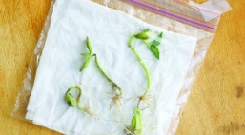  Grow a plant and measure it every day (A runner bean seed on tissue in a plastic bag or jar will allow you to measure the roots growing too!). Can you plot a graph/ bar chart to show the plant growing? You could make a bean diary and draw the bean each day.  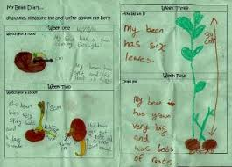  Use whatever seed you have.  Challenge: What do you think attracts particular insects to your garden? How can you attract insects? Create an explanation text to explain this. | A Activity 3: Teddy Zipwire  Make a teddy zip wire to find the quickest way for teddies to descend from different heights:  https://www.science-sparks.com/teddy-zip-wire/  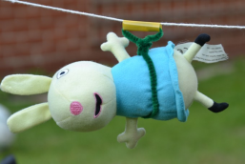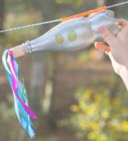  Challenge: Can you time the descent and find the fastest combination of zip line, harness and incline of the wire?  How can you make the teddy go quicker or slower? Think about materials and what creates more friction.
Activity 4: Wind Chime  Make a wind chime  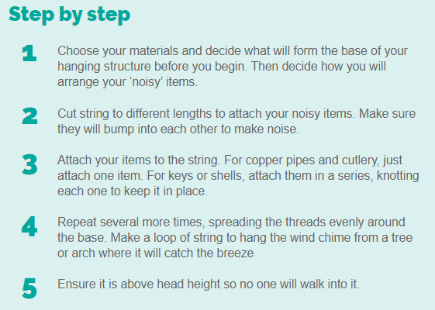  Challenge: Can you create different sounds from everyday objects and play a simple nursery rhyme, like ‘Three Blind Mice’. Make sure you get the correct notes. Think carefully about how you can make them different pitches – Remember long = low. | Activity 5: Problem Solving  Throw a hoop on the grass and count the different plants in the hoop or can you count different plants in your garden? How could you use this to help guess how many plants are in the whole garden?    If it’s raining can you count the different flowers in this picture? Write a list of the number of plants that you found.  Challenge: Include addition/subtraction/ multiplication/division (groups) or fractions to the problem. | Activity 6: Make a Den  Making dens is a fantastic way to problem solve, thinking about angles, height, length and shapes.  Can you make a den for a favourite toy instead? Measure the height, length and width of your den. How many people/toys can fit inside it? What South American animals could fit inside?  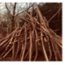  Challenge – If you made your den double/half the size how tall/wide would it be? Make three – one for each bear in Goldilocks and the 3 Bears. Think about the size of everything inside.
Activity 7: South American Flags  Research the flags of a South America. (Argentina, Brazil, Bolivia, Columbia, Ecuador, Guyana, Paraguay, Uruguay, Peru, Chile, Suriname, Venezuela) Use outdoor, natural materials to replicate this flag?    Challenge: Describe your flag to a family member- can they guess what it is? Describe what it looks like. What colours, shapes and lines can you see? What is it made from?  Can you remember all the flags?  https://www.sporcle.com/games/g/southamericaflags | Activity 8: South American Animals  Research a South American animal (caiman, toucan, emerald tree boa, guanaco etc.) Using an outdoor space, pretend to be the animal. Act as the animal- what might you look like? What sounds will you make? How will you move? What will you do?  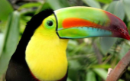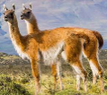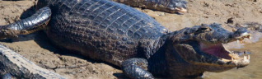  Challenge: Create a movement sequence, transforming from one animal to the next (caiman to a toucan to a guanaco). Think about your sounds, actions, body language. Create a jungle scene. Make a video of the scene outside. | Activity 9: Mini Garden  Design your own mini garden for one of your teddy’s or favourite book character. You can either create it in a shoe box, draw it on paper or use your imagination.  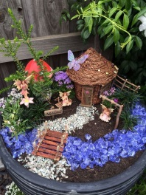  Challenge: Is all about the detail!! What might they like in their garden?  How are you going to use the space? What plants might it like?
Activity 10 : You have the day off today – it is a special May Day Bank Holiday.
It is VE Day – find out about what VE Day is and why we celebrate it.


Please blog to tell us about how you are getting on and feel free to post your work. Remember these activities are all optional.

