Year 3 and 4 Indoor Home Learning Grid Monday 18th May – Friday 22nd May & Monday 1st June – Friday 5th June
Activity 1: The Amazon Rainforest  Can you create an information poster all about the Amazon Rainforest? Look at where it is located? What species of animals are in the Amazon? What can you find out about the River Amazon?  Virtual School Trip of the Amazon.  https://www.youtube.com/watch?v=JEsV5rqbVNQ&t=157s  Challenge:  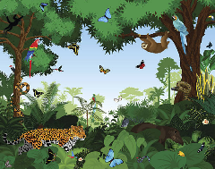  Can you use your information poster to persuade people to save the Amazon Rainforest? | Activity 2: Maths Hunt  Go on a Maths Hunt in your home or outdoor space.  Try and find examples of:  - Numbers in your home  - Interesting Repeating Pattern  - Triangles (Different Types) video reminder of triangles 😊 here  https://www.bbc.co.uk/bitesize/topics/zvmxsbk/articles/zggsfrd  Challenge:    Choose 3 t-shirts, 3 pairs of trousers and 3 pairs of socks. How many different combinations of an outfit can you make? Record them on paper so you can think logically. | Activity 3: Create your own mini museum  Think of a theme for your mini museum, this could be objects you collect, things that make you happy, family history.  Choose a few objects, stating what it is. The date (if known) and why the item is important.  Arrange the display and take a few photos for the blog.  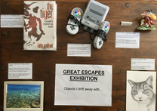  Challenge: Pretend that you are the museum curator and explain why you have chosen the objects and the significance of them.
Activity 4: Explanation  What emergency services can you contact by dialling 999? (Hint: there are more than three!)  Find out what these services do. Write an explanation of why these workers deserve to be called heroes.  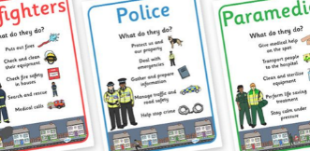  Challenge: What is the difference between 999 , 111 & 112? Can you present these in your own way? eg. Top trumps, mini fact files. | Activity 5: Positive Thinking Cap  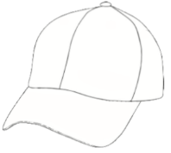  Draw or create a hat outline. Using the outline fill it with colourful messages for positive thinking. You can use different kinds of writing or use symbols or illustrations. Just remember to keep it positive.  Some helpful words and phrases: You can do it! Go For it! Resilience! Determined! Super me! I can do this!  Challenge: If you want to learn bubble writing.. https://www.lettering-daily.com/bubble-letters/ | Activity 6: Make a Rainstick.  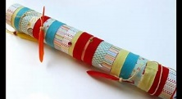  Use a kitchen roll inner tube and push cocktail sticks (or something similar) through the tube all the way round the sides. Cover one end. Experiment with different fillings such as rice, pasta, split peas, buttons, etc. to get the exact sound you want as you lift the tube up and the filling cascades down over the sticks. You may want to mix the fillings up. When you are happy, cover the other end securely and decorate the tube. You could wind wool around it, or paint it, or cover it with stickers.  Challenge: Read up about when and where rainsticks were invented. It’s interesting stuff!  https://en.wikipedia.org/wiki/Rainstick
Activity 7: South American Art  Find out all you can about Frida Kahlo and make an artist fact sheet about her. https://www.youtube.com/watch?v=wfbLR15Bh74  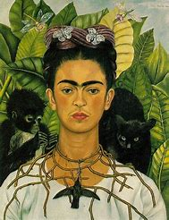  What colours does she use? Why do you think she painted these pictures? How do the paintings make you feel? Think of 3 adjectives to describe each painting.  Challenge: Create a piece of art influenced by Frida Kahlo. | Activity 8: Acrostic Poem  Write your own poem about an emergency services worker. It does not need to rhyme, and you could do an acrostic poem. If you are struggling, you can use this example to start you off:  Never stopping  Until everyone is well.  R  S  E  Challenge: Can you add alliteration? Could we do this about family members? | Activity 9: A Wheelbarrow  Design and make a mini wheelbarrow using junk and craft materials.  Possible supplies:  lollipop sticks, toothpicks, foil, duct tape, lego, cardboard, gears, bottle tops, pipe cleaners and yoghurt pots.    Challenge : Can you measure how heavy a load your wheelbarrow can carry? Start small and weight each item … a lego block? teaspoon? a toy car? An apple?
Activity 10 : Singing Assembly.
Have a singing assembly. This could be done inside or out, with your family, or even with your toys lined up! There are some links to songs we know on the website music curriculum area or just sing your favourite songs. Fill your lungs, dance, smile, ENJOY! Here’s one to start you off.
Spring Chicken https://www.youtube.com/watch?v=TKEwyLCKLwI
Please blog to tell us about how you are getting on and feel free to post your work. Remember these activities are all optional!

Year 3 and 4 Outdoor Home Learning Grid Monday 18th May – Friday 22nd May & Monday 1st June – Friday 5th June
Activity 1: Ice cream Shop/Van  Set up your own ice cream shop or van in your garden. Draw ice cream/ice lollies on paper or make them with playdough etc. Write price labels for them and invite your family to buy some. Use coins and take care to count carefully. Make sure you have pounds and pennies in your prices, e.g. 1 mint ice cream = £1.25.  NB: If you don’t have coins, have a go at making your own from paper or card.  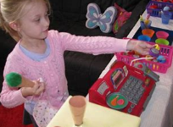  Challenge. How much change will you give from £5 if your mum/dad/sibling buys 3 ice creams? | Activity 2: A Sun Dial  Create an outdoor sun dial in your garden.  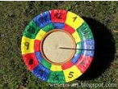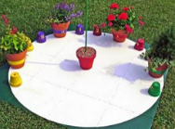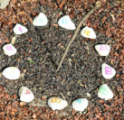  Paint a paper plate and draw a clock face with even intervals or make it with stones. In the centre, pierce a hole so that you can stand you pencil upright (ask an adult for help). Now use it to tell the time.  Challenge: Can you tell the 12 and 24 hour time?  Remember to position the sundial with the ‘12’ pointing north to determine the current time. | Activity 3: Street Map  Drawing a map is a good way to consider scale and the shape of buildings and streets from a bird’s eye view.  Make a map of your street or local area. Can you write directions for a route around your map? You could follow the route on your daily walk.  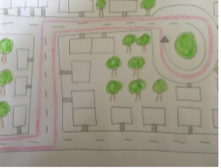  Challenge: Could you draw your map on a co-ordinate grid? https://www.twinkl.co.uk/resource/t2-m-2244-map-coordinates-differentiated-activity-sheets
Activity 4: Obstacle course  Using any materials, create an obstacle course. This could involve running, crawling, skipping, star jumps, hopping on one leg, balancing etc. You could even illustrate instructions!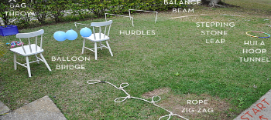  Challenge: Time how long it takes you to complete your obstacle course.  Can you improve your time?  Calculate how many times would you complete the course in 10 minutes / 20 mins?  Can you work this out mathematically? | Activity 5: South America Map  Find any natural materials (leaves, sticks, stones, bark) to create a map of South America. Carefully, locate the different countries and the seas. Use this map to help you!  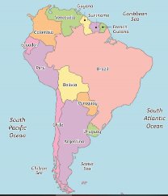  Challenge:  Add a key for the countries & seas.  Locate the capital cities of each country.  Can you add the landmarks? | Activity 6: Landscape  Paint/draw/ illustrate a landscape of your outdoor space or somewhere on a walk.  Can you use different colours, techniques, textures, materials, patterns to add detail?  Look carefully at natures’ palette. The different greens and browns, and sometimes vivid flower colours.    Challenge: Think of some descriptive language. Can you use the senses? Creatively write about your landscape, e.g. description, poem, story.
Activity 7: Make music from grass!  Watch the video below and have a go at making owl sounds with your hands and grass music. Can you change the pitch of your notes? What about playing a tune? How can you change the volume?  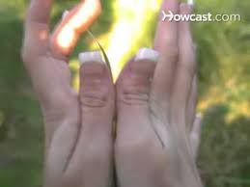﷟https://www.youtube.com/watch?v=JnVMToadzV0  Challenge: Play a scale of notes going up and down in pitch! | Activity 8: Positivity display  For passers by, at the front of your home, create a positivity display. This could be messages to boost positivity, drawings or even painting stones to put outside, with positive messages on them.  Positive image ideas: rainbows, sunshine, smiley faces  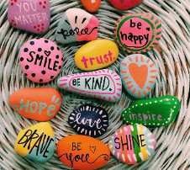  Challenge: Write a positive letter to yourself or someone in your family. What makes you/them special? | Activity 9: Fairy/Goblin House  In Auntie’s Woods, lots of fairy/goblin houses are appearing. Use anything from your garden or recycling to create a fairy house and fairy which you can take to the ‘enchanted’ Auntie’s Woods.  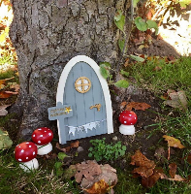  Challenge: Write a diary about your creature’s  life in the woods.
Activity 10 : Tied up in knots!
Can you tie your own shoelaces tightly? If not, now is the time to practice.
Challenge : If you are already an expert, why not try practising other bows and knots such as square knots, clove hitch, figure 8 loop, round turn and half hitches. Grab a stick and some string and get started or … teach a younger brother or sister to tie their shoe laces!
!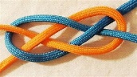 https://www.youtube.com/watch?v=5c5xI-3SnUU
Please blog to tell us about how you are getting on and feel free to post your work. Remember these activities are all optional.

