Frosty spellings  Are there any words you need to practise and are finding a little tricky to remember? Writing things in lots of different ways helps us to remember.  Wrap up warm, take yourself outside on a frosty morning and write those tricky words in the frost! Maybe you could practice word walls or your 100 words, or even any words related to any of your home learning.  Where is the best place to write them? Do you have a shed that you can write them on using your finger? Or maybe you could write giant words on grass using your feet!  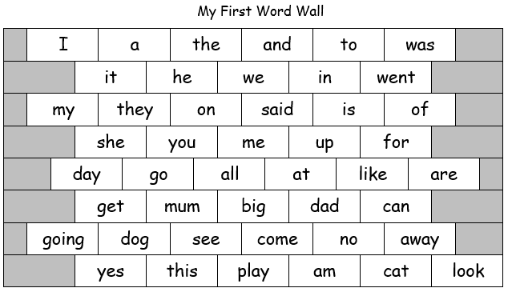 | Mindfulness Minutes – “I wonder…”  Choose 3 ‘I wonder…’ challenges to complete.  I wonder… how many colours of the rainbow I can find in nature.  I wonder… what I can create using 15 sticks I have collected.  I wonder… how many rocks I can stack before they fall over.  I wonder… what pictures I can see in the clouds today.  I wonder… what is under that log.  I wonder… which way the wind is blowing today. How could I find out?  I wonder… if different things of different colours feel different temperatures in the sunshine. Find something light in colour and dark in colour and feel both. Is one warmer than the other?  I wonder… if I can find my shadow and then make it disappear.  Which was your favourite challenge? Can you create any of your own “I wonder” challenges? Maybe you could add them to your blog so others can have a go! | Winter Leaf Hunt  Can you find all the different leaves shown in the hunt below? How do you think this hunt would be different if you completed it during a Summer month? What about Autumn?  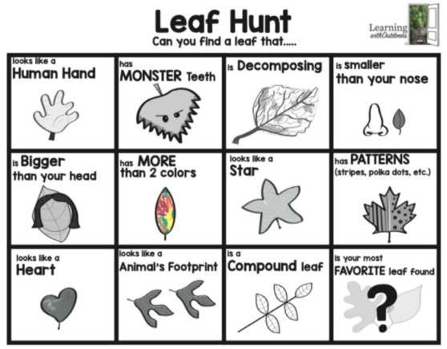  Perhaps once you have collected them all you could use them to make some art. Can you create a bird from the eaves you have collected? Or a self-portrait?

