Make a Bridge  Your challenge is to make a bridge that can go across a gap that is at least 30cm long. If it’s been raining, you could try to build your bridge across a puddle.  You can only use materials that you find outside and string. P  Think about the materials you have in your garden and how you could join them together to make a stable bridge.  You could use sticks and tie them together in bundles or perhaps find some large pebbles and practise your stone balancing skills in order to create your supports.  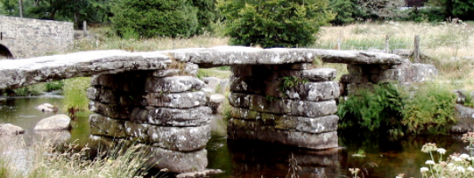Can you balance anything in the centre of your bridge? How much weight can it hold? | Build a Tower  Can you make a tall tower using only materials you find outside?  Perhaps you can stack sticks or balance stones or maybe you could use mud and leaves to create your own cement.  Test out lots of different natural materials – which works best?  Which material allowed you to make the tallest tower? Which tower was the most stable?  If you don’t have a ruler or tape measure at home, how else can you measure your towers in order to compare their height?  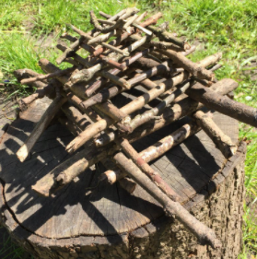 | Create a Shelter  Make a mini waterproof shelter using only natural materials. Try to collect things from around your garden that you think would keep the inside of your shelter warm and dry.  To test your full-sized shelter, stand inside and get someone to pour a bucket of water over the top! To test your mini shelter put some tissue or cotton wool into your shelter and water it using a watering can. You can then easily see if your wool or tissue gets wet!  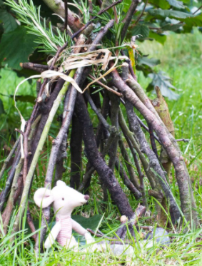Who do you think would live in your shelter? Would you like to live in your shelter?

