Monday 20th April- Friday 4th May - Indoor Home Learning Grid
Go on a shape hunt around the house. What can you find? Tell an adult their properties, number of corners and sides…  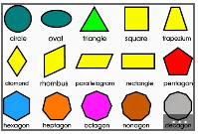  Challenge – can you write a description of some shapes for your family to guess? | Write a postcard to a friend or relative in self isolation. Cut out the card, draw a picture on the front and write a message on the back. | Draw and invent a new mythical creature.  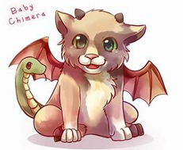  Challenge – can you write a description of your creature – what do they look like? How do they behave? | Doodle Arm - First - draw around your hand and arm and fill it with doodles.  What do your hands like to do? Bike rides, cooking, drawing? When you fill your arms with doodles, you might consider the things you are currently missing - or the things you are currently appreciating whilst being at home with your family.  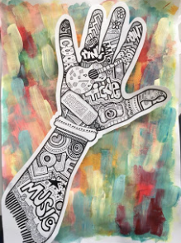
Draw a picture of what you can see from your window.  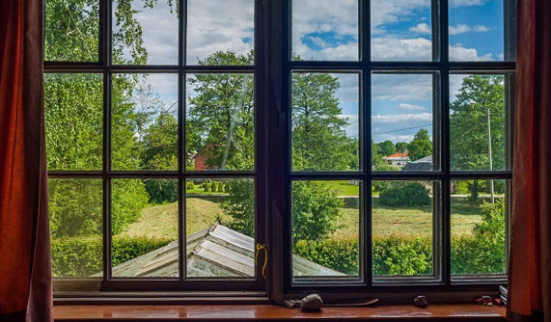  Challenge – write a setting description of what you can see. Can you describe what you can see, hear, smell? | This is our school telephone number: 01480 479890 How many different two digit numbers can you make using the numerals in our telephone number? Put them in a sequence starting with the smallest number first. | Listen to a piece of classical music and draw a picture of what you think it is about or what it makes you think about.  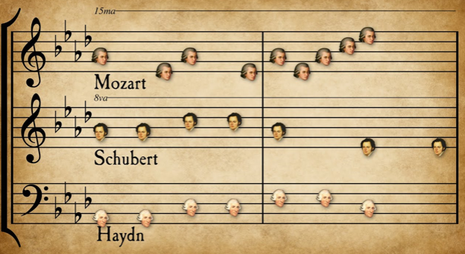
Plan and design and 3 course menu for your family.   | Create an information poster about a topic of your choice.    Challenge – can you write an information report about the topic you have chosen? | Find different numbers in your home (e.g. front door, clock, television channel, on packaging, in books). Which are odd and which are even numbers? Record some of these and draw where you found them. Order your numbers from smallest to biggest.

