- 1. SENSORY & TEXTURE WALKING  This is a fantastic exercise that combines the physical and the literary.  Sensory and texture walks help children to trust the world surrounding them, helping to develop motor skills and even improving problem-solving thinking patterns.  Before setting off, have a chat about the potential words you might want to use to describe the texture walk. Get those imagination juices flowing.  Ask your children to describe what they discovered by writing about ‘My Sensory Texture Walk’ - and challenge them to stretch their vocabulary. What did they enjoy, or find displeasing? What surprised them. | 2. EXPLORE AND MAKE A MAP  Combining geography, art and physical exploration, this fun activity will bring out those budding cartographers.  Grab the paper, clipboard, some pencils and crayons and set off into the outdoors to make a map of your local area!  Add all your favourite places and give them names (they don’t have to be the real names).  You could write a mini report about their map? What words would you use to describe the area they charted? | 3. OUTDOOR MASTERPIECES  Ask them to draw or paint the landscape, or perhaps ask them to choose one particular item that they find particularly interesting - a leaf, stone or a tree.  Remember we looked at the work of Monet. See if you can create a landscape like he did.  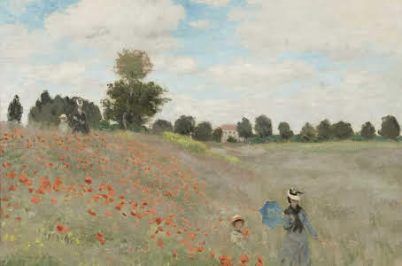 | 4. ‘WHAT’S THIS CRITTER THINKING?’  Grab the clipboards and get outside and find a little bug, insect or other creature.  When they’ve found one, get them to list down three thoughts that the critter might have.  There’s also plenty of follow-up material and post-exploration thinking. What role to certain animals or creepy crawlies play in our ecosystem? What is their place in the food chain, and what sits above and below them? What other roles do they fulfil?  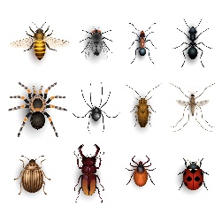 | 5. MINI BEASTS AND FANTASTIC FLOWERS HUNT  All you need are some pictures of the common mini beasts.  A pair of gloves might also be helpful for this one!  Explore under logs, stones, in piles of leaves and branches. How many of the creepy crawlies they can find?  Write a list and tally up your results. You could even make a bar chart to show your results.
6. BUILD A MINI DEN  Using natural collected materials build a den for your favourite bear to hid in.  How can you make it cosy? Strong? Is it big enough for more than one bear to fit in? | 7. MAGIC WANDS  When you go out for your walk today have a look for a stick. It can be any stick but select carefully!  This is now your magic wand! When you get home you can decorate your stick with ribbons, glitter or paper and then use it to cast magic spells.  What sort of magic spells will you cast with your wand?  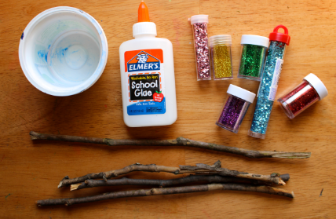 | 8. CREATE YOUR OWN MUSEUM OF NATURAL TREASURES  Take a look around your garden or when you are out on your walk and see what natural treasures you can find.  It might be an unusual stick or a shiny stone. It could be spiky leaf or a small fossil.  When you have collected your objects set them out in a space in your garden, add some labels and invite your family into your Museum of Natural Treasures. | 9. ICE ESCAPE  Take a yogurt pot and fill it half fill it with water. Place a Lego figure or plastic animal into the pot. Place it in the freezer.  Once it is frozen fill with water to the top and place back in the freezer until it is solid. Then remove the ice from the container.  Now you have a choice.  1. You can time how long the ice starts to melt and how long it takes for the figure to be freed.  Or  2. Work out your own way to get the figure free from the ice. | 10. SHADOW PICTURES  Lay out a piece of paper in your garden and select some toys of different sizes and shapes.  Draw around their shadows using pencils, felt tips or crayons.  What happens to the shadows during the day? Do they stay the same? Do they get bigger? Do they move?  Record what you notice.  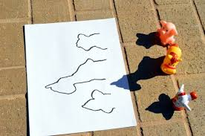

Outdoor Activity Learning Grid – Monday 4th to Friday 16th May

