Monday 4th May - Friday 15th May - Indoor Home Learning Grid
Please share your work on the blog and remember these activities are all optional.
Activity 1 – Create your own animal!      Can you design your own animal using a mixture of other animals? Will you animal have fur or scales? How many legs? How many arms? Will it have the head of a lion? Arms of a monkey? Tail of a kangaroo? Draw your own animal and label it  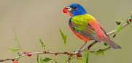  Challenge – Can you describe your animal? Try to use a 2A sentence. For example – It has a big, round head with long, brown arms. | Activity 2 – SEASONS  Draw a picture to show each season. Write one sentence beneath your picture to tell us what happens in each season.  CHALLENGE – What season are we in now? How do you know? | Activity 3 - Design your own perfect cupcake.    Can you design your own delicious cupcake? Draw your cupcake with and label it with adjectives or expanded noun phrases.  CHALLENGE - Can you then have a go at writing reasons why people should eat your cupcake. For example – This cupcake has sweet, tasty chocolate chips that will instantly make you want to take another bite. | Activity 4 - How many ways can you make and show the number 12?  Can you use addition, subtraction, multiplication and division? Can you draw it? Can you make it on a tens frame? Can you make it drawing diennes?  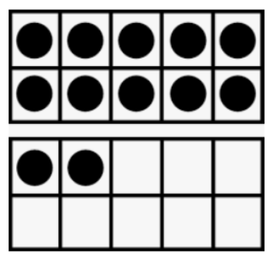  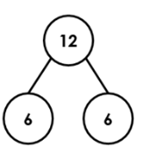
Activity 5 - Look at the picture below.  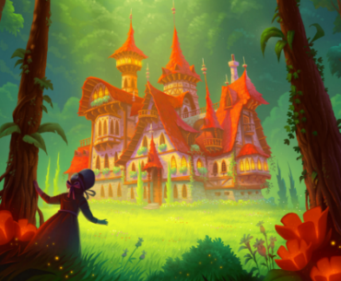  Can you write a 5-sentence story based on what you can see? Think about some exciting adjectives you could use. | Activity 4 – Make your own musical instrument  Use anything you have round you house to make your own musical instrument. You could make your own guitar with a cereal box, string and a carboard tube. Or you could make a shaker with a cardboard tube/tin/bottle and fill with rice. Here are some ideas. Remember to decorate your instrument. Be as creative as you like!  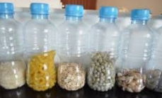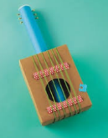 | Activity 7 - Learn your full name, when your birthday is and your address.  Challenge – Write a letter to your teacher (you do not have to post it!) You can use the school address. Tell us what you have been up to. Find the school address on the school website.  
Activity 8 – INDOOR CAMPING  Build yourself a den inside. Turn off all the lights and use a torch to explore round the den.  You could also use your torch to make shadow pictures on the den walls. | Activity 9 – HOT SEATING  As a member of your family to pretend to be a character from a favourite book or television programme.  Interview them by asking interesting questions. You could even make a microphone and dress up like the character.  Write a list of your questions before you start your interview. | Activity 10 – CREATE YOUR OWN GAME  Make a simple track or path on paper and number the spaces. Use a dice and small toys to play the game.  You could even have some ‘go back’ or ‘move forward’ or ‘miss a go’ spaces in your game.  

