The Round House Primary Academy
EYFS Reception Curriculum
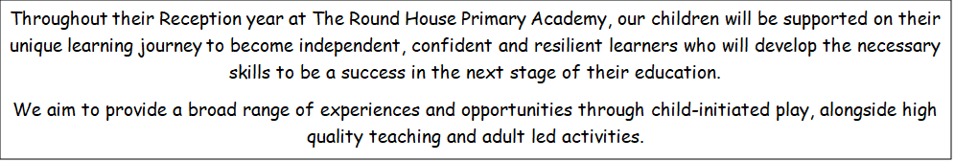
Intent | Implementation | Impact
Our EYFS intent is:  -To create a happy, safe and nurturing environment where children develop their independence as learners.  - To provide a curriculum which is exciting and motivates children to love learning.  - To ensure that learning is accessible for all and that children’s individual progress is valued.  - To provide a stimulating indoor and outdoor environment where children safely explore risks and challenge their own learning.  - To work closely and collaboratively with parents in order to ensure that home experiences are valued and develop a true reflection of the whole child.  - To effectively prepare children for the next stage in their school life. | Across our EYFS, we follow the Early Years Statutory Framework. This Framework specifies the prime and specific areas of learning we must cover in our curriculum.  In Pre-school, our main focus is on the 3 Prime Areas:  - Personal, Social and Emotional Development  - Physical Development  - Communication and Language Development  In Reception, we consolidate the skills within the Prime Areas, alongside developing the Specific Areas of learning:  - Literacy  - Mathematics  - Understanding the World  - Expressive Arts and Design  We also incorporate the characteristics of effective learning into all teaching and learning experiences. The children are taught the skills required in the EYFS through weekly or half-termly topics which are coherently planned to build upon the children’s current knowledge and understanding by a cumulative sequence of lessons. The pupils are encouraged to wonder and ask questions about what they are learning and this information is used to plan subsequent lessons. Parents are regularly informed about their child’s progress through Tapestry.  At The Round House, we promote a language-rich curriculum across our pre-school and reception classes and know that this is essential to the successful acquisition across the curriculum. The development of speech and language is embedded in all we do and in both pre-school and reception we follow the Little Wandle Foundation for language programme. | Through the delivery of a well-planned, child-led and challenging curriculum we aim that the pupils will leave the Early Years Foundation Stage as independent learners, with transferrable skills needed to start Key Stage One.  This will be measured at the end of Reception as to whether the pupils have achieved a Good Level of Development. We aim that our pupils will leave our Foundation stage ready for the next stage in their education and ready for year 1 by being able to:  - Use their phonics knowledge to read accurately with increasing speed and fluency.  - Write correctly punctuated simple sentences.  - Understand and use numbers competently and confidently.  - Have good personal, physical and social skills.  - Enjoy, listen attentively and respond with comprehension to familiar stories and rhymes.  - Demonstrate positive attitudes to learning through high levels of curiosity, concentration and enjoyment.  - Be resilient learners who are keen to learn and are proud of their achievements.

 | Autumn 1 | Autumn 2 | Spring 1 | Spring 2 | Summer 1 | Summer 2
Theme | Settling into School/Emotions  Families/Ourselves | Festivals – Bonfire Night, Diwali, Hanukkah and  Christmas | Space  Dinosaurs | Traditional Tales  Easter/Spring | Animals  Minibeasts | Transport  Superheroes  Summer/Transition
Texts for Group Time and Drawing Club | Have you Filled a Bucket Today?/ The Dot/The Colour Monster Goes to School/The Colour Monster  All are Welcome Here/The Big Book of Families | Little Glow/Dipal’s Diwali/Hetty’s Hanukkah  The Christmas Pine/The Jolly Christmas Postman/The Snowman | Aliens Love Underpants/Button Moon/Look Up  Dinosaur Roar/Dear Dinosaur/Non-Fiction articles about dinosaurs | Little Red Riding Hood/The Three Little Wolves and the Big Bad Pig/The Gingerbread Man/The Three Billy Goats Gruff/Errol’s Garden | What the Ladybird Heard/  The Very Hungry Caterpillar  Blown Away | Naughty Bus/ Mr Gumpy’s Motor Car  Superhero like you/Superworm  Ruby’s Worry
Additional Drawing Club Resources |  | Firework video  The Snowman | Video of moon landing |  | Lifecycle of a Ladybird  Pingu  Mr Benn  Seven world one planet | Thomas the Tank Engine  Banana Man
Reading and Writing | Phonics  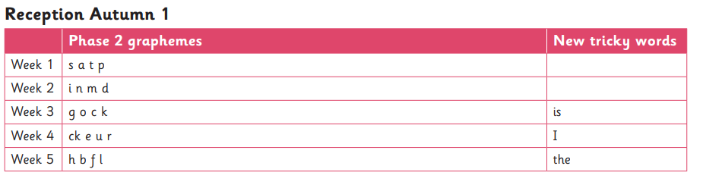  Develop routines for daily phonics sessions  Reading  Develop routines for 3 x weekly Reading Practice sessions – focus on decoding, prosody and comprehension  Writing  Dough Disco and fine motor control activities.  Daily name writing at registration – choosing lunch  -introduction to letter formation  -labelling all work with name  Drawing Club focus | Phonics  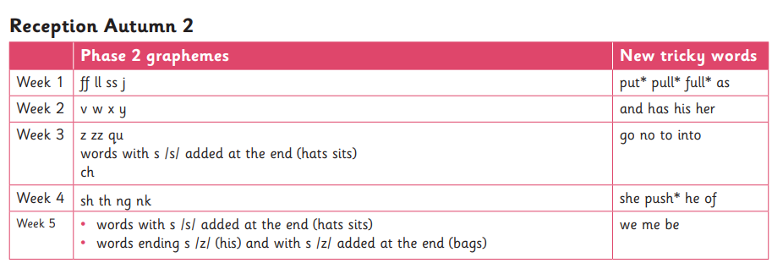  Reading  3 x weekly Reading Practice sessions – focus on decoding, prosody and comprehension  Writing  Drawing Club focus | Phonics  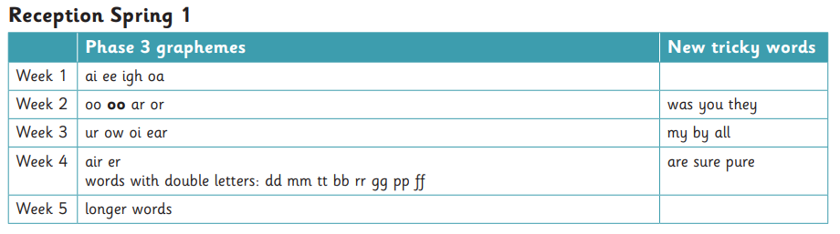  Reading  3 x weekly Reading Practice sessions – focus on decoding, prosody and comprehension  Writing  Drawing Club focus | Phonics  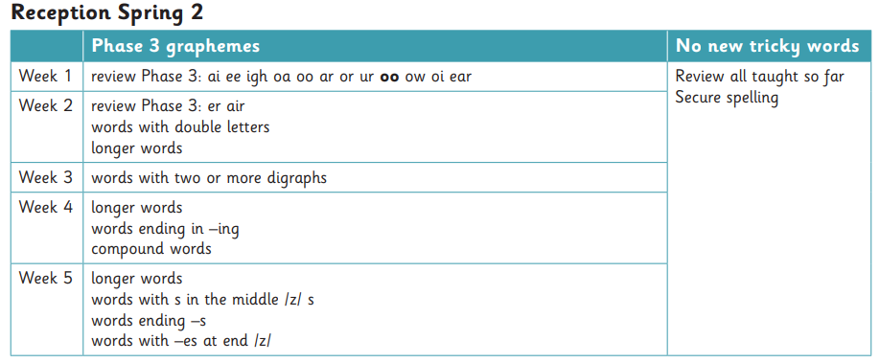  Reading  3 x weekly Reading Practice sessions – focus on decoding, prosody and comprehension  Writing  Drawing Club focus | Phonics  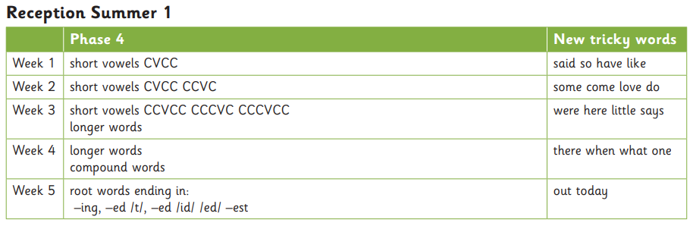  Reading  3 x weekly Reading Practice sessions – focus on decoding, prosody and comprehension  Writing  Drawing Club focus | Phonics  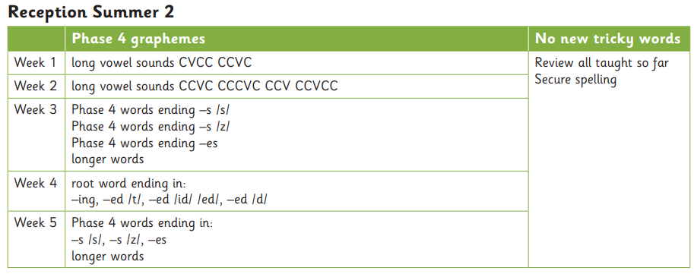  Reading  3 x weekly Reading Practice sessions – focus on decoding, prosody and comprehension  Writing  Drawing Club focus  Thomas the Tank Engine
Maths – Mastering Number NCETM | Revision of numbers 1-5 1:1 Correspondence Counting to 5 Counting Rhymes and Songs Showing and making numbers using objects Language of Comparison | Subitise within 5 Patterns within 4 Use fingers to represent quantities 1:1 Correspondence/ know the last number counted is how many Counting rhymes and songs Cardinality of 5 Count beyond 5 Recognise numerals to 5 Numbers made with 1s Compose own numbers within 5 Explore parts and wholes Compare sets Language of comparison Compare by looking/subitising Compare equal sets Patterns AB ABB AAB | Subitise within 5 – Structured and random Patterns to 5 and more than 5 Patterns with small group and 1 more Match arrangements to fingers Verbal counting to 20 and beyond Counting objects Order numbers Composition of 5 missing/hidden parts Composition of 6 Numbers to 10 as 5 and some more Compare and use language to compare play comparison games Compare by matching equal sets Explore making unequal sets 2D and 3D shapes | Symmetrical Patters/Doubling Cardinality of numbers within 10 Counting pattern beyond 20 Odd and even numbers using the ‘shape’ of these Begin to link even to doubles Begin to explore composition within 10 Compare numbers and reason using its ‘how manyness’/position in the number system Positional and ordinal language | Familiar subitising patterns Subitising with number patterns Know when to count and when to subitise Verbal counting to 20 and beyond Counting from different starting points Composition of 10 Order sets of objects Height and length- ordering 3 objects by a set criteria | Consolidation of their understanding of concepts previously taught through working in a variety of contexts and with different numbers Weight- ordering 3 objects by weight. Language of weight.
CL | ble to sit in a circle and wait their turn to speak. Repeats modelled sentences. Begins to direct their speech at an adult. Interacts with peers during play responding to direct questions and play activities  Vocab – Kindess, Unique, Ourselves, Emotions, Family | Passes a talking object and speaks on their turn. Voice is audible in a group and a basic sentence is used. Interaction with peers is expressive and shows their needs and wishes. Answers direct questions from adults and approaches them with worries or needs.  Vocab – Bonfire Night, Diwali, Christmas, Hannukah | Knows the rules of a circle and puts their hand up to speak or waits. Eye contact is made and voice is directed at listeners. Sentence is used, only sometimes needing a model or stem. Peer interaction is back and forth, with pauses and responses from each. Adults are engaged in conversation when playing alongside. Questions are answered with basic responses.  Vocab – Space, Planets, Atmosphere, Herbivore, Dinosaur, Carnivore | Topics of interest result in extended conversations where conjunctions are used. Questions are responded to and basic questions are asked. Peer interaction is sustained and questions are asked and answered during the interaction. There are clear pauses to show listening. Answers show awareness that they have listened.  Vocab -Traditional Tales, Story, Season, Spring, Easter | Pupils are given opportunities to explain by using why and how questions. More complex questions are being asked. Pupils are beginning to wonder and know how to seek answers from adults. Pupils are confident and will approach known adults and familiar friends. Pupils take account of what has been said, responding in an appropriate way.  Vocab – Mammal, Habitat, Insect, Features | Pupils are offering their own explanations for things, using increasing vocabulary. Questions are understood and responded to appropriately. They are able to share their feelings about things and show some emotional literacy. Taught vocabulary is used in different contexts to show mastery.  Vocab- Police, Doctor, Transport, Vehicle
PD | P ractice and refine movement skills they have already acquired Develop small motor skills to use tools independently and safely Attempt to manage own hygiene | Develop control when moving. Develop overall body strength, balance, co-ordination and agility Develop core strength Develop the skills to manage the school day- dressing and undressing, putting own shoes on. | Develop core muscle strength and posture Combine different movements with ease Establish the correct pencil grip and posture for writing To be able to put on and take off own coat. | Confidently use small and large apparatus Talk about how I can keep healthy Develop ball skills by taking part on group balls skills Begin to about different ways I can be healthy and keep active | Develop body strength Develop balance when using large equipment Develop confidence and accuracy when using a ball To be able to fasten own coat Develop coordination Develop handwriting style | Refine different ways of moving: hopping, skipping etc. Demonstrates overall body strength, balance, co-ordination and agility Negotiates space and obstacles safely, considering themselves and others Hold a pencil effectively, using tripod grip Use a range of small tools Talk about different ways I can be healthy and keep active
PSED | Being me in my world (Jigsaw)  - Selecting & using resources in their new classroom setting  - Getting used to new routines & rules  - Building relationships with adults & peers in the setting | Celebrating difference (Jigsaw)  - Continuing to develop friendships & relationships  - Exploring feelings  - Increasingly following rules and boundaries | Dreams & Goals (Jigsaw)  - Showing independence in selecting & using resources  - Identify the range of feelings and how others may feel  - Begin to take on challenges and show perseverance | Healthy me (Jigsaw)  - Begin to regulate their behaviour Show independence in managing their needs  - Begin to show resilience in the face of challenge | Relationships/Families (Jigsaw)  - Expressing & moderating feelings  - See themselves as valuable individuals (within a family unit)  - Finding solutions to conflicts  - Explain reasons for rules | - Changing me (Jigsaw) Manage own basic hygiene  - Working cooperatively & taking turns with others  - Show understanding of others feelings & perspectives  - Give focused attention
EAD | Kapow Art  - Mark making with wax crayons  - Mark making with chalk  - Observational drawing  - Drawing Faces | Kapow Art  - Mark making with felt tips  - Cutting skills  - Threading | Kapow Art  Joining  Painting and Outdoor Painting | Collage | Junk modelling  Sculptures
UTW | R and W  Science  History  Geography | R and W  Science  History  Geography | R and W  Science  History  Geography | R and W  Science  History  Geography | R and W  Science  History  Geography | R and W  Science  History  Geography
Trips, visit and enrichment

